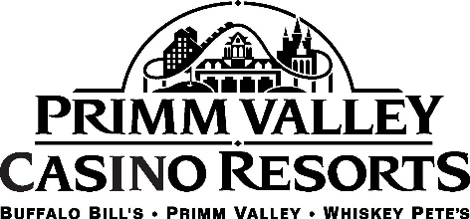

ABOUT

Primm provides an oasis for travelers, or those looking for a weekend getaway or staycation. The resort-town is situated on the state line, approximately 30 minutes south of the Strip. Consisting of three hotels, Primm Valley, Buffalo Bill’s and Whiskey Pete’s, the resorts are short on distance but not on fun.

Primm Valley is home to the famous Desperado roller coaster, which was nicknamed “The Speed Demon” by the Travel Channel. The Desperado is one of the tallest and fastest coasters in the United States. The Fashion Outlets of Las Vegas also call Primm home. The impressive list of designer stores includes Calvin Klein, Coach, Kate Spade New York, Michael Kors, and Neiman Marcus Last Call.

There are many other options in Primm, including the Lakes Course, the Desert Course, a movie theater, spa, dining and arcade.

