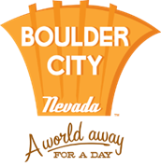
ABOUT BOULDER CITY

A World Away for a Day – Boulder City
Boulder City is known as a green oasis in the desert. Located approximately 20 miles from the glitter and excitement of Las Vegas and just a few miles from the grandeur of Hoover Dam and Lake Mead, the destination offers a quiet, relaxed living environment for residents and guests. Boulder City takes pride in its quality recreational facilities such as Bootleg Canyon mountain bike trails, Boulder City Golf Course, and Boulder Creek Golf Club.

The destination is also known for its annual events like the Fourth of July celebration – Damboree, Art in the Park, Santa’s Electric Night Parade, the Dam Short Film Festival and the Spring Jamboree.

In 2009, Money magazine ranked Boulder City sixth in its annual list of the top 25 places to retire in the United States, which was based on affordable housing, medical care, tax rates and arts and leisure.

