

PRODUCT DESCRIPTION:

**KISS BLOOMING LASH**

After the dress, a bride's makeup is the next exciting piece of bridal style. And to ensure she looks beautiful at every angle, make sure she's wearing real-like, voluminous KISS Blooming Lash. They're specially designed with exclusive, revolutionary Multi-Angle and Tapered End Technologies creating lashes that flourish. No bride should ever walk down the aisle without these universally flattering lashes! They'll make her eyes stand out and she'll look amazing in every photo—no matter what angle the photographer is shooting from.

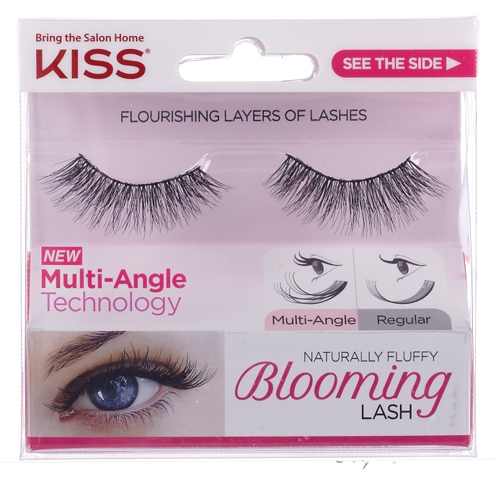

TECHNOLOGY:

* Multi-Angle Technology – Patent Pending Innovation, exclusive to KISS
  + Tapered End Technology- exclusive to KISS
  + Delivers volume while maintaining a natural look
  + Adds layers of length and dimension

BENEFITS:

* Flawlessly blends with your natural lashes
* Creates flutter effect around eye and lashes
* Ultra-thin lash band for added comfort
* Can be worn with or without mascara
* Available in six styles

APPLICATION/REMOVAL:

* If needed, trim lashes to fit eyes.
* Apply KISS Strip Lash Adhesive to lash band; wait 30 seconds for adhesive to become slightly clear and tacky.
* Apply lashes along the natural lash line. Hold in place, allowing adhesive to dry completely.
* To remove, gently peel off lash strip, starting at the outer corner
* Use oil-based makeup remover to remove excess adhesive from eyelid

**LAUNCH:** January 2016

SRP:KISS Blooming Lash $4.99

*Use with KISS Strip Lash Adhesive, sold separately $3.99

AVAILABILITY:Walmart, Walgreens, and Rite-Aid

WEBSITE: KISSusa.com

FACEBOOK: KISSNails

TWITTER/INSTAGRAM: @KISSProducts / #KISSLashes

MEDIA CONTACTS:

Kaitlyn Kirchner/ kkirchner@bratskeir.com

Bratskeir & Company / 212.679.2233

ABOUT KISS:

**KISS** is a worldwide leader in artificial nails. The first company to bring professional-quality nail products directly to the consumer offering at-home, easy-to-use kits that deliver salon results. Today, the KISS line of products has expanded to include nail care, nail jewelry, nail art, manicure & pedicure tools as well as eyelash kits and hot hair styling tools. Each of these quality products originated from KISS’s innovative thinking and vast salon experience. For more information visit [www.KISSusa.com](http://www.KISSusa.com)