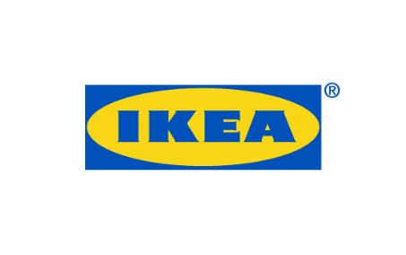
PRESS RELEASE April 2018
Älmhult, Sweden
IKEA collection FREKVENS receives RED DOT Award 2018 for Product Design
IKEA has received a Red Dot Award: Product Design for FREKVENS, developed in collaboration with IKEA designers and teenage engineering. The collection consists of products such as speakers, turn table, lighting and everything else you need in order to throw a really good music party, wherever you are. In addition, IKEA also received awards for the KUNGSBACKA kitchen front as well as the sofa platform DELAKTIG.
Insights of how important music is in young people's life was the starting point in the collection FREKVENS, where IKEA explores how to engineer new solutions for having fun, together with teenage engineering, a Stockholm-based consumer electronics company made up of engineers and computer programmers with a passionate design interest.
The sound part of the collection, created together with teenage engineering, which has Bluetooth® technology, includes speakers, a light system and a record player – everything you need to throw a party.
“What is needed in order to throw a great party at home? That’s what we wanted to explore with FREKVENS. Together with teenage engineering we wanted to explore the possibilities of bringing the party with you. We look forward to introducing FREKVENS to the many people around the world soon, a great reason to throw a party” says Michael Nikolic, Creative leader IKEA of Sweden.
“We’re really happy and proud that IKEA has received these Red Dot Awards. And they actually have something great in common. They are all showing that design can be bigger than just the design, that togetherness makes things better. That we can source waste together and turn it into KUNGSBACKA kitchen fronts. That we can create a DELAKTIG platform which others can add on to and develop further and that we can make a party collection like FREKVENS which encourages people to be together”, says Marcus Engman, Head of Design at IKEA.
FREKVENS will now be presented in the Red Dot Design Museum, the largest museum for contemporary design and the awards ceremony will take place in Essen in July 2018.
This year, submissions from 59 countries were received and the products entered were assessed individually by an independent and international jury of experts. The Red Dot Award is one of the world’s largest international product competitions.

