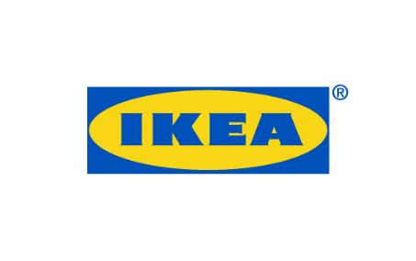
PRESS RELEASE April 2018
Älmhult, Sweden
IKEA DELAKTIG sofa platform receives RED DOT Award 2018 for Product Design
IKEA has received a Red Dot Award: Product Design for the sofa platform DELAKTIG, developed in collaboration with Tom Dixon. Red Dot Award is an internationally organised competition which reviews the best products of the year. In addition, IKEA also received awards for the KUNGSBACKA kitchen front as well as the portable music collection FREKVENS.

At IKEA we are both curious and eager to find new solutions to meet the new demands on the homes of today and tomorrow. With many people living in smaller and smaller spaces, there’s a growing need for products that can suit many different situations and activities. We were thinking, how can IKEA come up with an idea that meets the challenges of a new way of living?
“Together with Tom Dixon we decide to challenge the traditional role of the sofa in a home. With many people living in smaller spaces, there’s a growing need for products that can suit many different situations and activities. DELAKTIG is a completely open-sourced and customizable sofa platform, made to suit the needs of the many people, wherever they are.” James Futcher, Creative Leader IKEA of Sweden

The starting point of DELAKTIG was to industrialize the sofa, challenge traditional production methods and explore new material. The core of the DELAKTIG platform is an extruded aluminum profile which consist of at least 50% recycled material. Focus was also on exploring how people customize our products and the demand for the ability to personalize and adapt furniture and the technology industry was a huge inspiration in the design process for DELAKTIG.
We are really happy and proud that IKEA has received these Red Dot Awards. And they actually have something great in common. They are all showing that design can be bigger than just the design, that togetherness makes things better. That we can source waste together and turn it into KUNGSBACKA kitchen fronts. That we can create a DELAKTIG platform which others can add on to and develop further and that we can make a party collection like FREKVENS which encourages people to be together, says Marcus Engman, Head of Design at IKEA.
The DELAKTIG sofa platform will now be presented in the Red Dot Design Museum, the largest museum for contemporary design and the awards ceremony will take place in Essen in July 2018.

