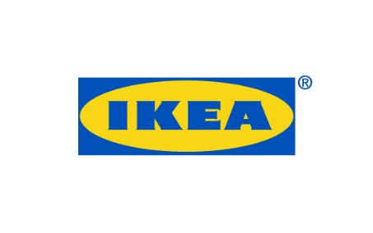
PRESS RELEASE April 2018
Älmhult, Sweden
IKEA kitchen KUNGSBACKA receives RED DOT Award 2018 for Product Design
IKEA has received a Red Dot Award: Product Design for KUNGSBACKA, the first kitchen fronts in the IKEA range made from both recycled wood and recycled plastic. The KUNGSBACKA kitchen is a more sustainable option without any compromise on quality, function, design or low price. In addition, IKEA also received awards for the DELAKTIG sofa platform as well as the portable music collection FREKVENS.
To IKEA, waste is a resource, not a problem. The KUNGSBACKA project started with a vision to create a more sustainable kitchen front and resulted in kitchen fronts made of recycled wood covered with plastic foil made from recycled PET bottles.
“We need to become better at using the planet’s resources in a smart way. Our ambition is to increase the share of recycled materials in our products. We are looking into new ways to re-use materials, such as paper, fibre, foam and plastic, so that we can give them a new life in a new product,” says Anna Granath, product developer at IKEA of Sweden.
25 half-liter PET-bottles are needed to cover the black surface of a 40x80 cm KUNGSBACKA kitchen front. This is an important step for IKEA on the journey towards a more circular business. KUNGSBACKA does not only give recycled plastic bottles and recycled wood a new life, but a considerably longer life.
“We are really happy and proud that IKEA has received these Red Dot Awards. And they actually have something great in common. They are all showing that design can be bigger than just the design, that togetherness makes things better. That we can source waste together and turn it into KUNGSBACKA kitchen fronts. That we can create a DELAKTIG platform which others can add on to and develop further and that we can make a party collection like FREKVENS which encourages people to be together”, says Marcus Engman, Head of Design at IKEA.
KUNGSBACKA will be presented in the Red Dot Design Museum, the largest museum for contemporary design and the awards ceremony will take place in Essen in July 2018.

This year, submissions from 59 countries were received and the products entered were assessed individually by an independent and international jury of experts. The Red Dot Award is one of the world’s largest international product competitions.

