PRESS RELEASE
Goodyear Vector 4Seasons Gen-2 for the Audi Q2

Bruxelles, November 13th 2017 – Goodyear has announced that the Vector 4Seasons Gen-2 has been accredited with original equipment fitment on the Audi Q2.
The tire has been developed for drivers who live in regions that experience milder winters and who don’t want to think about changing their tires every season. The Vector 4Seasons Gen-2 is especially suited for urban environments experiencing different road and weather conditions.
The tire was approved for the Audi Q2 with two sizes: 215/60R16 95V and 215/55R17 94V. The tires will be marked ‘AO’, showing that they are approved by Audi as original equipment.

The Vector 4Seasons Gen-2’s tread pattern is developed to match both summer and winter needs, as indicated by the M+S and snowflake sidewall markings. Thanks to SmartTread technology, the Vector 4Seasons Gen-2 also offers excellent performance on demanding wet, slushy and icy roads. Stability, handling and durability are key features which define the second generation Vector 4Seasons tires.
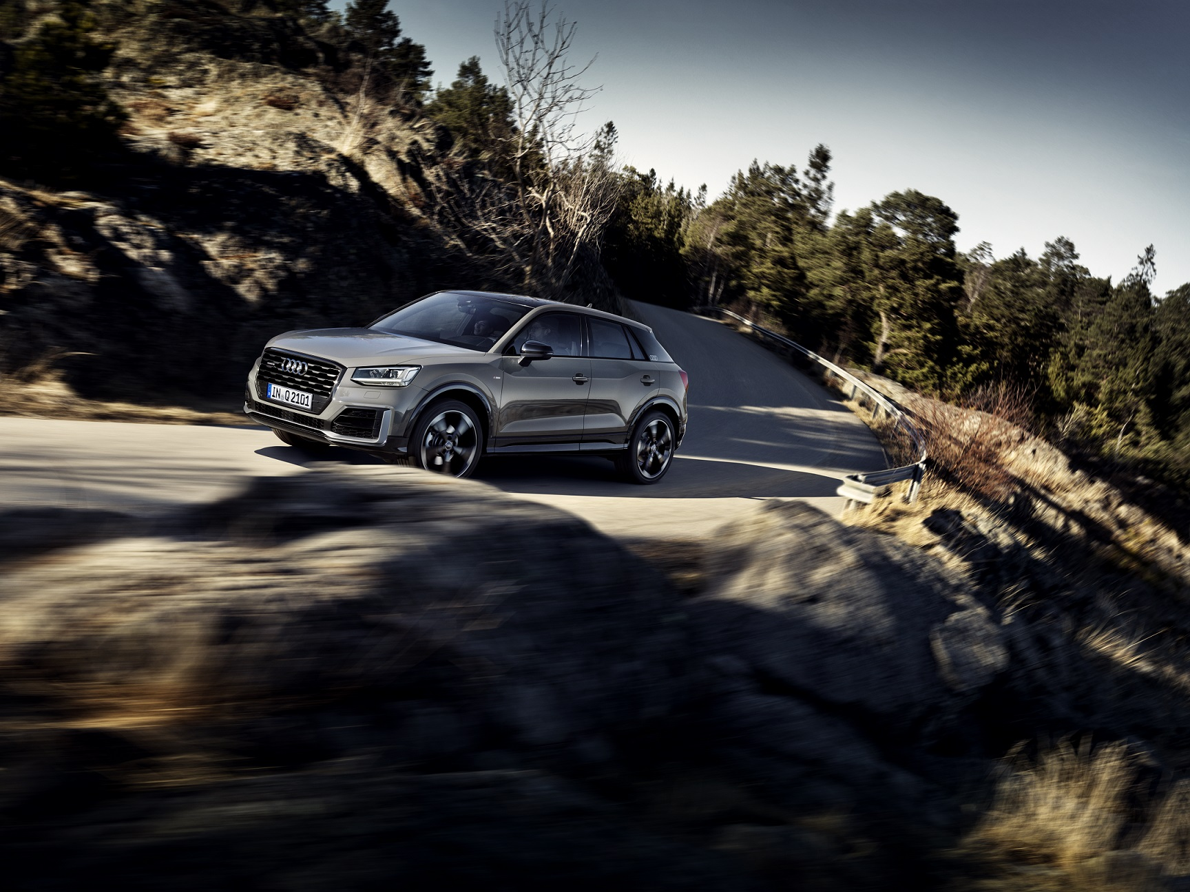
“Once again we can proudly announce that the Goodyear Vector 4Seasons Gen-2 has been chosen by a premium car manufacturer such as Audi. This tire is the right solution for a multipurpose car, allowing motorists to drive under different road and weather conditions without changing their tires before winter or summer.”, says Nick Harley, Goodyear’s Managing Director OE Consumer EMEA.

About Goodyear

Goodyear is one of the world’s largest tire companies. It employs about 65,000 people and manufactures its products in 47 facilities in 21 countries around the world. Its two Innovation Centers in Akron, Ohio and Colmar-Berg, Luxembourg strive to develop state-of-the-art products and services that set the technology and performance standard for the industry. For more information about Goodyear and its products, go to www.goodyear.eu.
For additional pictures, visit the online newsroom: http://news.goodyear.eu.

You can also follow us on Twitter @Goodyearpress and join our ThinkGoodMobility group on LinkedIn.

