Shocking Wonders of Nonwoven Fabrics主題 ：令人驚豔的不織布

Taiwan is renowned for its friendliness, and so is Taiwan famous for its 24/7 service convenient stores. In Taiwan, heated food from a convenient store is put into a “bag” that resembles a spring. The “bag” looks like a piece of paper when laid flat on the table; once an object is placed in the middle of it, and picked up from the sides, it transforms into a bag with the ability to endure up to one kilogram. This is one of the wonders of Taiwan’s nonwoven fabrics.

Nonwoven fabrics are also known as “non-woven cloth”. The sheet or web structures are bonded together by entangling fiber or filaments mechanically, thermally or chemically. Nonwoven fabrics parallel woven fabric in appearance, texture and strength. They are not made by weaving or knitting, hence the name “nonwoven”, and do not require converting the fibers to yarn. The applications of nonwoven fabrics are highly diversified. For instance, surgical masks, environmentally-friendly bags, diapers, and sanitary pads, and many other limited life, single-use products. In fact, the application of nonwoven fabrics in our daily life is beyond our imagination.

Nonwoven is a young star with great potentials in the textile industry. Its functions are numerous such as absorbency, liquid repellence, resilience, stretch, softness, strength, fire retardancy, washability, cushioning, thermal insulation, acoustic insulation, filtration, use as a bacterial barrier and sterility. Textile industries all over the world have been investing a lot of efforts in combining the properties to create fabrics suited for specific usages. For example, nonwovens are the ideal choice for covering gypsum plasterboards for they lessen the itchiness and ponderousness resulted from the gypsum and can be prepared efficiently for subsequent coating work.

In the past, farmers used plastic bags to protect the fruits from natural harms, such as birds, pests, wind, rain, and dews, etc. Nowadays, most Taiwanese fruit farmers have given up using plastic bags because nonwovens are more flexible and resilient. With Nonwovens, fruits are well protected and the freshness can be better preserved.
In combination with the advanced melt-blown technology, Taiwan Textile Research Institute (TTRI) is able to make a pair of shoes within 2 minutes. Recently, they invented a “fabric garden” featuring special nonwovens with the properties to prevent moths, odors, and molds. Loaded in nonwoven bags, plants can be hung on wherever people want. It can be a vertical garden wall or a roof that helps lower the indoor temperature and beautifying the environment. The design has won the IF Prize in Germany and is used in various green buildings.

In the age of renovation and innovation, the fast-thinking nonwoven industry has been eyeing on the “nanotechnology” market, especially the bio- and medical fields, such as surgical drapes, covers, gowns, scrub suits, medical packaging, etc. These products offer a high level protection against fluid and particles, preserve better air permeability, have a stronger resistance to tears and punctures, and offer a cloth-like comfort and feel, all important and perfect for the patients and medical practitioners.

Nonwovens have also been applied to technological industries. As a matter of fact, they are key components in products such as wire and cable, motors, transformers and batteries. Today’s commercial batteries mostly use nonwoven separators because nonwovens have the ability to separate positive and negative electrodes, prevent electrical short circuit, prevent passage of particulate between electrodes, allow ions to pass through, withstand assembly operations, hence prolong the lifespan of a battery.

In Taiwan, people in the field like to compare themselves with some special traits of nonwovens. They said “nonwovens are like Taiwanese people, always take on various challenges quietly, humbly, and seriously. They are never the center of attentions, yet, they are too reliable and resilient to fail any mission.

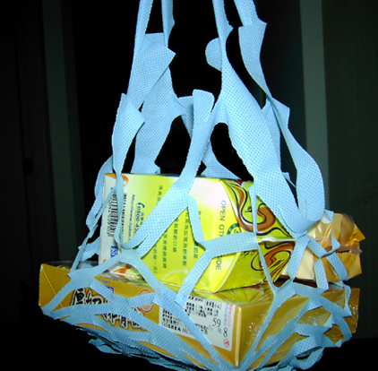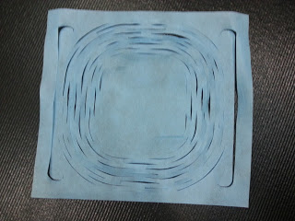
Picture01 Containers for heated food in Taiwan’s convenient store

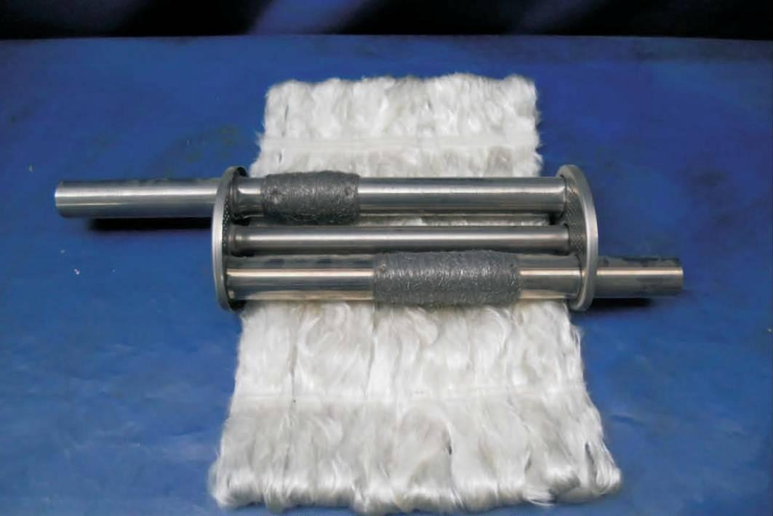
Picture 02-1Used in vehicles’ mufflers and exhausters. This piece of nonwoven fabric prevents erosion, absorbs sounds, and insulates heat, etc.
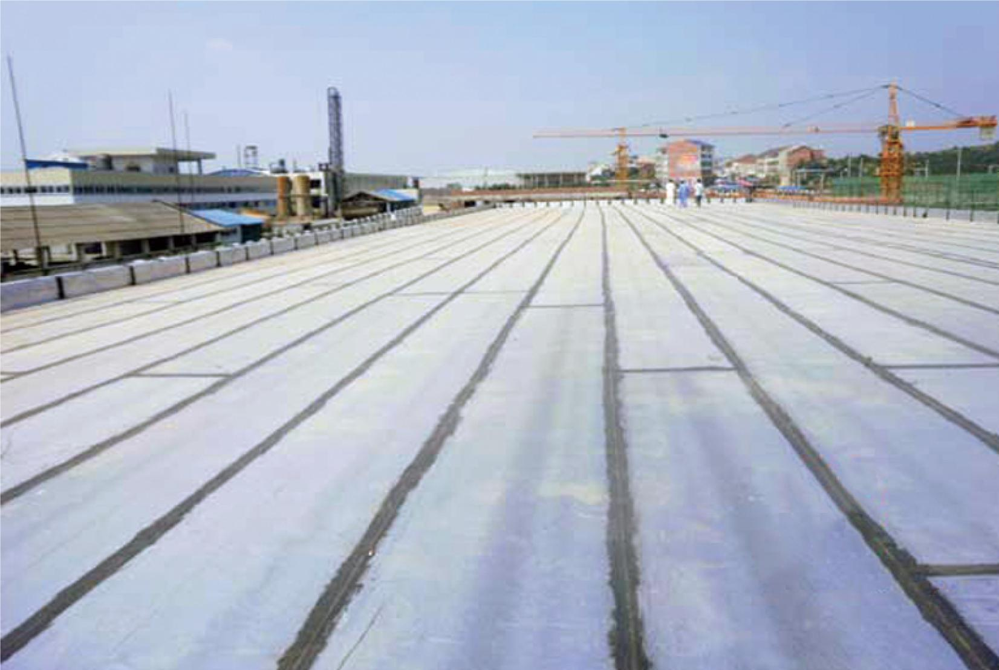
Picture 02-2 Nonwoven fabric used in road construction

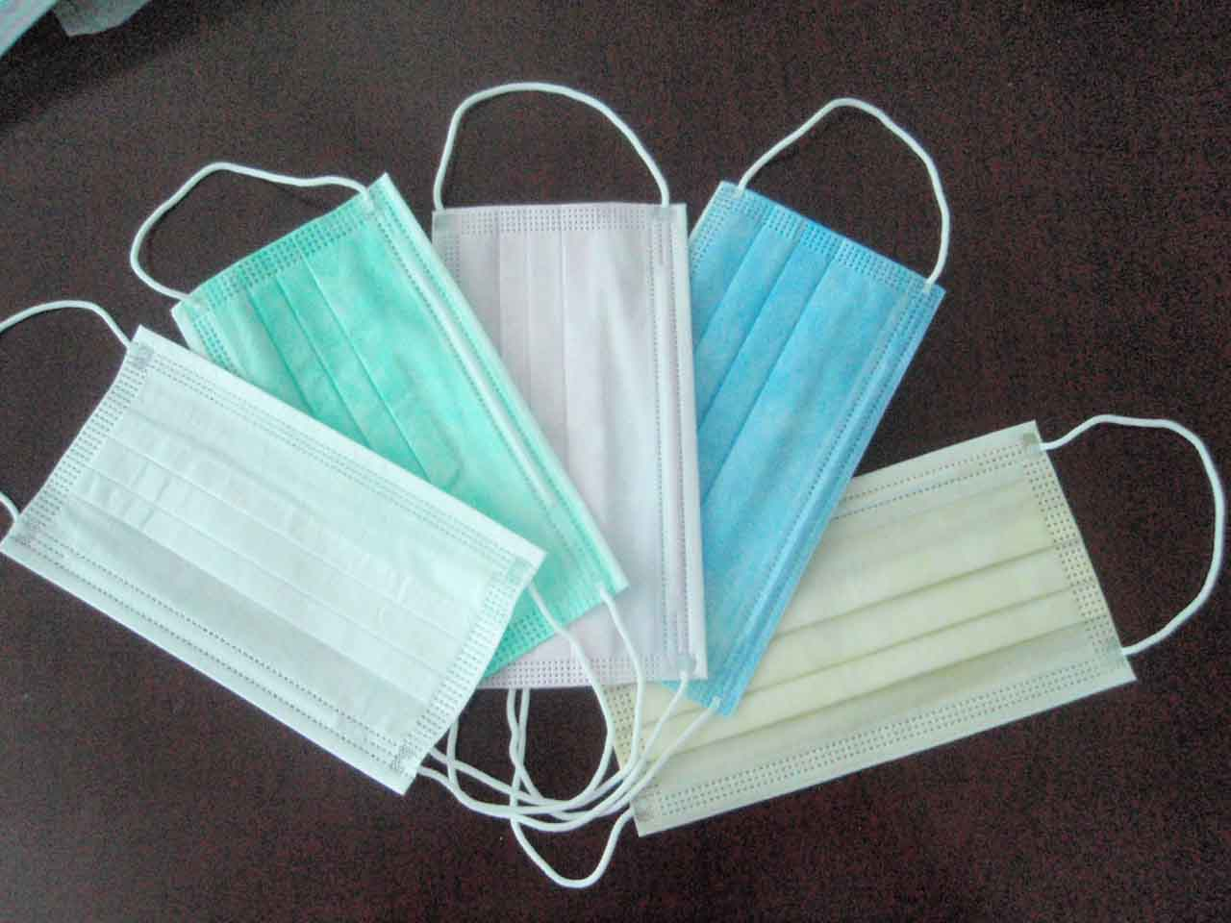
Picture 02-3 Nonwoven masks

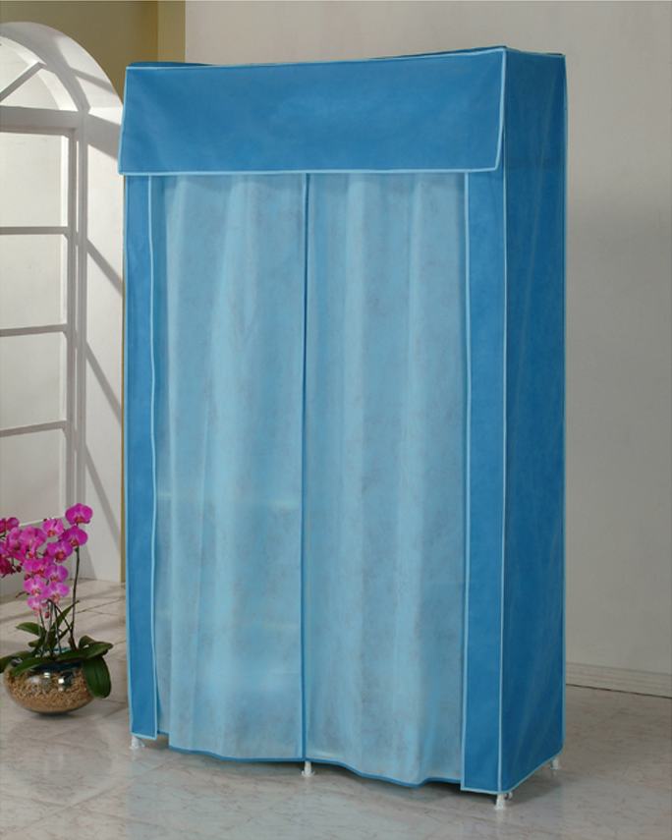
Picture 02-4 Nonwoven closets are a popular furniture choice for students
http://www.17life.com/be0ca42c-15ab-49f1-a124-8ed249a6b2a1
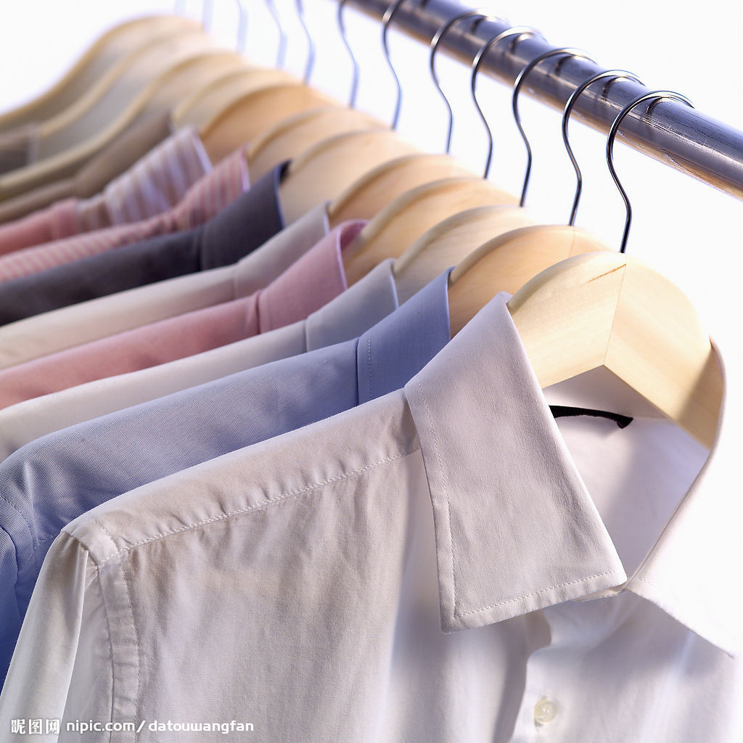
Picture 02-5 Nonwoven clothing products
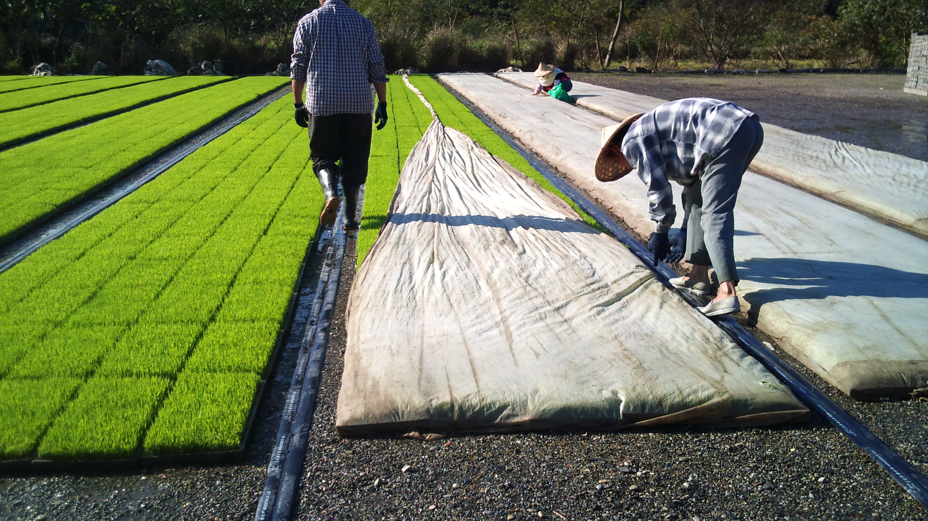
Picture 02-6 Taiwanese farmers use nonwoven sheets to protect produces
http://blog.xuite.net/aunt18/blog/57136648

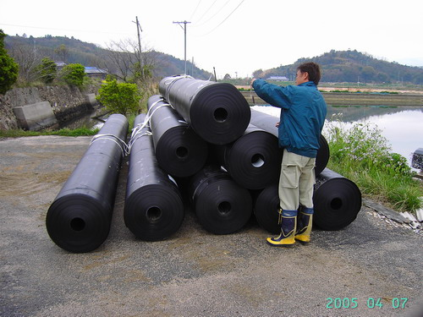
Picture 02-7 Nonwoven anti-humidity surface covers in architecture
http://s.web66.com.tw/_file/C2/26777/AB/1259655974099pic2.JPG?t=2013101211
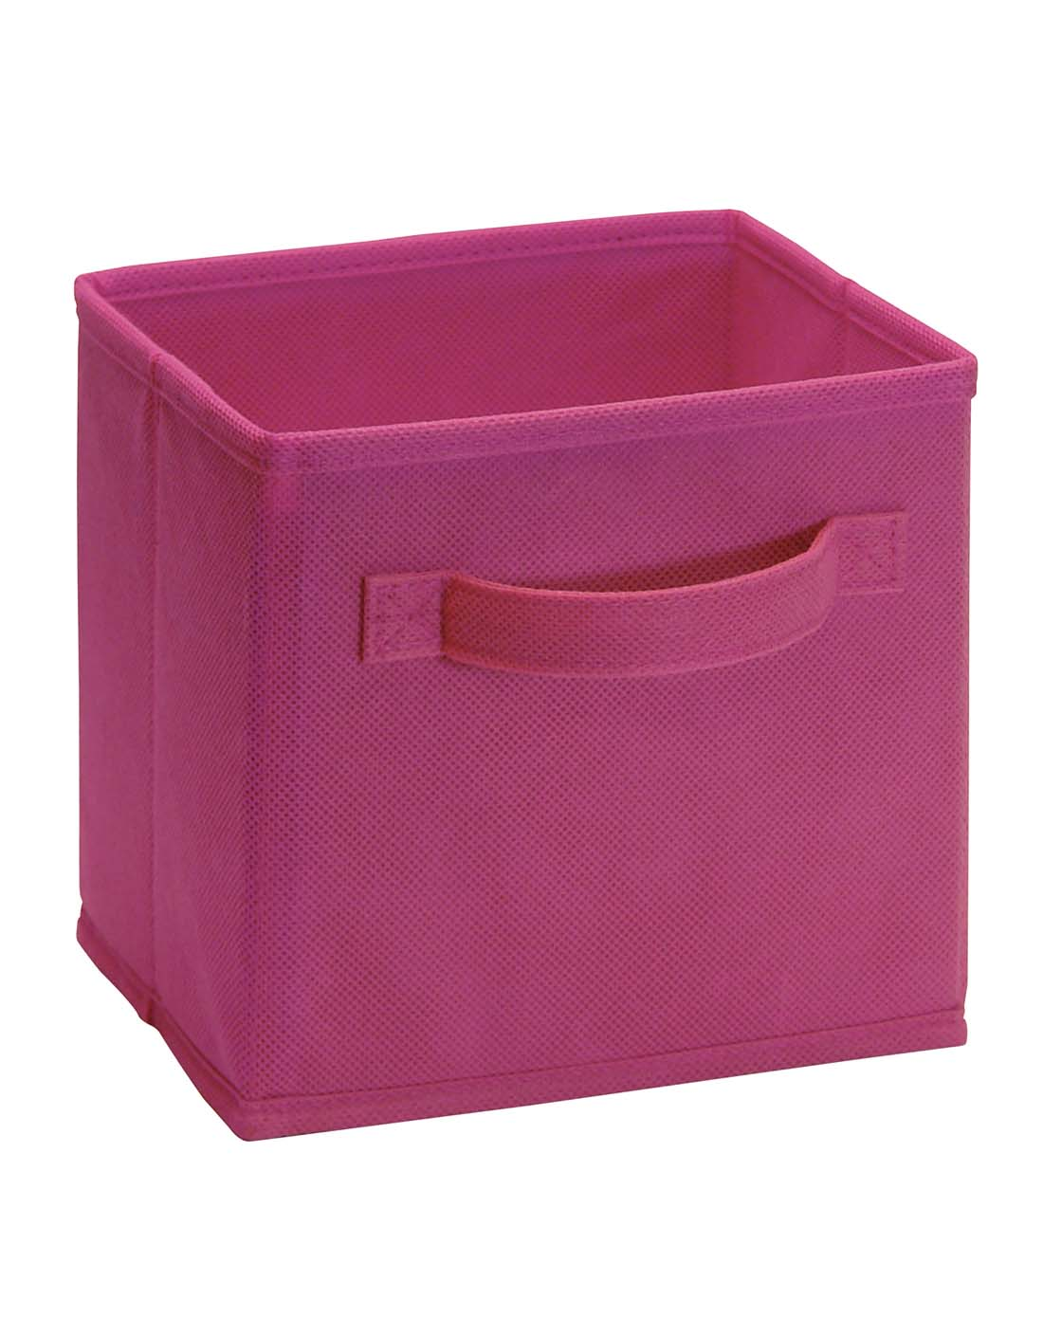
Picture 02-8 Nonwoven storage box – light and convenient to use

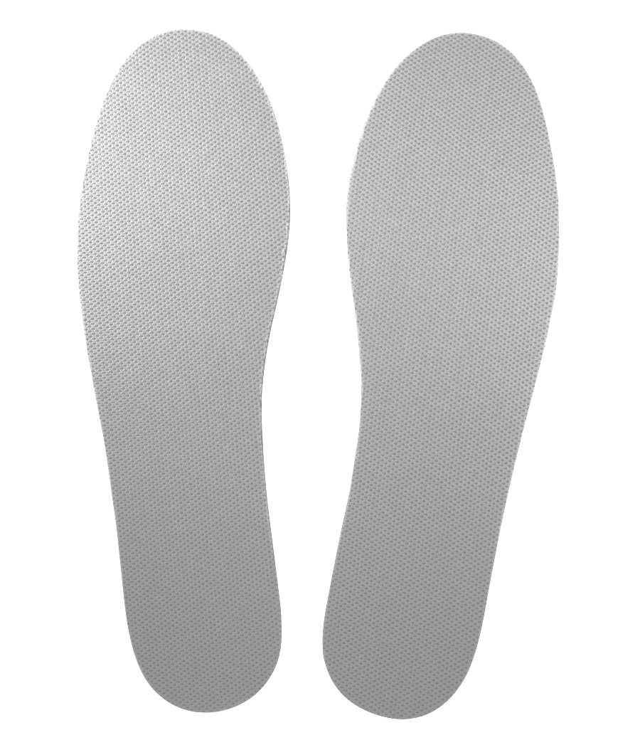
Picture 02-9 Nonwoven shoe-pads, highly ventilative and durable

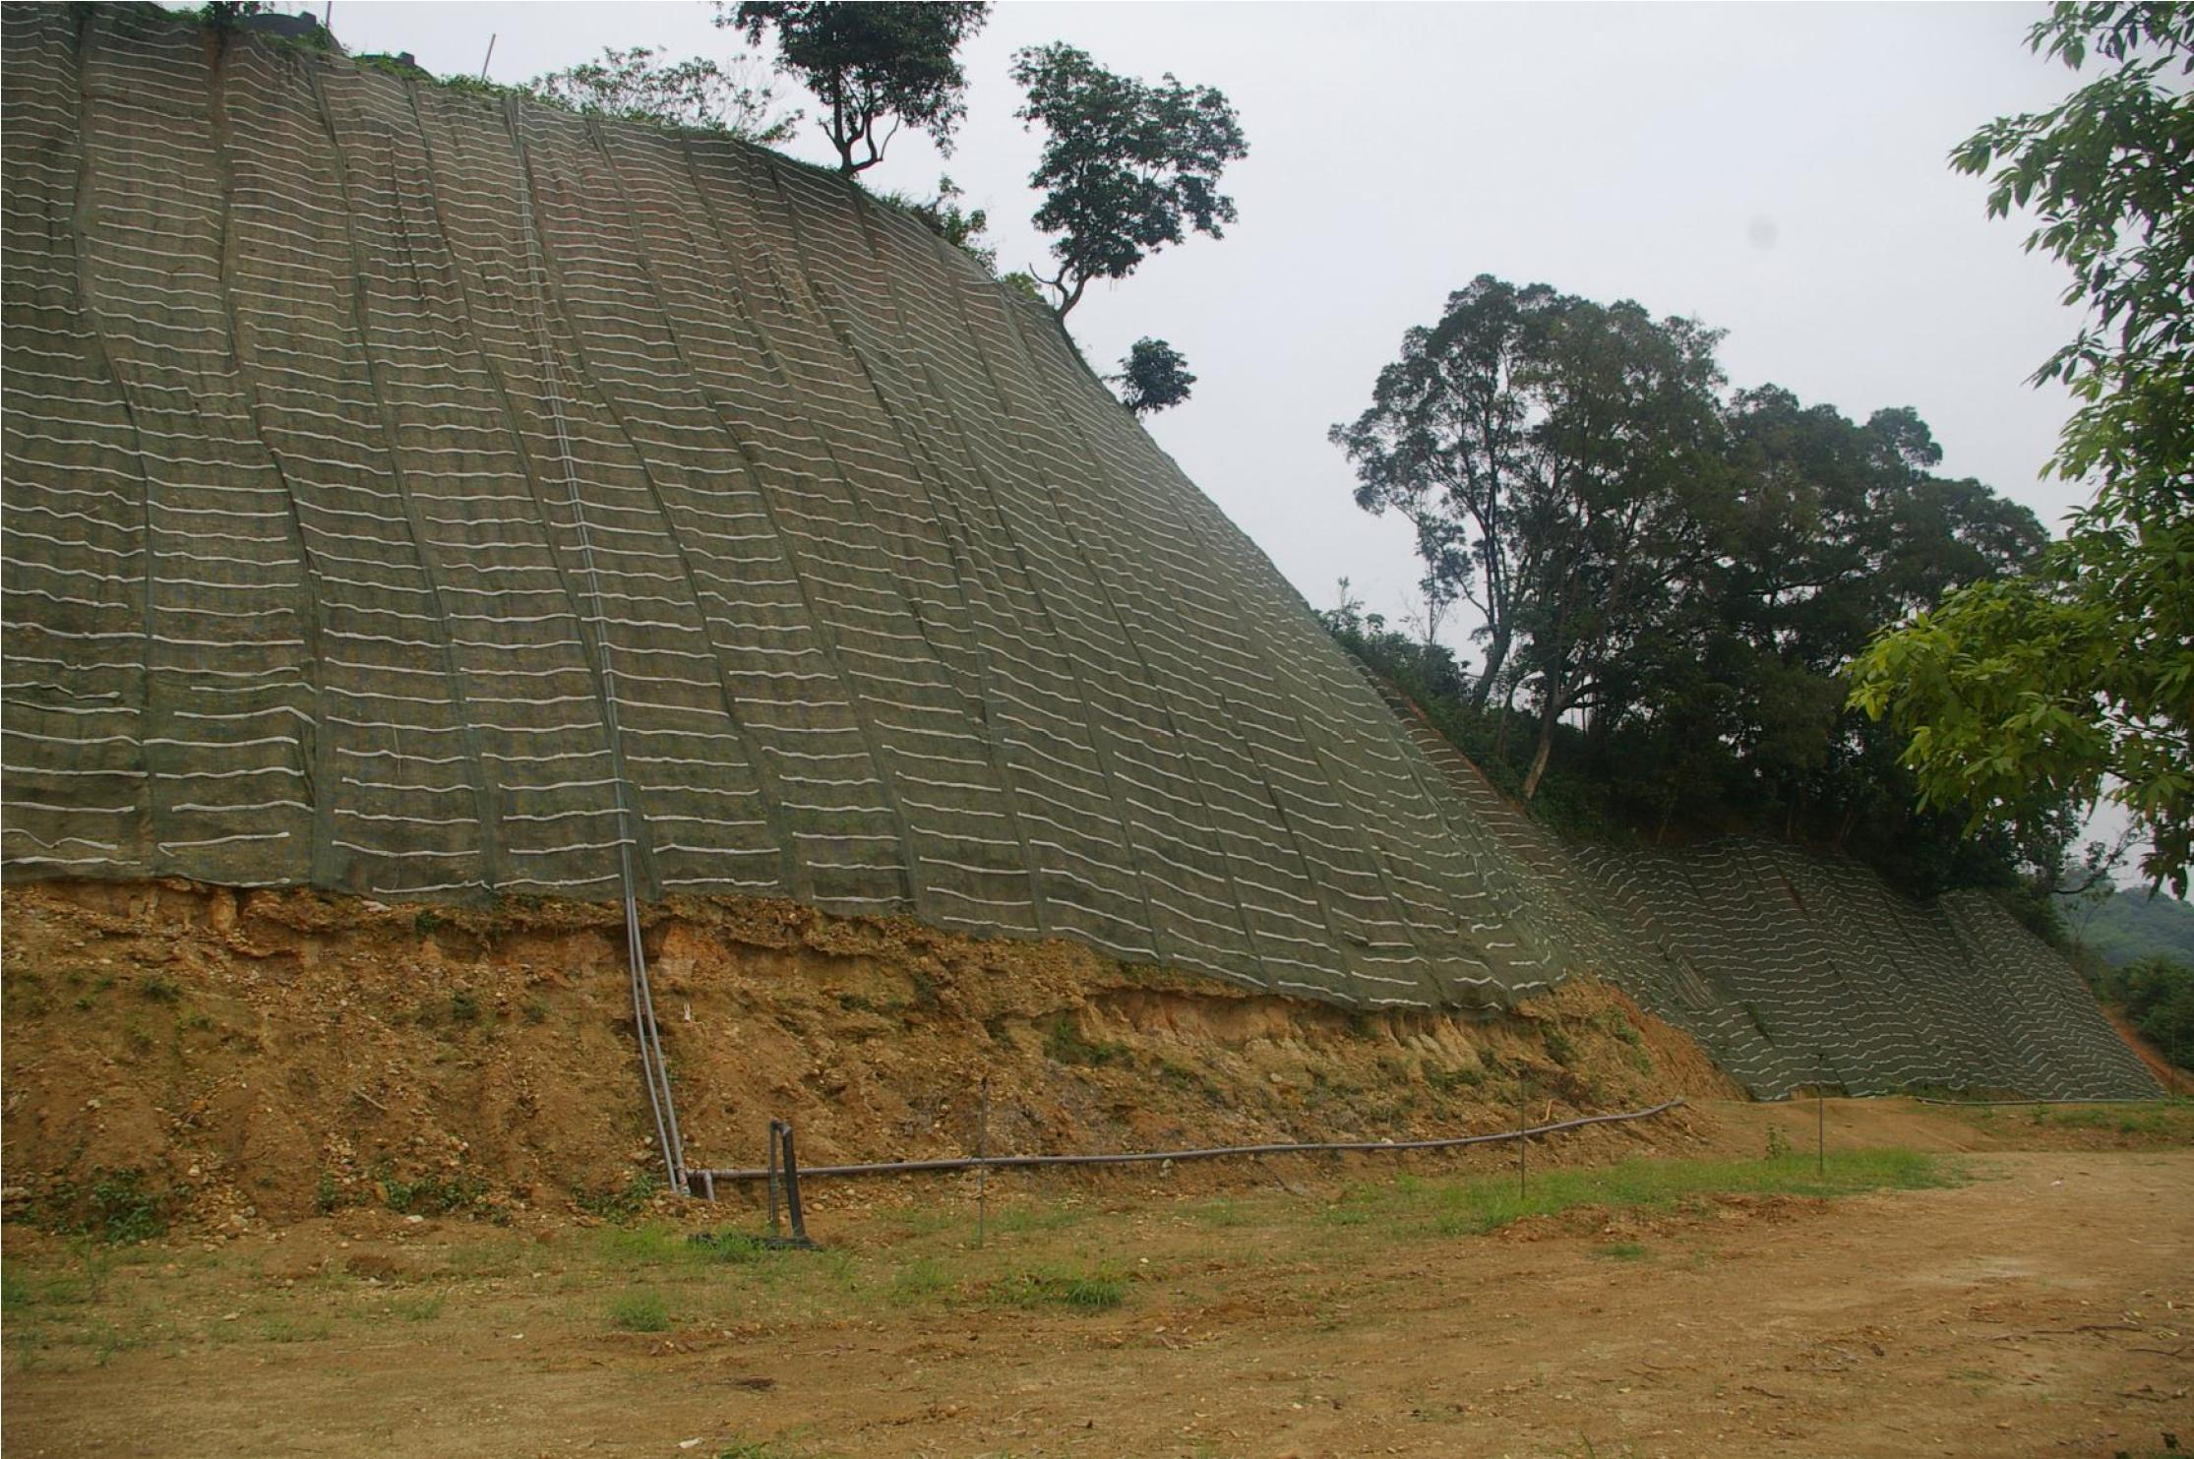
Picture 02-10 Nonwoven water and soil conservation net on the slope
http://chimao96857333.sg1002.myweb.hinet.net/images/case/02.pdf

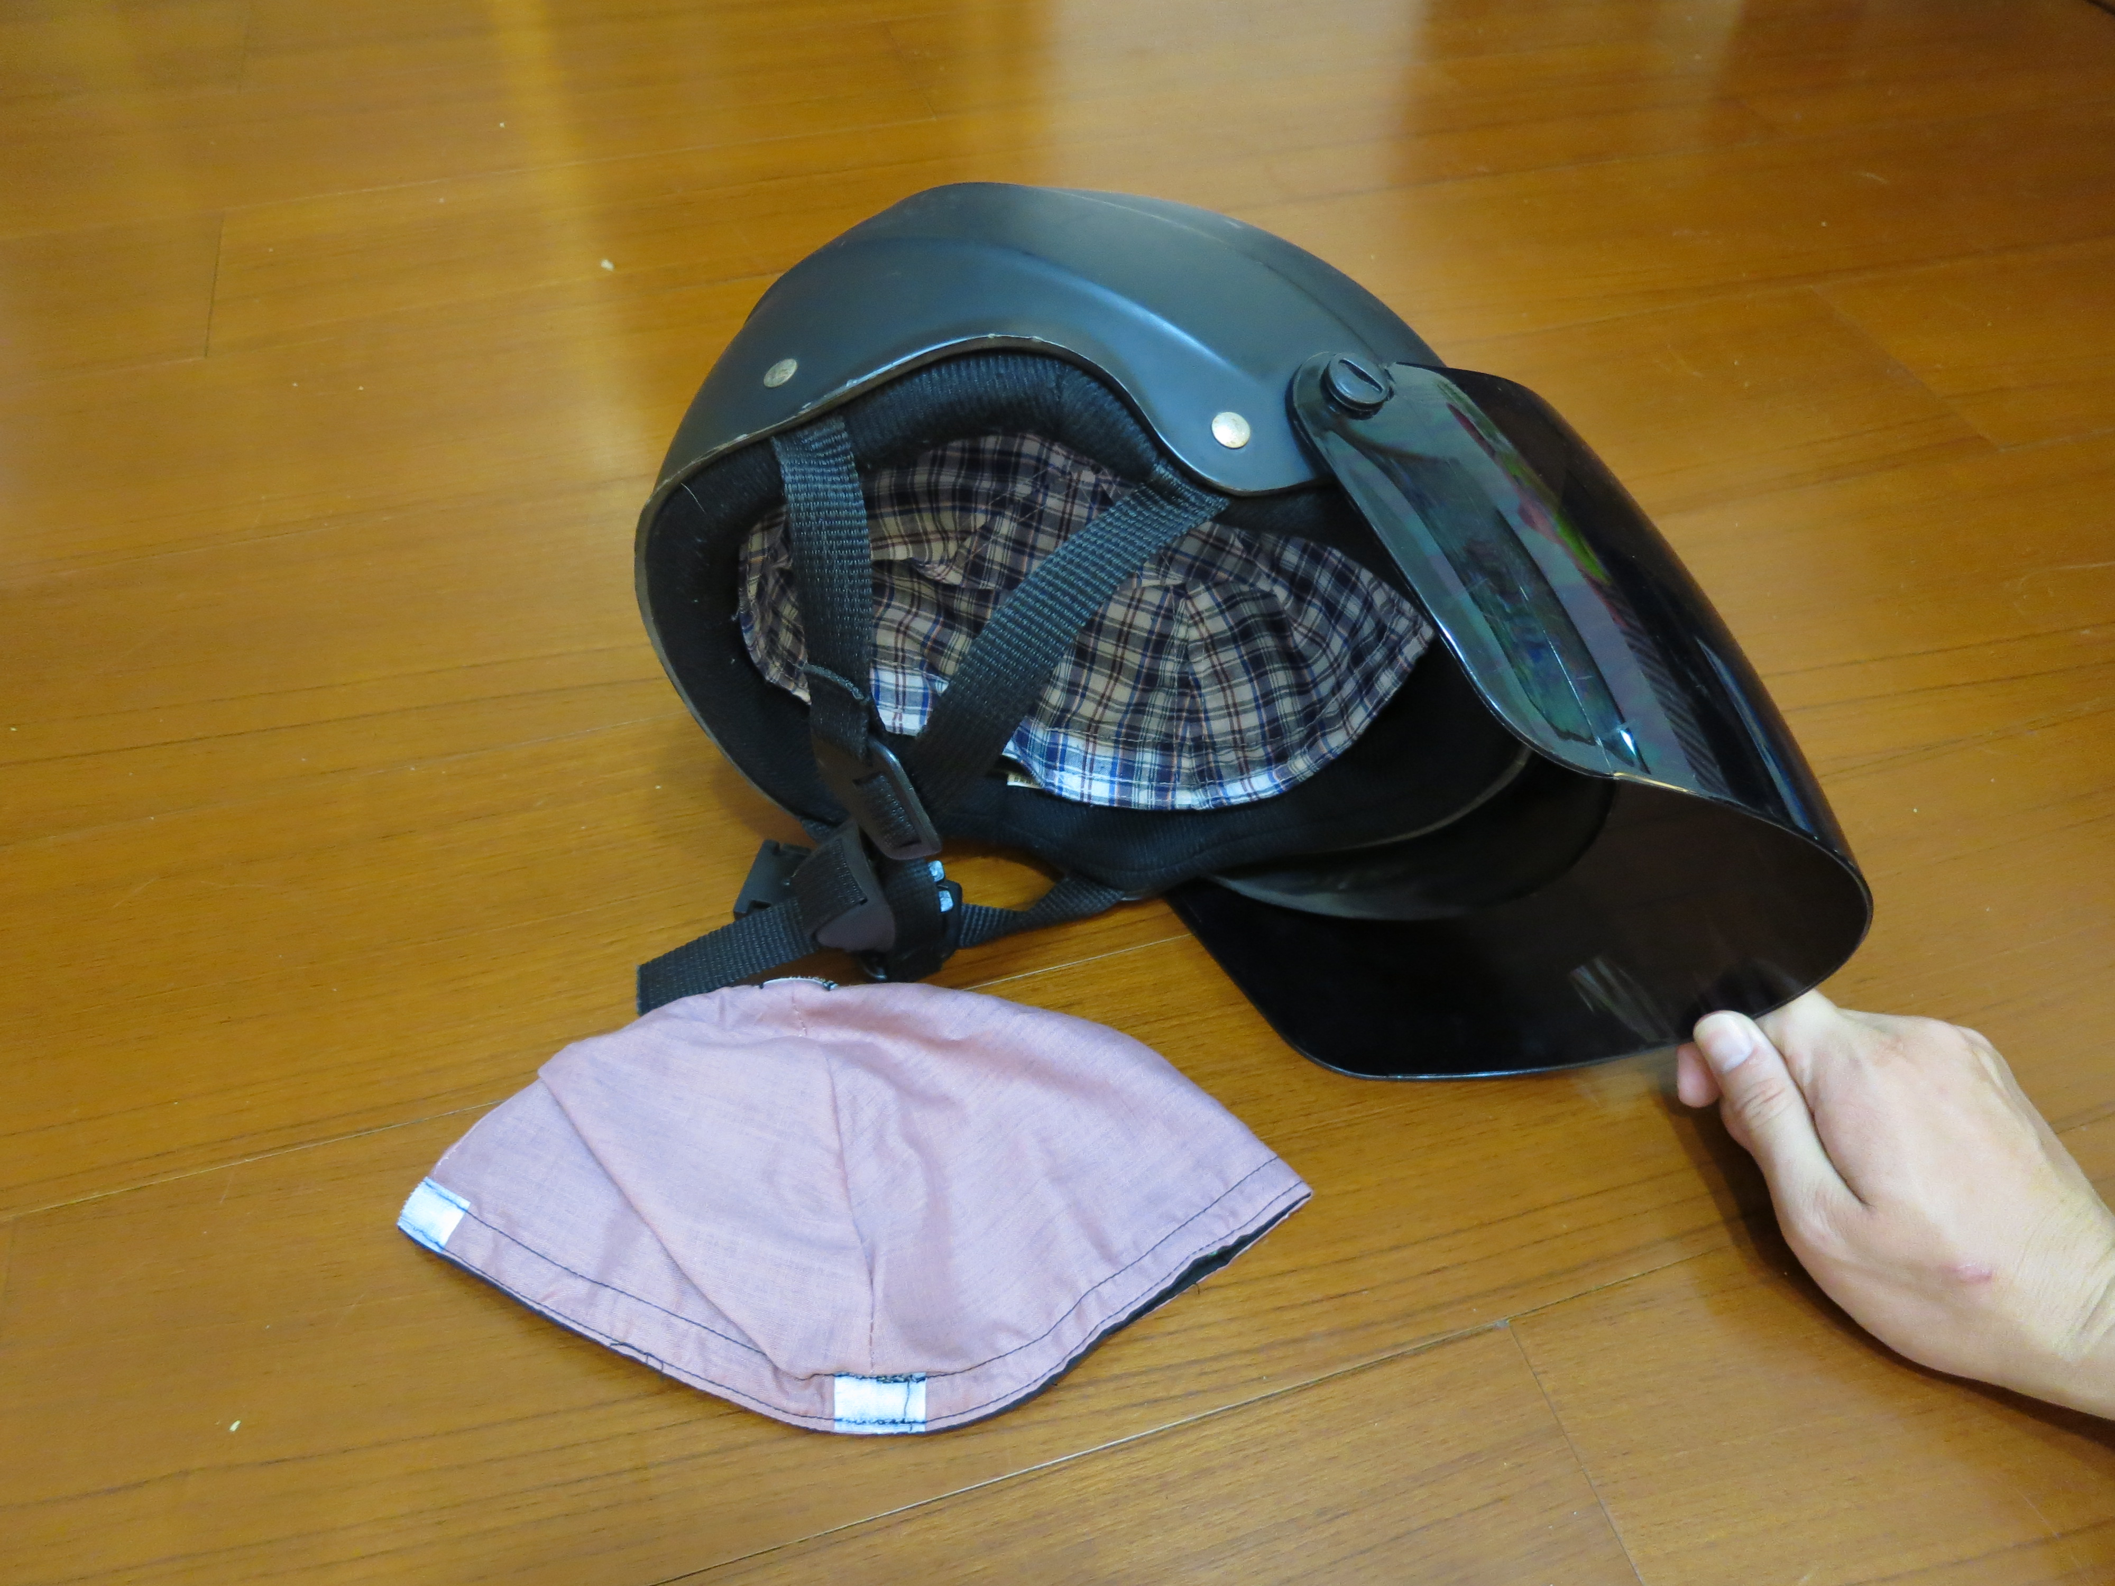
Picture 02-11 Nonwoven protective cushion in the helmet

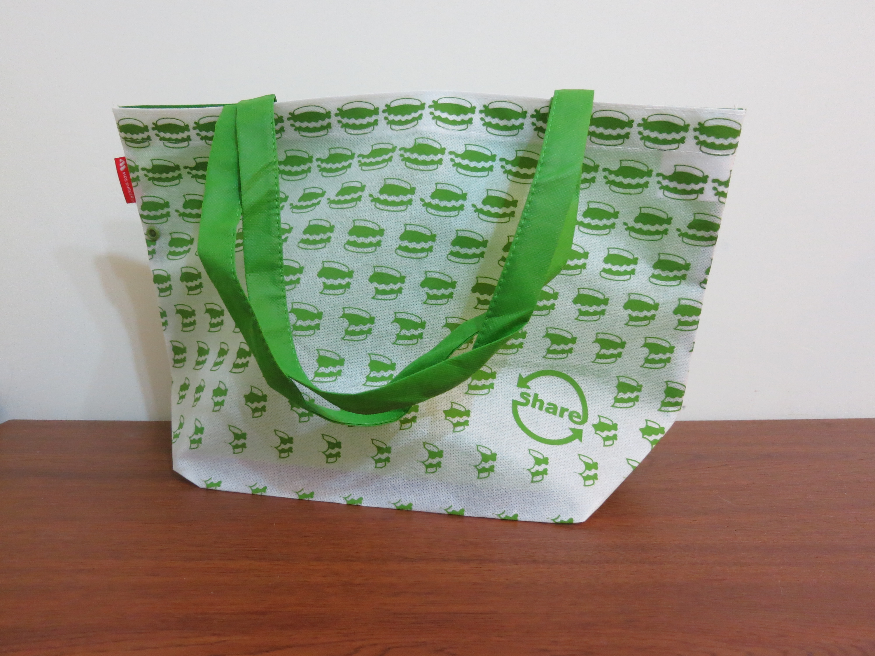
Picture 02-12 Environmentally-friendly nonwoven bags

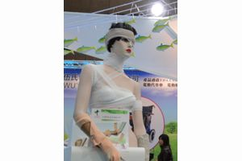
Picture 03 Nonwoven bandages and covers

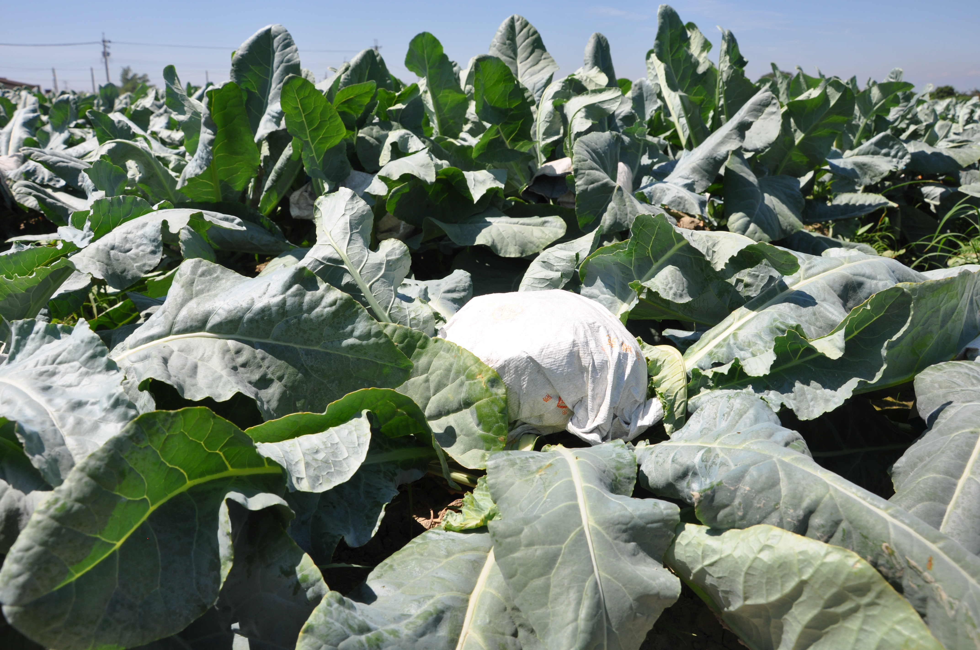
Picture 04 Nonwoven products in a farmland
http://kmweb.coa.gov.tw/subject/public/Attachment/012151642671.JPG
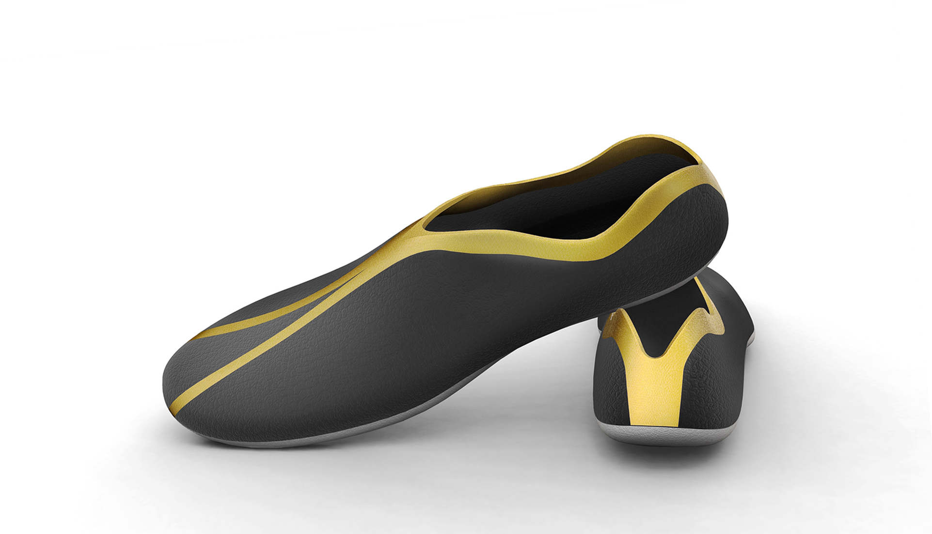
Picture 05 Nonwoven melt-blown shoes

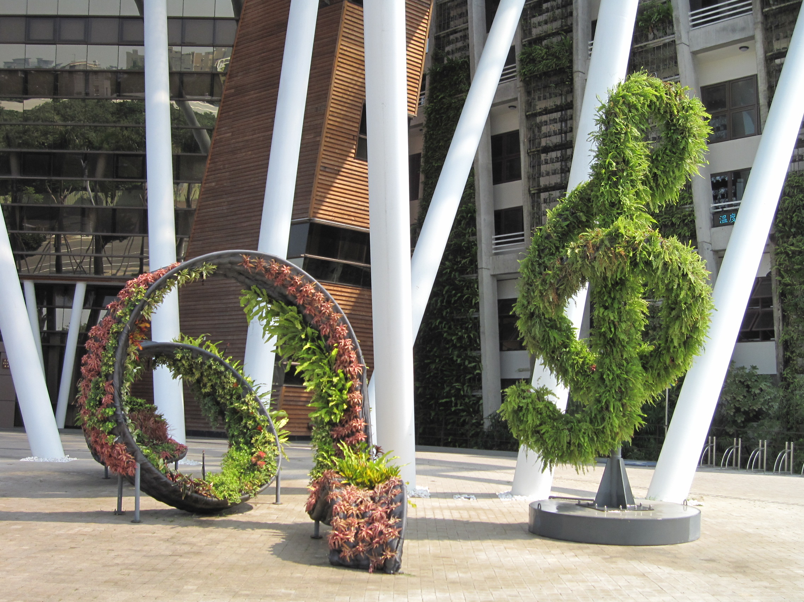
Picture 06 Nonwoven Fabric Garden

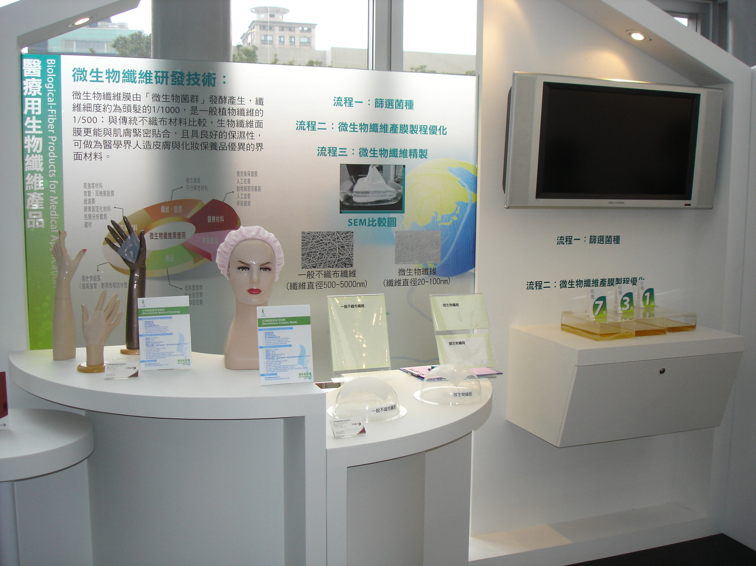
Picture 07 Nonwoven medical products

