Superlative Safety: Genesis G80 and G90 Earn
2018 IIHS “Top Safety Pick+” Ratings

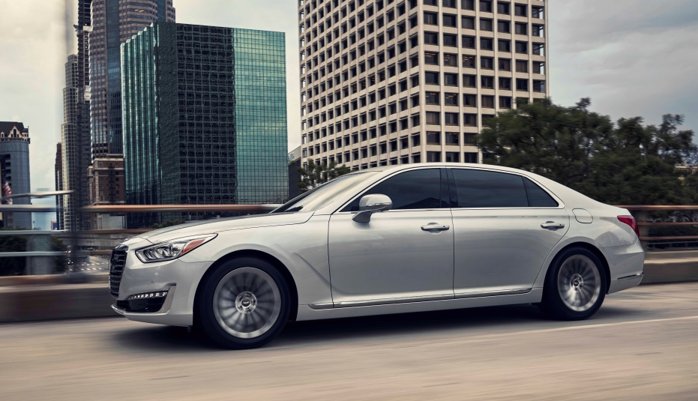

FOUNTAIN VALLEY, Calif., Dec. 13, 2017 – This month the Genesis G80 (when equipped with specific headlights) and G90 earned the Insurance Institute of Highway Safety’s (IIHS) highest rating by being placed in the TOP SAFETY PICK+ category. Both cars earned that rating within the “Large luxury cars” segment.

“Among the awards Genesis has earned for design, customer appeal and appreciation, this IIHS designation confirms our commitment to build vehicles whose safety is rock solid,” said Erwin Raphael, General Manager of Genesis Motor America.
To qualify for 2018 TOP SAFETY PICK+ designation, a vehicle must earn good ratings in several test categories. The G80 and G90 achieved those ratings in the driver-side small overlap front, moderate overlap front, side, roof strength and head restraint tests, as well as an acceptable or good rating in the passenger-side small overlap front test. It also must earn an advanced or superior rating for front crash prevention and a good headlight rating.
“Vehicles that earn our TOP SAFETY PICK+ award belong to an elite group,” said IIHS president Adrian Lund. “They excel in preventing crashes from happening, and they afford people optimal protection if a crash does occur.”
Genesis provides a comprehensive suite of segment-leading safety features that work to minimize risk and maximize protection for the driver, passengers and fellow drivers and pedestrians. Some of these advanced safety features include:
- Automatic Emergency Braking (AEB) with Pedestrian Detection
- Smart Blind Spot Detection with Rear Cross-traffic Alert
- Lane Keep Assist
- Driver Attention Alert
- Dynamic Bending Light with High Beam Assist

The G80 earned the IIHS’ designation under the provision that it was equipped with the optional Dynamic Bending Lights within its Ultimate package. This is the second model year in a row for TOP SAFETY PICK+ designations for the G80 and G90.

Genesis Motor America
Genesis Motor America, headquartered in Fountain Valley, Calif., distributes, markets and services Genesis vehicles in the United States. Genesis is a global luxury automotive brand that delivers the highest standards of performance, design and innovation. A total of six new Genesis models will launch by 2021 and will compete with the world’s most renowned luxury car brands. All Genesis vehicles sold in the U.S. are covered by an industry-leading warranty with enhanced roadside assistance and concierge services.

For more information on Genesis and its new definition of luxury, please visit www.genesis.com

Please visit our media site for the latest news at www.genesisnewsusa.com

Genesis Motor America on Twitter │ YouTube │ Facebook | Instagram

-Ends-
Contact:
Kevin Smith
kdsmith@gma.com
(714)887-2433

