2017 GENESIS G90 EARNS TOTAL QUALITY AWARD FROM STRATEGIC VISION

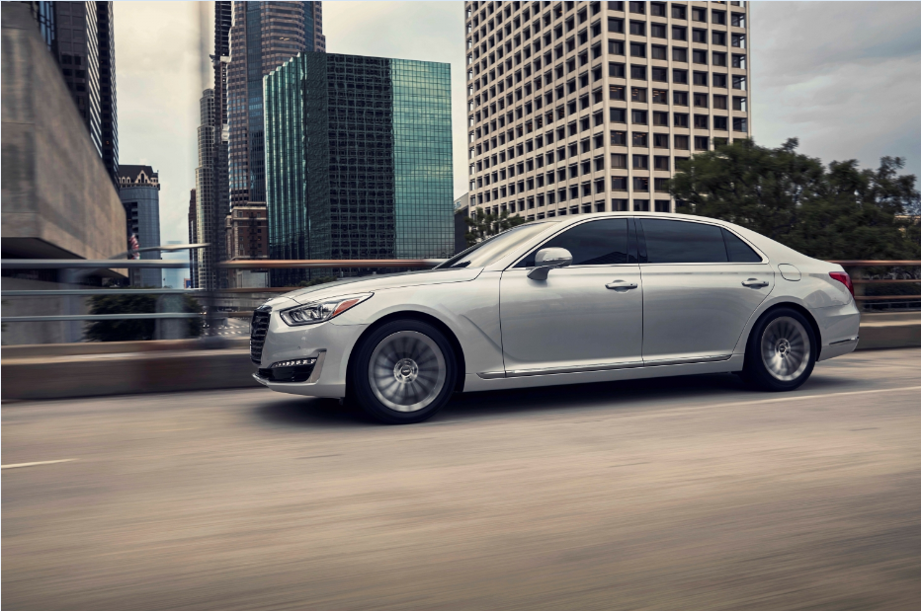

FOUNTAIN VALLEY, Calif., July 20, 2017 – The 2017 Genesis G90 won a Total Quality Award as the highest quality vehicle in the luxury segment by car buyers in Strategic Vision’s annual Total Quality Impact (TQI) report based on results from its New Vehicle Experience Study (NVES). In addition, the Genesis G90 received the third-highest TQI score in the entire industry.

The NVES surveyed over 42,000 new vehicle buyers from July to December 2016 after the first 90 days of ownership. New vehicle buyers rated their vehicles on over 150 different attributes regarding the value and quality of their ownership experience. The Total Quality Impact score represents true differences between vehicles, including an evaluation of the vehicle’s physical and perceived aspects.

“Receiving this award is a strong testament to our commitment to respecting the vehicle ownership experience and connecting with owners on every level,” said Erwin Raphael, general manager of Genesis in the U.S. “It is a great honor to receive this award from the prestigious Strategic Vision organization in our first year in the U.S. market among other established luxury brands.”

The Genesis G90 redefines the luxury experience. It is a vehicle shaped by consumer-focused values and grounded in performance engineering, innovative technology and premium comfort. An advanced H-TRAC® AWD system is available with G90’s 3.3-liter twin-turbocharged V6 and the powerful 5.0-liter V8 GDI engines for confident control under adverse driving conditions. The G90 offers an impressive list of standard features and premium conveniences including a Lexicon® 17 Speaker 7.1 Quantum Logic® Surround-Sound Audio System, 12.3-inch HD Navigation System with Driver Information System (DIS) multimedia controller, wireless device charging, and Smart Cruise Control with stop/start functionality.

Additionally, the G90 features a multitude of standard advanced safety technology and has received the 2017 Top Safety Pick+ rating from the Insurance Institute for Highway Safety. This comprehensive suite of standard safety features works to minimize risk and maximize protection for the driver, passengers, and other road users. Some of these advanced safety features include:
- Automatic Emergency Braking (AEB) with Pedestrian Detection
- Smart Blind Spot Detection with Rear Cross-traffic Alert
- Lane Keep Assist
- Driver Attention Alert
- Dynamic Bending Light with High Beam Assist
- 360-degree Multi-view Camera

To complete the luxury ownership experience, Genesis offers exclusive consumer focused programs and amenities, each designed to provide convenience and a more efficient use of time for Genesis owners.
- 3 years/36K miles Complimentary Scheduled Maintenance
- 3 years/36K miles Complimentary Service Valet
- 3 years Complimentary Genesis Connected Services (including Connected Care, Remote, and Guidance)
- 3 years Complimentary SiriusXM® Travel Link (Traffic & Data)
- 3 years Complimentary Map Care - Annual map updates
- Best-in-Industry Warranty with Enhanced Roadside Assistance and Concierge Service

Genesis Motor America
Genesis Motor America, headquartered in Fountain Valley, Calif., markets and services Genesis vehicles in the United States. Genesis is an all new global luxury automotive brand that delivers ‘human-centered’ luxury and the highest standards of performance, design and innovation. A total of six new Genesis models will launch by 2021 and will compete with the world’s most renowned luxury car brands. All Genesis vehicles sold in the U.S. are covered by an industry-leading warranty with enhanced roadside assistance and concierge services.

For more information on Genesis and its new definition of luxury please visit www.genesis.com

Please visit our media site for the latest news at www.genesisnewsusa.com.
Genesis Motor America on Twitter │ YouTube │ Facebook

-Ends-

Contact:
Christine Henley
chenley@genesismotorsusa.com
(714) 965-3547

