GENESIS RANKED SECOND HIGHEST PREMIUM NAMEPLATE IN J.D. POWER 2017 APEAL STUDY

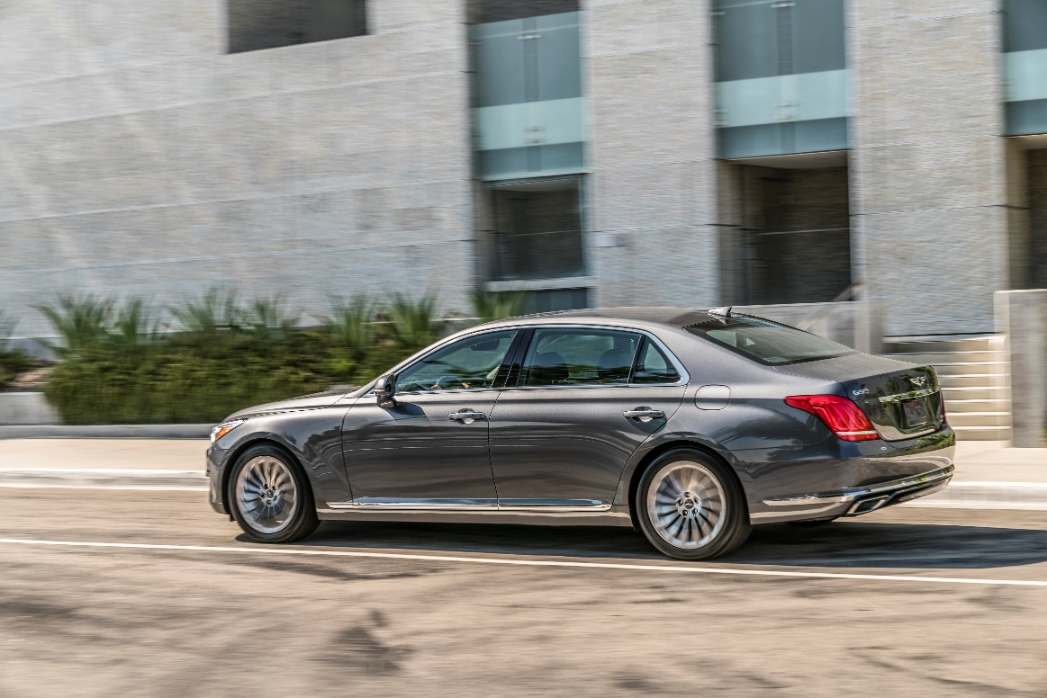

FOUNTAIN VALLEY, Calif., July 26, 2017 – The 2017 Genesis G90 was rated the most appealing vehicle by J.D. Power in the competitive Large Premium Car segment* this year with a score of 905. Additionally, the Genesis brand placed second in J.D. Power’s U.S. Automotive Performance, Execution and Layout (APEAL) Study among premium vehicles.

The APEAL Study assesses how much owners like or dislike 77 attributes in 10 categories of their new vehicle at 90 days of ownership. These attributes include driving dynamics, visibility and safety, storage and space and interior and exterior design. A total of 69,990 surveys were completed encompassing 33 brands and 243 models.

“We believe in respecting vehicle owners and their passengers and designed a flagship vehicle that redefines the meaning of luxury,” said Erwin Raphael, general manager of Genesis in the U.S. “It is an honor to know that our vehicle owners have rated the G90 number one overall in this year’s J.D. Power APEAL survey.”

The Genesis G90 is a vehicle shaped by consumer-focused values and grounded in performance engineering, innovative technology and premium comfort in all seasons. From the heat of the summer to the harshest winters, an advanced H-TRAC® AWD system is available to help navigate drivers’ varying weather conditions. The G90 is confidently equipped with either 3.3-liter twin-turbocharged V6 and the powerful 5.0-liter V8 GDI engines for the ultimate in refined performance. In addition, the G90 offers a formidable list of standard features and premium conveniences including a Lexicon® 17 speaker Premium Surround Sound System, 12.3-inch HD Navigation System with Driver Information System, wireless device charging, and Smart Cruise Control with stop/start.

Additionally, the G90 features a full suite of standard advanced safety technology and has received the 2017 Top Safety Pick+ rating from the Insurance Institute for Highway Safety. This comprehensive suite of standard safety features works to minimize risk and maximize protection for the driver, passengers, and other road users. Some of these advanced safety features include:
- Automatic Emergency Braking (AEB) with Pedestrian Detection
- Smart Blind Spot Detection with Rear Cross-traffic Alert
- Lane Keep Assist
- Driver Attention Alert
- Dynamic Bending Light with High Beam Assist
- 360-degree Multi-view Camera

To complete the luxury ownership experience, Genesis offers exclusive consumer focused programs and amenities, each designed to provide convenience and a more efficient use of time for Genesis owners.
- 3 years/36K miles Complimentary Scheduled Maintenance
- 3 years/36K miles Complimentary Service Valet
- 3 years Complimentary Genesis Connected Services (including Connected Care, Remote, and Guidance)
- 3 years Complimentary SiriusXM® Travel Link (Traffic & Data)
- 3 years Complimentary Map Care - Annual map updates
- Best-in-Industry Warranty with Enhanced Roadside Assistance and Concierge Service

*G90 did not qualify for an official APEAL award due to an insufficient segment category sample.

Genesis Motor America
Genesis Motor America, headquartered in Fountain Valley, Calif., markets and services Genesis vehicles in the United States. Genesis is an all new global luxury automotive brand that delivers ‘human-centered’ luxury and the highest standards of performance, design and innovation. A total of six new Genesis models will launch by 2021 and will compete with the world’s most renowned luxury car brands. All Genesis vehicles sold in the U.S. are covered by an industry-leading warranty with enhanced roadside assistance and concierge services.

For more information on Genesis and its new definition of luxury please visit www.genesis.com

Please visit our media site for the latest news at www.genesisnewsusa.com.
Genesis Motor America on Twitter │ YouTube │ Facebook

-Ends-

Contact:
Christine Henley
chenley@genesismotorsusa.com
(714) 965-3547

