GENESIS REVEALS GV80 FUEL CELL concept SUV
at new york international auto show

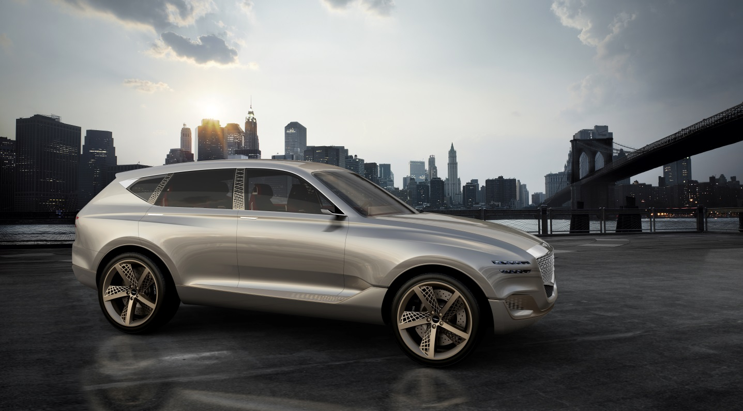

- Genesis further defines “Athletic Elegance” design language in innovative and high-tech SUV concept
- Advanced plug-in hydrogen fuel cell powertrain delivers truly refined performance
- ‘GV80 Concept’ explores a progressive approach to personal experience

NEW YORK, April 12, 2017 – Today, Genesis unveiled its progressive GV80 Concept SUV at the New York International Auto Show. The new fuel cell concept SUV continues to build on the global brand’s expressive and refined ‘Athletic Elegance’ design direction. The GV80 Concept reveals precision details and a confidently evolved design language that provides subtle glimpses into the bold future of Genesis’ design and product development.

The GV80 Concept is the brand’s first interpretation of a versatile luxury SUV, which strikes a perfect balance between elegance and versatility. On the exterior, this is seen in the concept’s confident posture and athletic prowess, while the spacious interior indulges passengers and immerses them in technology that connects them to the vehicle. Recognizing the brand’s global impact, the GV80 Concept utilizes the latest plug-in hydrogen fuel cell electric technology to combine eco-performance and capability, all skillfully designed to fulfill the needs and explore the escapes of the urban adventurer. Genesis will continue to study the benefits of similar alternative propulsion systems and eco-friendly technologies for future product applications.

“The GV80 Concept is a SUV that alludes to the confidence and evolution of the Genesis brand – its design is timeless, with an understated yet dynamic overall surface complexity,” said Head of Genesis Design, Luc Donckerwolke. “These are all characteristics that embody Genesis products and delicately reflect distinctive elements, which you’ll continue to see in future models from our brand.”

“There is a unique energy and diverse global culture to New York that is fitting for Genesis, and we are excited to unveil the GV80 Concept here,” said Head of Genesis Brand, Manfred Fitzgerald. “This concept is an important milestone for the brand to share our vision of the future, introducing a further expansion of our product portfolio.”

Exterior Design & Inspiration
The GV80 Concept presents a modern and refined interpretation of a capable sport utility vehicle, building on the strength of architecture and the beauty of natural elements. The design team thoughtfully expressed these ideas throughout the exterior and interior of the vehicle in utilizing exceptional materials and purposeful forms to create a feeling of desire. The concept’s overall shape is distinguished by its proportions, finely balanced with dominant surfaces, exhibiting sophistication and functionality that conveys the SUV’s infinite versatility to the driver.

The front of the GV80 Concept showcases the signature Genesis crest grille proudly presented by the lower grille surround, which establishes a dominant center spine that runs through the length of the vehicle. The diamond motif mesh grille and wide-set horizontal quad headlamps that encase jewel-like graphics assert the SUV’s powerful stance and stately presence. Below the lower setting, an aerodynamic fascia channels air through precision facet cut-outs around the front wheels and side rocker panels. These warm-toned alloy elements signal key structural components and technical features alluding to the GV80 Concept’s functionality and alternative powertrain. The rest of the exterior panels’ bespoke Ice Granite finish provides a subtle contrast against the rest of the precision detailing.

The elegant posture of the GV80 Concept is defined by a parabolic line that establishes the confident side profile, and visually connects the front and rear to further reveal the SUV’s athletic and nimble nature. Muscular fenders house bold 23-inch mesh alloy wheels designed to reduce weight and cool the large brake system. Electronic door handles sit flush underneath the concept’s dynamic crease line for enhanced aerodynamic performance and simplicity.

The core of the vehicle is extended through the rear, visualized by the center spine detail in the upper rear brake light. Further fortifying the GV80 Concept’s athleticism, slim quad lamps elongate towards the powerful rear quarter panel for a planted stance. Laser fiber optic technology in the tail lamps produces a truly unique Genesis lighting signature at night. The lower rear fascia provides soft visual intrigue and function with purposely integrated vents to cool elements of the alternative powertrain.

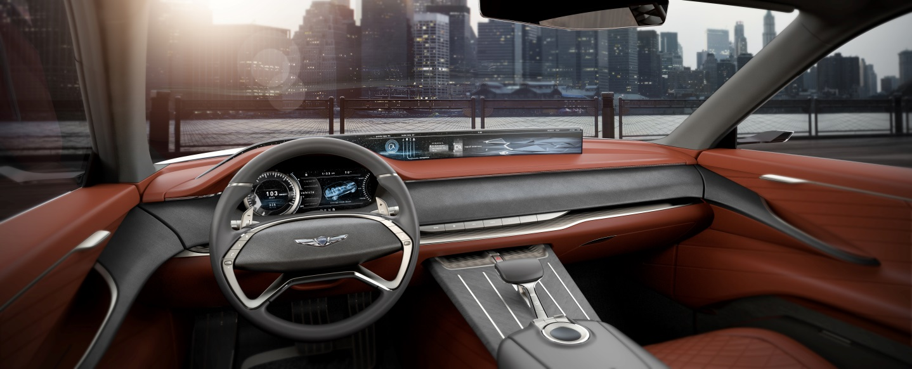

Interior Design Concept
Designed in harmony with the refined exterior, the interior of the GV80 Concept creates a sophisticated environment for its passengers through superior craftsmanship, creative attention to detail and advanced technology.

The interior cabin immediately greets passengers with a bridge instrument panel that stretches from door to door creating a welcoming and spacious ambience. A wide 22-inch curved display set in the instrument panel cascades into the driver’s cluster, which combines the precision of a classic speedometer with the immersive flow of information from a digital display.

Further uniting the interior and exterior, the GV80 Concept’s side pillars are constructed with a structural truss design viewable from inside and outside the vehicle. This detail brings in the exterior environment, promoting a unique interaction with the outside landscape. Additional versatile storage compartments are creatively integrated throughout the SUV concept in the lower doors for ultimate convenience.

Interior HMI Concept
The GV80 Concept’s interior features an innovative Human Machine Interface that offers users intuitive operation and function control through the use of a new multi-function interactive controller with capacitive touch. All of this technology is seamlessly blended into the precision designed details of the vehicle.

The horizontal 22-inch curved OLED infinity display presents two distinct zones, providing separate driver and passenger experiences. An ash wood lower center console integrates the high-tech controller and polished linear metal inlays with capacitive touch capabilities. The top of the interactive multi-function controller features a concave gorilla glass touchpad and knurled metal wheel with handwriting recognition as another method for interacting with the informational panel. Through touch control, each metal string allows direct access to the most commonly used functions including Navigation, Entertainment, Communication, and Environment (or customized driver settings). By tapping these metal strings, passengers gain separate control of a mini-view on the right side of the wide display without disturbing the driver. The custom inlayed console runs through the center spine of the SUV emphasizing the length of the vehicle while creating four separated zones. Each passenger is invited to a tailored seat with access to the capacitive touch inlays and an individual entertainment system allowing for control of a customized user experience.

Interior Color and Materials
To complement the refined exterior, the GV80 Concept’s beautifully crafted interior environment showcases a curated combination of high-quality materials, vibrant colors and rich textures that lend themselves timeless sophistication. The GV80 features exquisite semi-aniline leather interior, with quilted diamond stitching on the interior door panels, seat inserts and center console side, harmonizing with the facet details on the exterior.

The meticulously-wrapped rich leather on the upper instrument panel is contrasted with distinctive Architexture suede on the instrument panel bridge that elegantly surrounds the front passengers for an interesting tactile accent. Echoing the warm alloy metal from the exterior, the trim detail below the bridge indicates the flow of cabin air and is highlighted by polished aluminum trim pieces.

Embracing its urban and outdoor spirit, the GV80 Concept’s ash wood center console and floorboards provide a contemporary organic element to contrast against the other authentic materials. Finally, the SUV’s cargo area features an elegant tonal and texture effect by Architexture suede, dark gray leather and slate ash wood that is both visually appealing and functional with contrasting sleek metal tie downs.

Genesis
Genesis, the luxury automotive brand, strives to make a positive difference in the lives of discerning customers, thus becoming an important element of their lifestyle. As a design-focused brand, Genesis has introduced fascinating models that embody athletic elegance, starting from the brand’s flagship model G90, mid-size luxury sedan G80 and its derivative G80 Sport. Genesis will be opening dedicated brand stores in major cities throughout the country in the near future.

-Ends-
Contact:
PR@GenesisMotorsUSA.com

