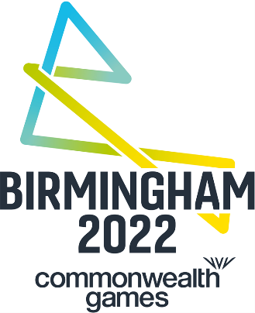

BIRMINGHAM 2022 SHARES ITS VISION OF A ‘GAMES FOR EVERYONE’
WITH NEW CAMPAIGN
To mark the milestone of three years to go, the Birmingham 2022 Commonwealth Games has revealed its new advertising campaign which features people from across the West Midlands coming together to showcase Birmingham 2022’s vision to create a ‘Games for everyone’.

Featuring people from across the West Midlands, the new campaign showcases a range of real people and community groups participating in a variety of fun physical activities. Playing on the theme of a ‘Games for everyone’, the creative showcases the inclusive nature of the upcoming Games, which is a once-in-a-lifetime opportunity to put Birmingham and the West Midlands on the global stage.

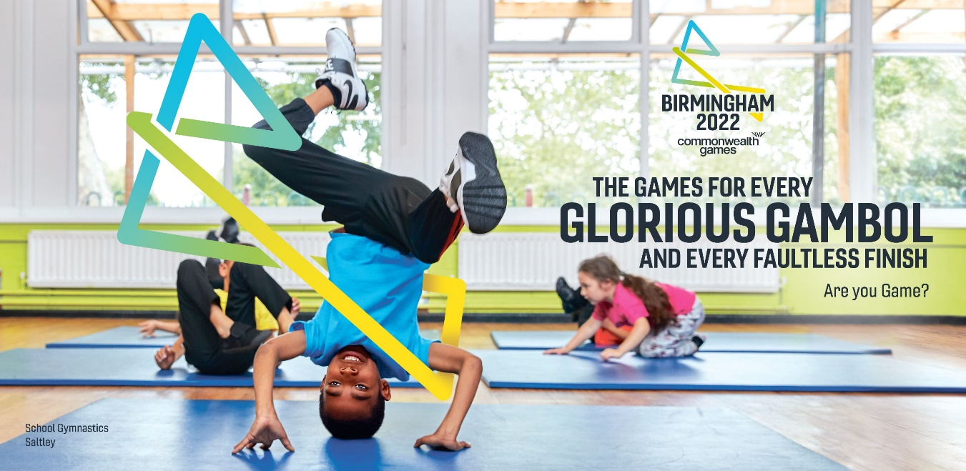
Birmingham 2020 campaign image - School Gymnastics Saltley
With headlines such as ‘the Games for every big fan and every little star’ and ‘the Games for every Cannock chaser and every road racer’, the new Birmingham 2022 campaign is putting local people and communities at its heart, celebrating what makes the West Midlands so special. Featuring in the campaign are Moseley Rugby Club fans, a Warwickshire Bears Wheelchair Basketball Club player, pupils from a school in Saltley, local cyclists at Cannock Chase, runners from Sutton Park Run, City of Birmingham Striders Running Club and Birmingham based Team England gymnast Mimi Isabella Cesar.

Naved Akhtar, campaign participant and Running Coach for City of Birmingham Striders Running Club said: “Being involved in the Birmingham 2022 campaign is a real honour. It is such an exciting opportunity and I’m looking forward to being a part of the journey.
“I love the fact that Birmingham is such a diverse and culturally rich, young city and The Games is a fantastic opportunity to showcase that on the world stage. I’m particularly excited about the plans to upgrade Alexander Stadium which will leave behind an amazing legacy and inspire more people.”
With the people and places at the heart of the Birmingham 2022 Commonwealth Games, the campaign also reveals the new brand identity for the Games, which has been created from in-depth consultation with local communities across the West Midlands. Creating a unique ‘B’ shape, the architecture of the logo has been formed by visually connecting communities from ten key locations across the region, many of which will be hosting events throughout the Games, including Cannock, Sutton Coldfield, Walsall, Wolverhampton, Sandwell, Birmingham, Stourbridge, Solihull, Royal Leamington Spa and Coventry.

Josie Stevens, Chief Marketing and Communications Officer for Birmingham 2022, said: “The people and communities of this great city and region are at the heart of Birmingham 2022, they have co-created the Games’ identity with us and we are putting them front and centre of our first campaign.

“Birmingham 2022 is a once in a lifetime opportunity to put this city and region on the global stage. We’ll be taking this message nationally and globally over the next three years, as we countdown to what’s sure to be a spectacular opening ceremony.”

The Birmingham 2022 Commonwealth Games is a once-in-a-lifetime opportunity that will bring athletes, officials, spectators and local people together in a unique celebration of sport, culture and business, creating growth and positive change in Birmingham and wider the West Midlands.

The campaign invites the people of the West Midlands to get involved by asking ‘Are You Game?’ and launches on 27 July 27 across Birmingham and the West Midlands in out of home media, digital screens and social media and is also featured on www.birmingham2022.com .

ENDS

NOTES TO EDITORS

The Birmingham 2022 Commonwealth Games, which will be held from 27 July until 7 August 2022, will be a once in a lifetime opportunity to put the city, the region and its people on the global stage.

The Games is already proving to be a catalyst for transformation across the West Midlands, attracting new investment and funding, creating jobs and apprenticeships for local people and new opportunities for local businesses, as well as accelerating projects that will ensure the region is ready to host a fantastic sports and cultural celebration.

Birmingham 2022 will be the Games for everyone, bringing people together from across Birmingham and the region, to provide a warm welcome to its millions of visitors during the summer of 2022. Find out more at www.birmingham2022.com

For more information about the Birmingham 2022 Commonwealth Games, please contact:

GUNG HO Communications

Teamcommonwealth@gunghoco.com 0121 6046366

