Athlete Name | Sport | From | Achievements
Alice Kinsella  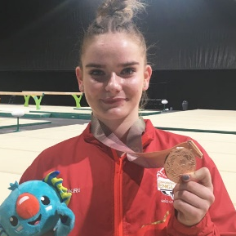 | Gymnastics | Basildon, England | Gold Coast 2018 Commonwealth Games - All-around bronze, beam gold and team silver  2017 British Championships - All-around silver  2016 Junior European Championships - Beam silver, floor silver and team silver  2016 Junior British Championships - Beam gold  2014 Espoir British Championships - Vault champion, bars silver  Link to biography here
Dominick Cunningham  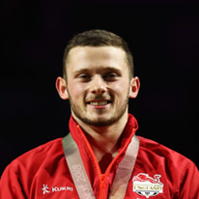 | Gymnastics | Birmingham, England | Gold Coast 2018 Commonwealth Games - Team gold and vault bronze  2017 British Championships all-around silver, floor silver, vault gold, high bar bronze, masters vault silver  2016 English Championships - Floor and vault gold  2013 Australian Youth Olympics - Team and floor gold, all-around, parallel bars and rings silver and high bar and vault bronze  Isle of Man 2011 Commonwealth Youth Games - Team, all-around and high bar gold, pommel horse bronze and vault silver  2011 European Youth Olympics Festival - Team silver  Link to biography here
Mimi-Isabella Cesar  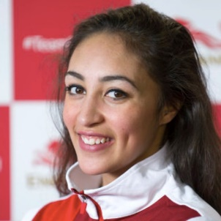 | Gymnastics | Birmingham, England | 2017 British Championships - Clubs and ribbon silver, all-around and hoop bronze  2016 British Championships - Ribbon bronze  2014 British Championships - All-around and ball bronze  2012 British Championships - Ribbon silver, all-around, ball and clubs’ bronze  2011 British Championships - All-around, hoop, ball, clubs and ribbon bronze  2010 Junior British Championships - Hoop, ball and clubs gold  Link to biography here
Taeja James | Gymnastics | Nottingham, England | Gold Coast 2018 Commonwealth Games - Silver  2016 European Team Silver  2017 Junior British All Around Champion  Link to biography here
Ama Agbeze  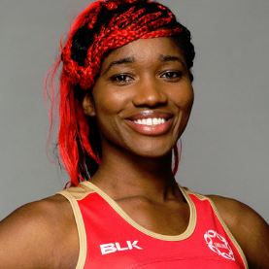 | Netball | Selly Oak, Birmingham | Gold Coast 2018 Commonwealth Games – Gold  Melbourne 2006 Commonwealth Games - Bronze  Link to biography here
Dominique Allen  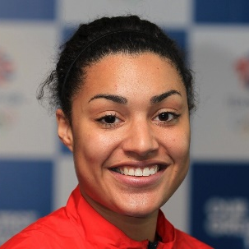 | Basketball | Wordsley, England | Gold Coast 2018 Commonwealth Games – Bronze  Link to biography here
Kofi Josephs  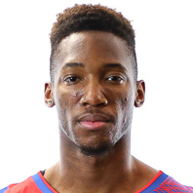 | Basketball | Birmingham, England | Competed as part of Team England’s men’s basketball team  Link to biography here
Sarah-Jane Perry  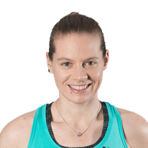 | Squash | Birmingham, England | Gold Coast 2018 Commonwealth Games - Silver  2014 World Team Championships - Gold  2013 European Squash Championships - Team gold  Link to biography here
Galal Yafaj  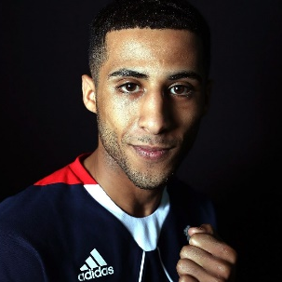 | Boxing | Edgbaston, England | Gold Coast 2018 Commonwealth Games - Gold  Represented Team GB at the Rio 2016 Olympic Games,  2016 AIBA Olympic Qualification Event – Gold  2015 Olympic Test Event – Bronze  Link to biography here
Ben Whittaker  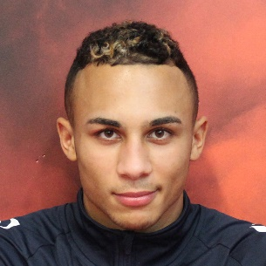 | Boxing | West Bromwich, England | 2017 England Elite Championships - Gold  2016 Golden Gong - Gold  2016 England Elite Championships - Gold  Samoa 2015 Commonwealth Youth Games – Silver  Link to biography here
Denise Payet  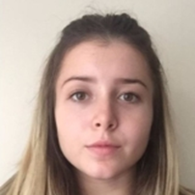 | Table tennis | London, England | Gold Coast 2018 Commonwealth Games - Bronze  2017 Hungarian Competition Grand Prix - U15 gold and junior silver  2016 Slovakian Open - Bronze  2016 European Championships - 5th  Link to biography here
Maria Tsaptsinos  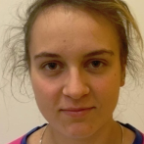 | Table Tennis | Reading | Gold Coast 2018 Commonwealth Games - Bronze  2017 National Table Tennis Championships - Gold  U21, U18, U15 and U14 National Champion  Represented England at three European Youth Championships  World Junior Championships - Quarter finalist  Commonwealth Championships - Team bronze  Link to biography here
Nathan Douglas  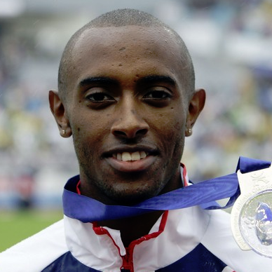 | Athletics | Oxford | Gold Coast 2018 Commonwealth Games - 5th  Glasgow 2014 Commonwealth Games - Finalist  Delhi 2010 Commonwealth Games - 4th place  Represented Team GB at the Beijing 2008 and Athens 2004 Olympic Games  2007 European Indoor Championships - Silver  2006 European Outdoor Championships - Silver  Link to biography here
James Rodwell  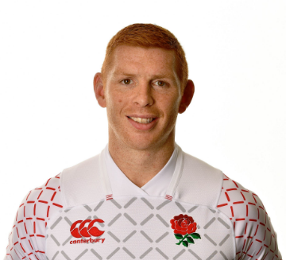 | Rugby Sevens | Wendover, Buckinghamshire | Gold Coast 2018 Commonwealth Games - Bronze  London 7's 2009, Twickenham, Dubai 7's 2010,2011, Wellington 7's 2009, 2013  Link to biography here
Katrina Hart  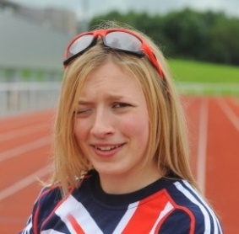 | Para athletics | Worcester, England | Delhi 2010 Commonwealth Games - Gold in the T37 100m  Link to biography here

CONTACT:

Teamcommonwealth@gunghoco.com 0121 6046366

