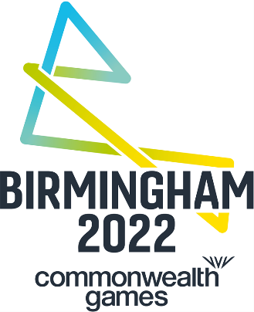

BIRMINGHAM 2022 COMMONWEALTH GAMES FACT SHEET
Commonwealth Games facts and figures
- The first Commonwealth Games were held in 1930 in Hamilton, Canada, in which 11 countries competed in six sports and 59 events
- Almost a third of the world’s population are under the Commonwealth flag, with a combined population of 2.3bn people
- 10,250 total medals have been won during the Commonwealth Games since 1930.
- The Commonwealth Games is expected to be watched by 1.5bn spectators across the globe
- Birmingham 2022 is being delivered in unprecedented circumstances, with a significantly truncated timescale after the hosting rights were withdrawn from Durban in March 2017 and awarded to Birmingham in 2017
Birmingham and the West Midlands
- Birmingham is the UK’s second-largest economy and has the highest number of start-up businesses outside of London
- 28 million people are within two hours’ drive of Birmingham and 90% of the UK is within four hours’ travel
- International, national and local transport links provide access to 400 million people across Europe
- It is one of the youngest cities in Europe, with nearly 40% of the population under 25. Birmingham also has the highest proportion of under 20 year olds of any major city in the UK
- Birmingham is home to 187 different nationalities, with 314,000 (6%) of residents in the West Midlands born in a Commonwealth Country

Benefits to the region
- Potential boost to the economy in excess of £1bn, based on 2018 Commonwealth Games
- £778m is being invested into the city and region to stage the Games and to part fund the redevelopment of the stadium and the building of the Sandwell Aquatics Centre.
- The Perry Barr village development will be supported by a further £165m of government funding
- Hosting the Games is also accelerating the development of infrastructure and public transport improvements. This will benefit the city and wider region for years to come
- 4,330 jobs created annually between now and 2022
- There will be 45,000 Games time roles
- 3,000 contractors and 300 apprentices will help to deliver the Athletes’ Village
- Planned schemes for new housing and transport have been brought forward as a result of the Games
- 1,400 new homes built in Perry Barr as part of a wider regeneration project in the area, including highway improvements
- Overhaul of the Alexander Stadium which will see capacity increase from 12,700 to more than 30,000 during Games time
- A brand new Aquatics Centre in Smethwick will be built and will offer opportunities for trainees to gain valuable skills as well as increase demand for skilled trades as the new facility is constructed.
- Transport upgrades including a new regional transport co-ordination centre; upgrades to University and Perry Barr railway stations
- More than one million tickets will be made available for spectators across the Games, encouraging tourism and providing the hospitality sector with a boost

Birmingham 2022 participation
- More than 6,500 athletes and officials from 71 nations and territories will be part of Birmingham 2022
- With the proposed inclusion of Women’s T20 cricket, Para table tennis and beach volleyball, Birmingham 2022 will be the most inclusive Games thus far with more female and para athletes than ever before
- More than 12,500 volunteers will be recruited from across the region to help deliver a momentous celebration of sport, community and competition

Budget
- The public funding for Birmingham 2022, which includes contingency, is £778 million and this is split approximately 75% / 25% between investment from central government (£594 million) and Birmingham City Council and a number of its key partners (£184 million)
- Birmingham 2022 will see a significant decrease in direct Games delivery costs, compared to Gold Coast 2018. Birmingham 2022 is bucking the trend for global sports events

