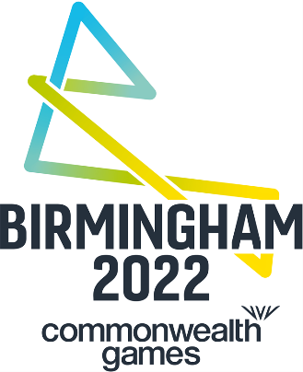

BIRMINGHAM 2022 - THREE YEARS TO GO FACT SHEET
The Commonwealth Social
Three Commonwealth sports will be showcased at the Commonwealth Social – netball, wheelchair basketball and table tennis.

14 different acts from across the region will perform at the event. These include:
- Motionhouse Youth- contemporary dance company
- Global Funk Soundz by DJ Deesh and Kadence
- Lionesses of Punjab, Cubs of Punjab- bhangra dancers
- Gavin Young – Storyteller
- ACE Dance and Music
- DJ Sam Redmore’s Tropical Soundclash
- Sampad Ta Na Na- South Asian/British Asian dance
- Bostin’ Brass Band
- DJ Glyn Philips including Freewheelin’- inclusive wheelchair dance
- Rajasthan Heritage Brass Band
- The Pantasy Steel Band- Steel Drum Band

15 Team England athletes will be at the Commonwealth Social. They’ll chat to attendees and provide advice and encouragement to those people taking part in the sports activities.

Athletes in attendance include:
- Alice Kinsella – Gymnastics
- Dom Cunningham – Gymnastics
- Mimi Cesar – Gymnastics
- Taeja James – Gymnastics
- Dominique Allen – Basketball
- Ama Abgeze – Netball
- Kofi Josephs – Basketball
- Galal Yafai – Boxing
- Ben Whittaker – Boxing
- Sarah-Jane Perry – Squash
- Denise Payet - Table Tennis
- Nathan Douglas – Athletics
- Maria Tsaptsinos – Table Tennis
- James Rodwell – Rugby Sevens
- https://teamengland.org/team-england-athletes

Common Ground

- Birmingham 2022 staged an art-led community research project called Common Ground, inviting people to have a conversation about the Games and to explore how Birmingham 2022 can benefit their community and the people that live there
- With the aim of connecting communities across the West Midlands, the following ten locations were visited during June and July:

  - Cannock
  - Coventry
  - Wolverhampton
  - Stourbridge
  - Sutton
  - Solihull
  - Walsall
  - West Bromwich
  - Leamington Spa
  - Birmingham City Centre

- More than 650 people have taken part in in-depth conversations throughout the project.

The Birmingham 2022 Brand

- The new brand was co-created with local people and more than 1,000 people took part in roadshows, workshops and focus groups
- This included 160 hours of in-depth consultation with local communities over a four-month period
- The new brand connects key West Midlands locations – many of which will host events during the Games – bring these locations together to create a unique ‘B’ shaped design
- The locations include Stourbridge, Cannock, Sutton Coldfield, Walsall, Wolverhampton, West Bromwich, Birmingham, Solihull, Royal Leamington Spa and Coventry
- The primary colour palette was also developed directly from feedback during the consultation to represent Birmingham as the youngest city in Europe

The advertising campaign

- Local people feature in a new advertising campaign, launched to raise awareness and excitement for the Games and showcases Birmingham’s 2022’s vision to create a ‘Games for everyone’
- The adverts put local people at the heart of Birmingham 2022 - featuring in the campaign are Moseley Rugby Club fans, a Warwickshire Bears Wheelchair Basketball Club player, pupils from a school in Saltley, local cyclists, runners from Sutton Park Run, City of Birmingham Striders Running Club and Birmingham born Team England gymnast Mimi Isabella Cesar
- The campaign features a call to action asking ‘Are You Game?’ and launches on July 27 2019 across Birmingham and the West Midlands in out of home media, digital screens and social media and is also featured on www.birmingham2022.com

