3 Toy Tips to Keep Your Child Safe This Holiday Season…
and All Year Long

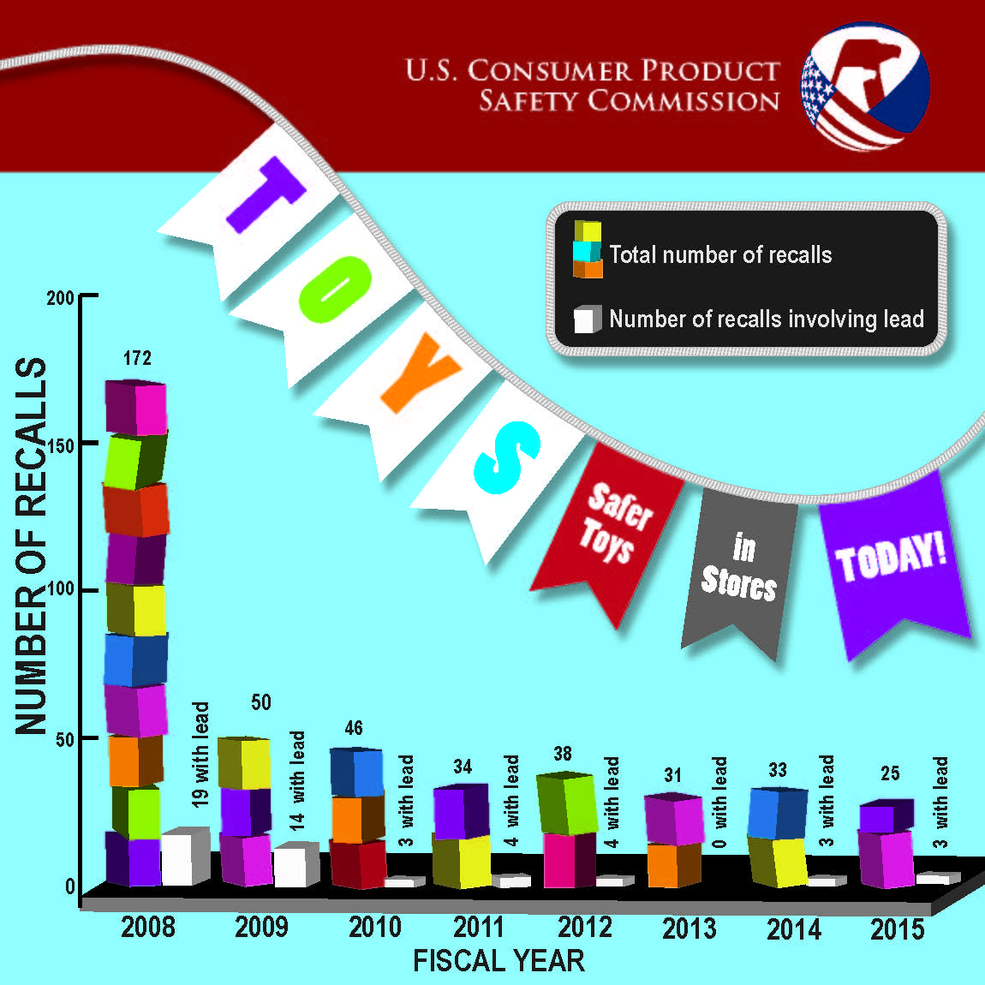
Sometimes the holiday season can be stressful. But, shopping for toys doesn’t have to be. In fact, the good news is that the U.S. Consumer Product Safety Commission (CPSC) has reported a decline in toy recalls in the past few years and consumers can shop with confidence.

In fiscal year 2015, CPSC issued 25 toy recalls, way down from 172 in 2008. Even with the decline in recalls, CPSC continues to detect and detain too many violative toys at U.S. ports. These dangerous imports have excessive lead and phthalates, as well as small parts. Thankfully, these toys never reached the hands of kids. CPSC also receives reports of kids who have suffered toy-related injuries and even deaths. A new report released for calendar year 2014 shows an estimated 183,800 toy-related injuries and 11 deaths. For toy-related deaths and injuries, it is important to note that although a toy was associated with many of the incidents, the toy was not necessarily the cause of the death or injury.

Here’s what you can do to help keep your little ones safe and avoid these hazards:

- Choose age appropriate toys by reading the age label on the toy. For children younger than 3, avoid toys with small parts, which can cause choking. In particular avoid deflated or broken balloons, small parts or small balls.

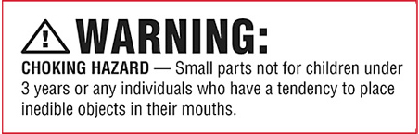

- Scooters and other riding toys - Riding toys, skateboards and in-line skates go fast, and falls could be deadly. Helmets and safety gear should be worn properly at all times and they should be sized to fit. Avoid riding a scooter on a street or roadway with other motor vehicles.
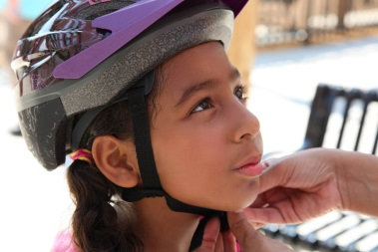
- Magnets – Children's magnetic toys are covered by a strong safety standard that prevents magnets from being swallowed. High-powered magnet sets, which are covered by a mandatory standard, also have small magnets that are dangerous and should be kept away from children. Whether marketed for children or adults, building and play sets with small magnets should also be kept away from small children.
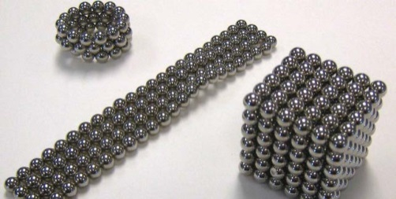
Toy safety continues to be a top priority for CPSC, as we work to keep our most vulnerable consumers safe.

So Play It Safe this holiday season by following these safety tips and for more toy and product safety information don’t forget to visit www.cpsc.gov.

