09/07/2019

New Holland launches Grain Loss Calculator application to help with optimal adjustment of combine harvester

- A quick calculation to optimally adjust the combine harvester for maximum efficiency
- Support for optimising the combine settings with linked Harvest Excellence app

New Holland has launched a Grain Loss Calculator application for mobile devices to help farmers optimise the settings of their combine harvester to maximise its efficiency and productivity. The application has been developed to support farmers operating combines of all brands and models, testament to the brand’s ethos of openness.

Lars Skjoldager Sørensen, Crop Harvesting Product Management, explains: “This new app is an example of our customer focus, of how at New Holland we look at all the ways we can help farmers by making their work simpler and maximising their efficiency. In developing the app, we wanted to include all farmers – not just owners of New Holland combines – because we believe in working together with them towards a common purpose: a sustainable, efficient agriculture that does more with less.”

A quick calculation to optimally adjust the combine harvester for maximum efficiency
With the Grain Loss Calculator, the farmer can determine the combine’s grain loss in three easy steps: enter the brand of the combine, header and shoe widths; select the crop from a choice of 30 types and enter the yield; insert the kernels counted on the ground in a limited area.
The app instantly calculates grain loss, showing the result in percentage and in kilograms per hectare.

Support for optimising the combine settings with linked Harvest Excellence app
The Grain Loss Calculator, having displayed the combine’s grain loss, offers a link to New Holland’s Harvest Excellence app, which will help the operator to optimise the settings of the combine harvester taking into account the soil and crop conditions. It also offers an issue resolution service to further optimise the settings of the combine, which will guide the operator step by step.

The Grain Loss Calculator app is available for iOS and Android operating systems on the App Store and Google Play.

New Holland Agriculture's reputation is built on the success of our customers, cash crop producers, livestock farmers, contractors, vineyards, or groundscare professionals. They can count on the widest offering of innovative products and services: a full line of equipment, from tractors to harvesting, material handling equipment, complemented by tailored financial services from a specialist in agriculture. A highly professional global dealer network and New Holland’s commitment to excellence guarantees the ultimate customer experience for every customer. For more information on New Holland visit www.newholland.com
New Holland Agriculture is a brand of CNH Industrial N.V. (NYSE: CNHI /MI: CNHI) a global leader in the capital goods sector with established industrial experience, a wide range of products and a worldwide presence. More information about CNH Industrial can be found online at www.cnhindustrial.com

https://www.facebook.com/NHAgriUKandROI/
https://twitter.com/NHAG_UKandROI
https://www.instagram.com/NEWHOLLANDAG/
https://www.youtube.com/user/NewHollandAG

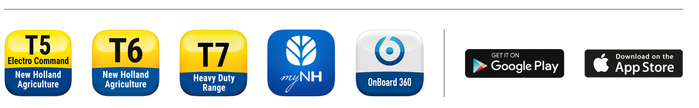

Press contacts:

Sara Sebastianelli, Brand Communications UK&ROI - Phone: +44 (0) 01268 295 268
email: sara.sebastianelli@newholland.com

