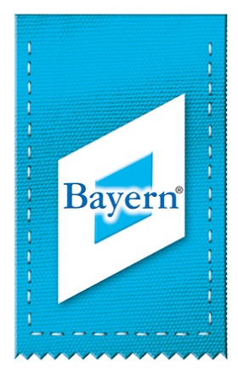

“Almabtrieb” in Bavaria - 2016
The summer spent by the cattle in the mountains traditionally closes with the 'Almabtrieb'. After around a hundred days grazing on the Alpine meadows, the yearlings are brought back down into the valleys in September.
The herders drive the cattle up into the mountains shortly after the snowmelt in spring to increase the animals' robustness and resistance. The herders carry a great amount of responsibility, as they promise the owners to return all of their animals to them in good health in the autumn. If all has gone well, the leading cow is elaborately decorated. Whilst all of the cattle are decorated in most parts of Bavaria, only the leading cow, or 'Kranzkuh', is decorated with a wreath, the 'Kranz', in the Allgäu region. It leads the procession of animals wearing a wreath fashioned from Alpine flowers, and bearing a cross and a mirror. All the other cows wear huge bells to ward off any evil demons the cattle might encounter on their way back down into the valley. This is the traditional way of giving thanks for a good grazing season without losses.
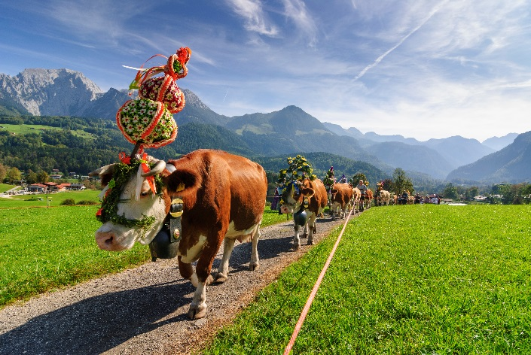
The time spent up in the mountains is not always easy for the herders. They often live in very simple conditions and lead extremely lonely lives. Besides milking and generally tending to the cows every day, they might also make cheese and butter.
Over the years, the various Almabtriebe have increasingly become popular public events. It is therefore advisable to get their early to get a good view. The festivities usually take place in the middle of September. However, depending on the weather, an Almabtrieb may also be delayed. More information and dates: bit.ly/1V8IG8X.
About BAYERN TOURISMUS Marketing GmbH
BAYERN TOURISMUS Marketing GmbH (by.TM) is the official marketing company for the Bavarian tourism and leisure industry in Bavaria, Germany. The company presents the entire range of tourist attractions in the Free State of Bavaria under the Bayern® umbrella brand. Thus, together with all Bavarian tourism partners, by.TM provides guests from across the globe with attractive and varied holiday ideas. Over the past year, the holiday region of Bavaria has succeeded in further consolidating its position as the number one holiday destination in Germany. The latest figures from the Free State of Bavaria record 34.2 million guest arrivals and 88.1 million nights spent in the region. For more information about the diversity of holidays in Bavaria and about BAYERN TOURISMUS Marketing GmbH, please visit www.bayern.by.
Claudia Hinnerkopf
Director of Communications
Arabellastraße 17
81925 Munich
Telephone: +49 (0)89 212397-27
Fax: +49 (0)89 212397-99
hinnerkopf@bayern.info

www.press.bavaria.by
www.bavaria.by

