TWO ADIDAS ATHLETES SABASTIAN SAWE AND YOMIF KEJELCHA BREAK THE SUB-2-HOUR MARATHON BARRIER IN THE REVOLUTIONARY ADIZERO ADIOS PRO EVO 3, AS SABASTIAN AND TIGIST ASSEFA SHATTER WORLD RECORDS IN LONDON
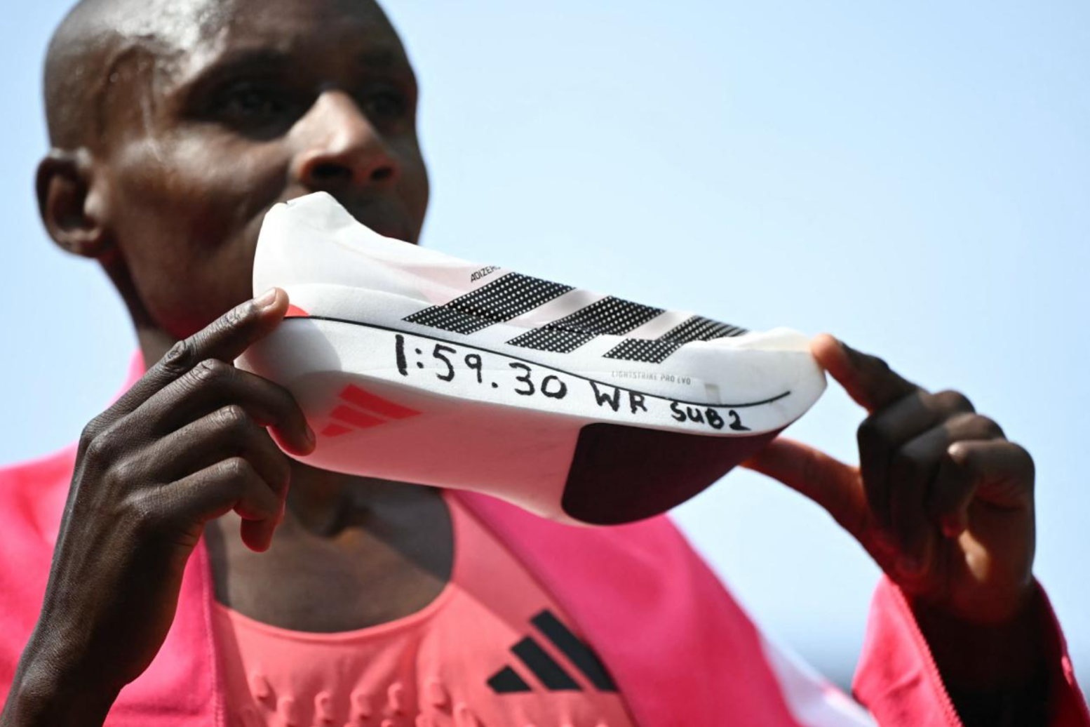
A new era of running has dawned as adidas athletes Sabastian Sawe and Yomif Kejelcha broke the sub-2-hour marathon barrier at the London Marathon, with Sabastian and Tigist Assefa making history becoming the fastest male and female marathon runners of all time. Sawe broke the sub-2-hour barrier and set a new world record of 1:59.30, with Yomif running 1:59.41 in his debut marathon, and Assefa setting a women-only world record of 2:15.41.
Kenyan-born Sabastian said: “To break the world record is something I have dreamed about for a long time, and to achieve it means so much to me and to the sport of running. It reflects the hard work behind the scenes, the support of my team, and the role of innovation in helping me push beyond limits. I’m honoured to be part of a new chapter for the sport.”
Ethiopian-born Tigist said: “Breaking the world record has been in my mind for many years, and to finally do it is very special. It shows the work that happens every day, the strength of the team around me, and how everything comes together to go beyond what we thought was possible. I’m grateful to be part of this moment for the sport.”
All three athletes wore the new adidas Adizero Adios Pro Evo 3 – the world-record and sub-2-breaking fastest, lightest Adizero shoe ever made.
The adidas innovation team worked closely with Sabastian, Tigist and Yomif to deliver an unmatched range of innovative running products to support this moment of history, including the Techfit+ Endurance Shorts and Climacool+ Singlet worn by Sabastian and Tigist, as well as the Techfit+ Endurance Suit worn by Yomif.
Patrick Nava, General Manager at adidas Running said: “The adidas family is incredibly proud of Sabastian and Tigist’s historic achievements, marking the fastest times humans have ever run in a marathon. This is a testament to the years of hard work and dedication they have made, alongside our innovation team, who have built a supershoe which breaks new ground in the Adizero Adios Pro Evo 3.”

- ENDS -
NOTES TO EDITORS:
Midsole measurements: Heel: 39 mm / Forefoot: 33 mm – Drop: 6 mm
THE ADIZERO ADIOS PRO EVO SUCCESS
Since launching in April 2025, the Adizero Adios Pro Evo has helped adidas athletes break three world records and win over 30+ key road races which includes six World Marathon Major wins, seven national records, five course records and one Olympic record time.

THE ADIZERO FRANCHISE SUCCESS
Since 2020, adidas’ Adizero franchise has helped athletes secure 200+ victories at key running and track competitions – as well as shattering 24 world records. This dominance continued in 2024, with adidas athletes wearing Adizero models winning six out of 12 World Major Marathons – more than any other brand.

ABOUT ADIDAS
adidas is a global leader in the sporting goods industry. Headquartered in Herzogenaurach/Germany, the company employs more than 65,000 people across the globe and generated sales of € 24.8 billion in 2025.

ABOUT ADIDAS RUNNERS
adidas Runners is an international community comprising people from different backgrounds and walks of life, united by a desire to become better: better runners, better athletes and, ultimately, better humans. Spanning 48 countries, adidas Runners is one of the largest running communities worldwide.

