Key visual
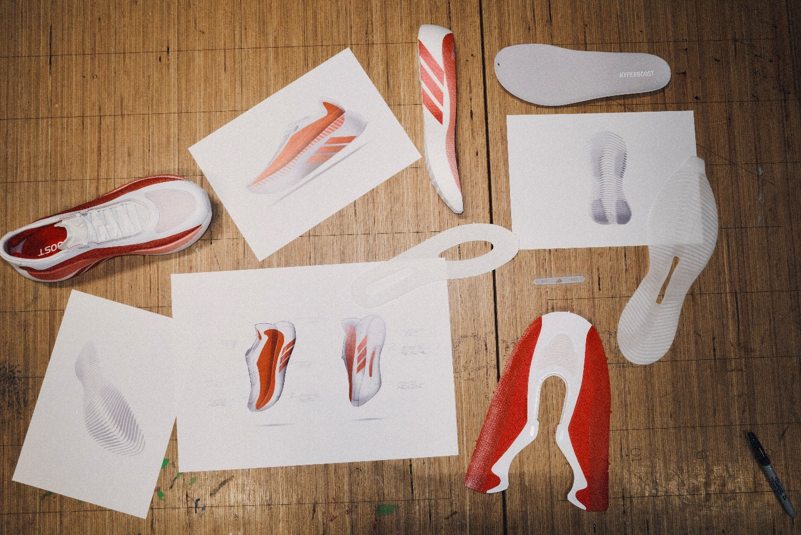
Hyperboost Edge Unlocked:
10 Things You Need to Know from VP of Design for adidas Running
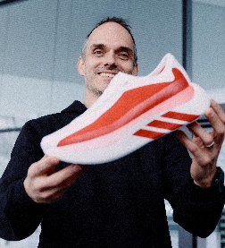
With 18 years at adidas, Moritz Hoellmueller - VP of Design for Running - channels his two lifelong passions: sport and design. An industrial designer shaped by a life where sport has always played a defining role, Mo is driven to create what’s next for runners everywhere, fuelled by the pinnacle of innovation and future product expression, always pushing the boundaries of what performance footwear can be. “If you are passionate about it, you never stop sketching, ideating and improving. Very much like running - the beauty is in the process”.

- How does the Hyperboost Edge compare to other running shoes in the market?
The Hyperboost Edge is a lightweight super-trainer, bridging the gap between high-performance race shoes and daily trainers, perfect for your Sunday long run or everyday fun running experience. Unlike traditional daily trainers, which often focus on stability or cushioning at the expense of responsiveness, Hyperboost Edge introduces a new era of road running by combining maximum cushioning, high energy return and lightweight performance in one shoe. These three breakthrough enefits combine to deliver super-trainer levels of performance, in a running shoe built for every day, at only 255grams
- What technical innovations and features are built into the Hyperboost Edge to address common runner problems?
The Hyperboost Edge introduces a series of innovations designed to elevate every run:
- Hyperboost Pro midsole: Delivers maximum cushioning paired with exceptional energy return, creating a smooth, comfortable, and energized ride from start to finish.
- PRIMEWEAVE upper: Provides a hyper-light, soft, and adaptive fit that wraps securely around the foot. The integrated heel pods enhance comfort and stability, ensuring a confident and distraction-free run.
- LIGHTTRAXION outsole: Offers reliable grip and precise foot placement across a variety of road surfaces, giving runners confidence without adding unnecessary weight.
- Plate-free design: Promotes a natural, fluid running experience by allowing the shoe to move in harmony with the foot, supporting efficient and effortless strides.
Together, these innovations create a running experience defined by lasting comfort, responsive energy, secure fit, and confident traction - helping you feel smooth, supported, and ready for every mile.
- What exactly is Hyperboost pro foam? Is it still an eTPU foam or is it something else?
Hyperboost Pro is a pelletized Superfoam. We have taken formulations of our Ligthstrike Pro foam that you know from models like the Adizero Adios Pro line and rebuild it as Hyperboost Pro. So, it combines the Adizero foam magic with the Boost processing.
- Who is the ideal runner for the Hyperboost Edge, and what specific running goals does it support best?
The Hyperboost Edge is ideal for every type of runner, from daily sessions to high-mileage training.
- What do real runners and influential communities say about the Hyperboost Edge’s performance in early reviews?
German Sport University Cologne study has tested the Hyperboost Edge with 60 runners. Their findings are:
- 73% preferred energy return
- 77% noticed softer cushioning
- Over 50% preferred overall comfort
- Majority agreed it delivered a superior running experience
Our team are delighted with the response and reviews we’ve seen in the first two weeks; A few I can recommend:
Footwear News: “adidas is delivering the most significant update to boost yet”.
Runner’s World: “Something meaningful, unique and delivering a running experience that really isn’t out there in the market.”
Highsnobiety: “The only thing moving faster than adidas' style game is its running offerings.”

- Why do you have a new lacing system?
It ensures great lockdown and structure through the midfoot, together with the gusseted tongue a key feature for a comfortable and structured fit. At the same time, it visually lives up to the progressive nature of Hyperboost Edge.

- Is Hyperboost a race shoe?
Hyperboost Edge is our lightweight super-trainer. Made to run. Adizero is built to race.
- What’s the main difference between Hyperboost running line-up, Adizero and Supernova and what roles they play in shoe rotation?
Love this question. Adizero is built for speed, to break personal bests, be fast and feel fast. We built it to equip you for race day or get ready for it, featured by Lightstrike Pro foam and energy rods.
Hyperboost is built for max cushioning, high energy return resulting in a (non-plated) lightweight supertrainer; featured by Hyperboost Pro foam.
Supernova is your daily trainer, with more supportive comfort, featured by Dreamstrike +.
All can coexist in a shoe rotation or be used individually for their distinct purpose. I personally use Adizero Adios Pro for race day, Adizero Evo SL for fast training runs, and Supernova for easy runs. Hyperboost Pro ( I run a testing pair) became a staple for me in my rotation for various use cases, from short to long runs - the great thing it has that “hidden” gas pedal insight that you can always hit.
My verdict: If you need only one shoe - Hyperboost Edge is a great choice.
- Why is there no heel bevel like on Adizero or Supernova shoes?
The heel bevel is the perfect geometry to amplify the high energy return and max cushion feel of our brand new Hyperboost pro foam technology. It allows you to activate its benefits early in your gaitcycle and enables a smooth and energized transition. We have optimized all transition aspects for an energetic, cushioned and smooth heel to toe ride for the Hyperboost Edge and tested it with various test groups in different stages of the creation process.
- Is the Hyperboost Edge worth the price?
Hyperboost Pro represents a new level of innovation, where advanced technology and extensive research come together to deliver the shoe’s exceptional feel.
Innovative new materials and technologies are always more costly to explore and produce. In addition, the development process itself is significantly more complex and resource-intensive, which further increases overall costs.
The experience you get is a total unlock and enables whole new level of running.


