adidas Originals and Thug Club Bring Playground Energy to Sports Culture in Their Second Global Collection

- The collection subverts traditional sporting codes with a defiant streetwear attitude inspired by football and athleisure culture
- All over print graphics are matched with photorealistic metal Thug Club emblems
- Bold sneakers span the Superstar Vintage, adiFOM IIInfinity Mule & adiFOM Megaride
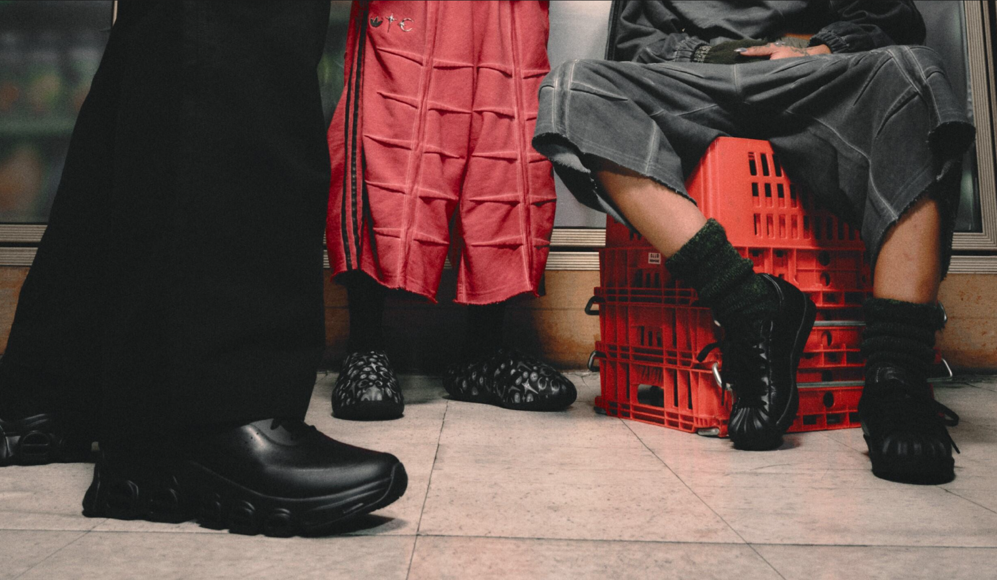
Herzogenaurach, March 18th, 2025 - Continuing the collaborative mission to subvert traditional sport aesthetics, Korean brand Thug Club and adidas Originals return with a new collection infused with disruptive playground energy. The latest drop channels Thug Club’s rebellious street ethos while boldly reimagining athleisure’s casual codes.
A bold fusion of sport and street attitude, built on the deep bonds of the club. The collection features pieces infused with photorealistic metal Thug Club emblems and unexpected design twists. The radical sportswear capsule spans apparel, footwear, and accessories, drawing inspiration from street football and the beautiful game, warped through Thug Club’s distinct lens of bike culture and street life, and grounded in unity.

Apparel Pieces Merge Metal‑Infused Graphics with Elevated Football Heritage
The TC SST Jacket features a detachable padded vest with a photorealistic all-over print of metal rivets and is paired with TC SST Jogger. The TC SWEAT HD meanwhile takes the familiar hoodie silhouette and reimagines it in a french terry construction with a garment-dye finish and bone shaped tucking detailing on the back. The striking hoodie is available in red and gray colorways and is paired with matching sweat jorts.

Inspired by the archive Predator goalie jersey, the all‑over‑print long‑sleeve top in black and off‑white colorways completes the apparel offering and reflects the spirit of football as fun born on Korea’s playgrounds, while connecting it to the rising global excitement for the FIFA WORLD CUP 2026™ and the energy of stadium subcultures. A mohawked balaclava punctuates the accessories selection.

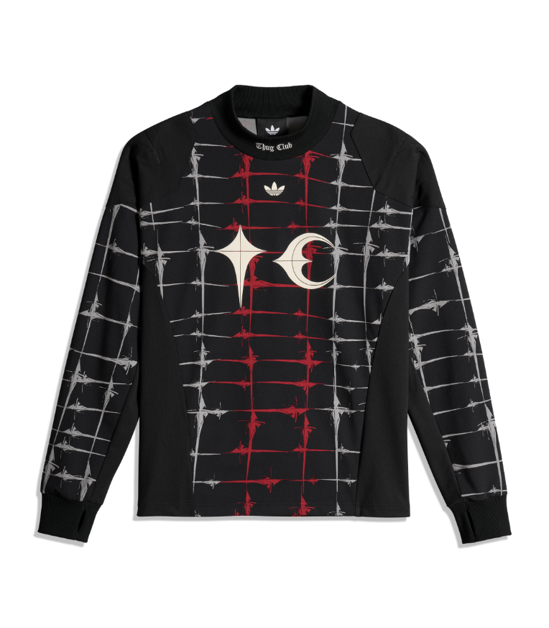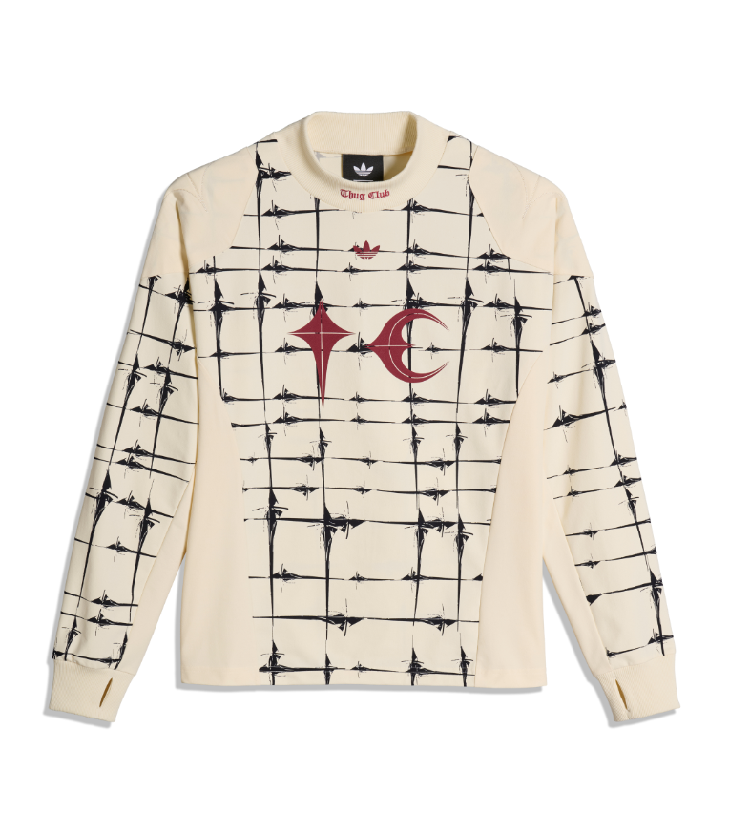

A Bold Footwear Lineup Blending Sport Innovation with Playground Rebellion
The footwear collection, meanwhile, consists of three silhouettes: the Superstar Vintage TC, the adiFOM Megaride TC and the IIInfinity Mule TC. The Superstar Vintage TC takes the previously introduced custom shell-toe and brings it to an all-black leather version of the iconic sneaker. The all-black adiFOM Megaride TC then dramatically collides sport and style with perforated three stripes and a synthetic leather upper. The adiFOM IIInfinity Mule TC embodies the spirit of playground crew fun, translating the ease of a slip-on silhouette into a symbol of casual neighborhood culture, where all kinds of playground sports are spontaneous and style is effortless - finished with an all-over print of photorealistic metal rivets echoing the SST jacket.

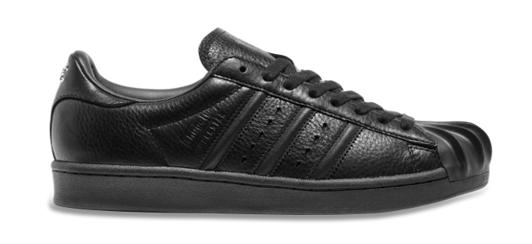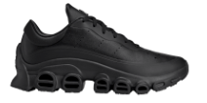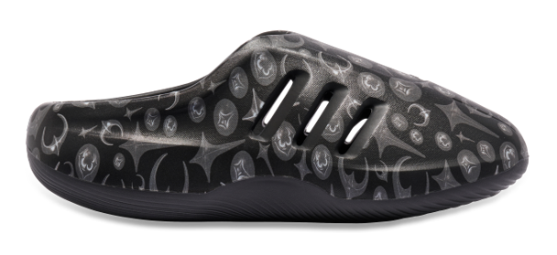

Arriving on March 25th, the latest adidas Originals x Thug Club collection is available on adidas.com, CONFIRMED, and through select retailers.

About adidas Originals
Inspired by the rich sporting heritage of adidas - one of the world’s leading sports brands and a global designer and developer of athletic footwear and apparel - adidas Originals is a lifestyle brand founded in 2001. With the adidas archive at its foundation, adidas Originals continues to evolve the brand’s legacy through its commitment to product innovation and its ability to filter the creativity and courage found on the courts and sporting arenas through the lens of contemporary youth culture. Marked by the iconic Trefoil logo that was first used in 1972 and championed by those that continue to shape and define creative culture, adidas Originals continues to lead the way as the pioneering sportswear brand for the street.
About Thug Club
Thug Club is a defining force in Korea's streetwear movement, known for its uncompromising identity and subversive design language. Rooted in Korean heritage yet driven by disruptive cultural friction. The name Thug Club derives from a rebellious mindset - the understanding that there's no single way to exist. Blurring the lines between luxury and streetwear, THUG CLUB has captured Korea's attention and is now expanding its influence on a global stage.

