ADIDAS REVEAL THE HYPERBOOST EDGE, BEGINNING A NEW ERA OF ROAD RUNNING

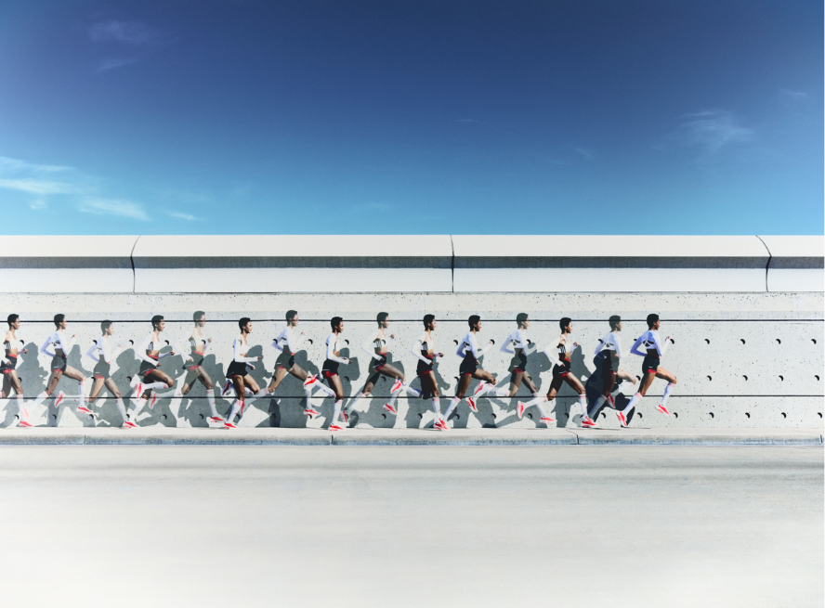

- Hyperboost Edge introduces a new era of road running by combining maximum cushioning, high energy return and lightweight performance in one shoe
- Three breakthrough technologies combine to deliver super-trainer levels of performance, in a running shoe built for every day, at only 255grams
- The bold, high-stacked silhouette launches globally in a red colorway on March 17, 2026, at select retailers and adidas.com, with additional colorways arriving from May 1

Herzogenaurach, March 5, 2026 – adidas today reveal the Hyperboost Edge, an all-new lightweight super-trainer set to begin a new era of road running. The shoe combines three breakthrough technologies: the new Hyperboost Pro midsole, a PRIMEWEAVE upper and a LIGHTTRAXION outsole to balance comfort and responsiveness in every stride.

Hyperboost Edge has been designed as the first adidas lightweight non-plated super-trainer. Crafted with no plates or stiffening elements, a new foam works naturally through the gait cycle creating a lightweight and propulsive ride. The shoe weighs just 255grams* but delivers supreme comfort and high energy return.

At the heart of this new running experience is the Hyperboost Pro foam, a high-performance material that provides maximum cushioning but with no compromises. Drawing on adidas’ elite racing midsole technologies, the new foam formulation delivers an experience optimized for every type of run, whether its daily sessions or high mileage training. A bold 45mm rearfoot stack and 6mm drop delivers a uniquely energetic feel across the entire foot and means the foam defines the experience and visual identity of Hyperboost Edge.

The Hyperboost Pro foam has been designed using proven material insights and extensive laboratory testing, by adidas and through consumer research undertaken by the University of Cologne. In a study of 60 runners, Hyperboost Edge outperformed runners’ current footwear across key performance and comfort metrics: 73% of runners preferred its energy return, 77% perceived softer cushioning, more than half preferred its overall comfort, and a majority agreed that it delivers a better overall running experience – showing Hyperboost Pro as a new benchmark in running shoe technology.
Complementing the disruptive new foam technology is an upper and outsole that combine to turn every run into a natural high – allowing runners to experience comfort, energized. A PRIMEWEAVE super-soft, hyper-light woven upper delivers effortless comfort and reliable lockdown for a secure fit. Integrated heel pods provide targeted cushioning and added stability around the heel, enhancing step-in comfort without distraction. Soft, premium materials and a cushioned, secure heel work together to support every run—comfort that looks as good as it feels.
The newly designed outsole is inspired by adidas race shoe DNA; the lightweight, full-length LIGHTTRAXION material delivers high traction and grip from heel to toe. Built on a thinner, lighter base, it brings the adidas Adizero performance mindset to everyday running, helping every step feel stable and confident while maintaining durable grip across varied conditions.
Beyond performance, the shoe introduces a new design aesthetic for adidas Running shoes. The bold, inflated midsole silhouette draws inspiration from industrial forms, placing the focus firmly on the Hyperboost Pro technology beneath the foot. For the first time in adidas running footwear, the iconic three stripes are positioned on the stacked midsole, intentionally highlighting the performance engine. The upper is deliberately clean and progressive, creating a sleek future-facing look with minimal detailing, hidden eyelets and light-bonded elements.
Patrick Nava, GM adidas Running, said: “We wanted to bring something truly transformative to runners. Hyperboost Edge is where the Power of Three comes to life—cushioning, energy, and lightness combined seamlessly in one shoe. By harnessing these three elements without compromise, we’ve created a supertrainer that feels light on foot, responsive through every stride, and cushioned under impact—supporting runners across all types of mileage. This is just the beginning of what Hyperboost Pro can unlock across our performance portfolio.”
Priced at $200, and launched in a bold red colorway, the Hyperboost Edge is available from March 17 via adidas stores and adidas.com. The first release will be followed by new colorways and drops from May 1 as the future of running gets a fresh looks with the changing seasons.

- ENDS -
*255g for men’s 8.5 shoe

