adidas Originals and SP5DER Launch Global Collaboration with a First-ever, SP5DER Superstar Supermodified
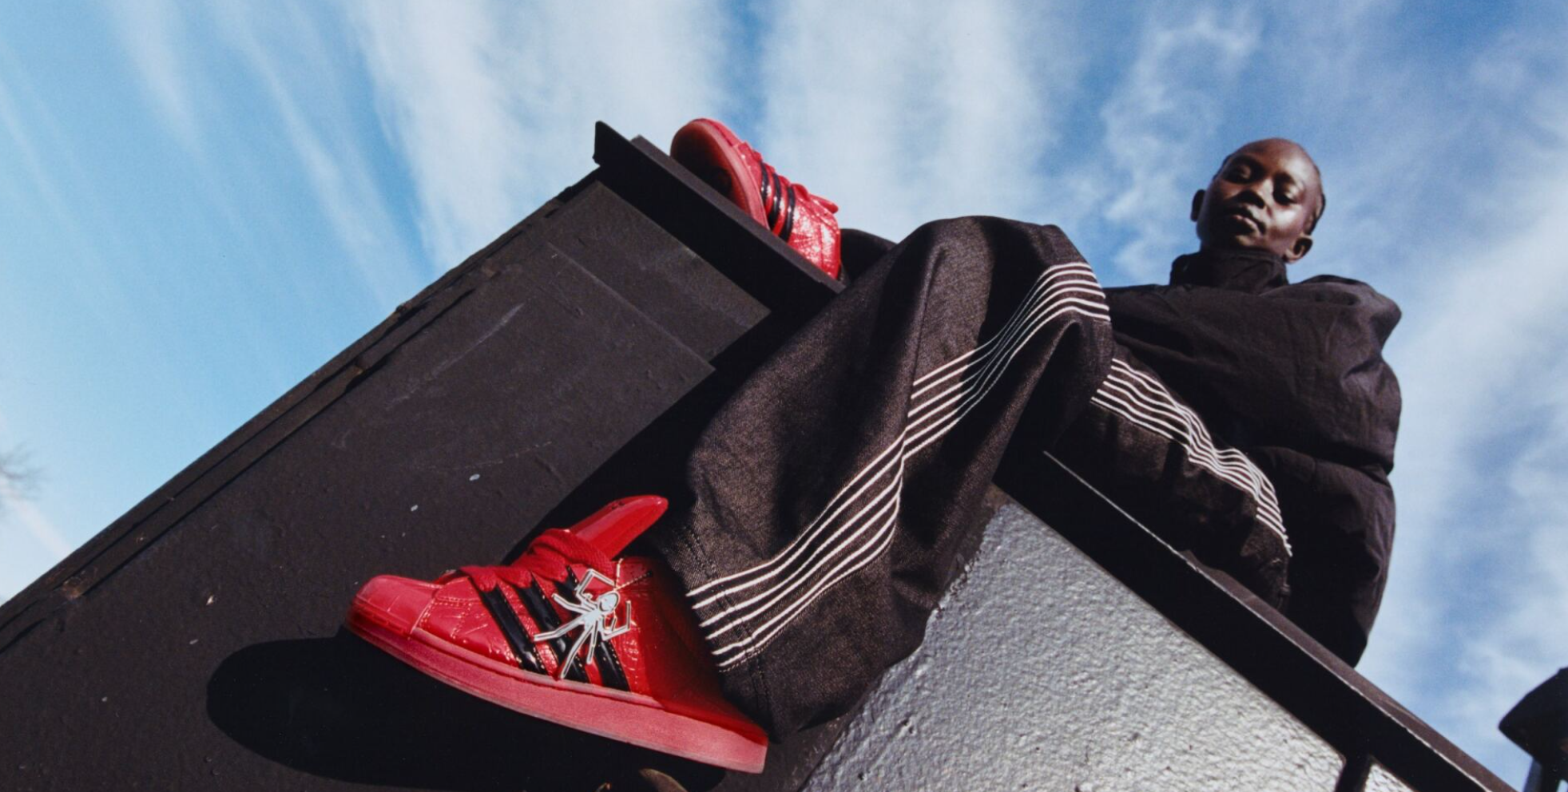
Herzogenaurach, February 24th, 2026 - This February, adidas Originals and SP5DER join forces on a multi-release, global collaboration featuring a boldly designed Supermodified Superstar and graphic T-shirts.
The co-branded designs draw on SP5DER’s disruptive aesthetic set alongside a fresh take on the Three Stripes. Taking the Superstar to new heights, SP5DER added patent leather uppers debossed with the brand’s spider web and metallic heel accents. Each pair comes with a laser-engraved spider keychain. The three stripes on the sneaker are stressed, bolder, and pushed further up the forefoot of the SP5DER Superstar Supermodified.
SP5DER Supermodified Superstars will be available initially in two colorways: black with tonal black stripes and red with black stripes. Both arrive in special corrugated boxes stuffed with different color thick laces - the black one comes with solar green, Sp5der pink and Sp5der yellow laces and the red one with white, Sp5der yellow and Sp5der pink laces, both come along with the spider keychain.
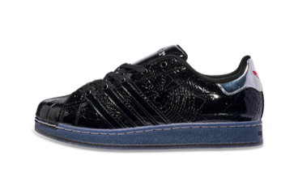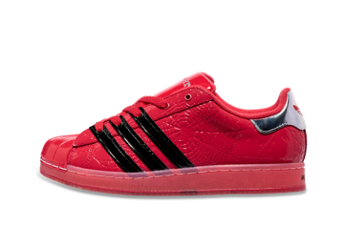
Offered with the SP5DER Supermodified Superstars is a puff print “I Love Sp5der” graphic T-shirt that plays on adidas Originals classic Trefoil logo in place of a heart, available in two colorways: white and black.
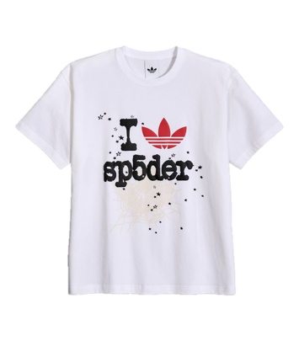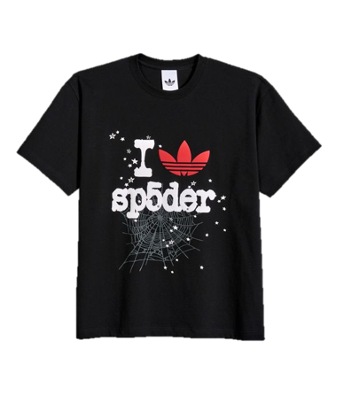
The first adidas Originals with SP5DER release pre-launches on February 27th 2026 via KINGSPIDER.CO followed by a full global launch on March 3rd 2026 via the adidas CONFIRMED app, KINGSPIDER.CO, select adidas Originals stores and select retailers.

About SP5DER
Founded in 2019, SP5DER is a lifestyle brand based out of Los Angeles by way of Atlanta. The brand is a visual commentary on the pulse of the South. A loud, boisterous sense of self-expression inspired by Atlanta and the community that shapes it. Designed from a luxury perspective with a punk spirit, SP5DER stands at the juxtaposition of nostalgia and invention.

About adidas Originals
Inspired by the rich sporting heritage of adidas - one of the world’s leading sports brands and a global designer and developer of athletic footwear and apparel - adidas Originals is a lifestyle brand founded in 2001. With the adidas archive at its foundation, adidas Originals continues to evolve the brand’s legacy through its commitment to product innovation and its ability to filter the creativity and courage found on the courts and sporting arenas through the lens of contemporary youth culture. Marked by the iconic Trefoil logo that was first used in 1972 and championed by those that continue to shape and define creative culture, adidas Originals continues to lead the way as the pioneering sportswear brand for the street.

MARKET LINK

NAM | adidas.com/us | https://www.adidas.com/us/confirmed
NAM | adidas.ca/en | https://www.adidas.ca/en/confirmed
NAM | adidas.ca/fr | https://www.adidas.ca/fr/confirmed
LAM | adidas.com.ar | https://www.adidas.com.ar/confirmed
LAM | adidas.cl | https://www.adidas.cl/confirmed
LAM | adidas.co | https://www.adidas.co/confirmed
LAM | adidas.mx | https://www.adidas.mx/confirmed
LAM | adidas.pe | https://www.adidas.pe/confirmed
LAM | adidas.com.br | https://www.adidas.com.br/confirmed
EU Big 6 | adidas.co.uk | https://www.adidas.co.uk/confirmed
EU Big 6 | adidas.de | https://www.adidas.de/confirmed
EU Big 6 | adidas.de/en | https://www.adidas.de/confirmed
EU Big 6 | adidas.fr | https://www.adidas.fr/confirmed
EU Big 6 | adidas.it | https://www.adidas.it/confirmed
EU Big 6 | adidas.es | https://www.adidas.es/confirmed
EU Big 6 | adidas.nl | https://www.adidas.nl/confirmed
EU | adidas.cz | https://www.adidas.cz/confirmed
EU | adidas.dk | https://www.adidas.dk/confirmed
EU | adidas.at | https://www.adidas.at/confirmed
EU | adidas.ch/de | https://www.adidas.ch/de/confirmed
EU | adidas.ch/en | https://www.adidas.ch/en/confirmed
EU | adidas.ch/fr | https://www.adidas.ch/fr/confirmed
EU | adidas.ch/it | https://www.adidas.ch/fr/confirmed
EU | adidas.gr | https://www.adidas.gr/confirmed
EU | adidas.be/en | https://www.adidas.be/fr/confirmed
EU | adidas.be/fr | https://www.adidas.be/fr/confirmed
EU | adidas.be/nl | https://www.adidas.be/fr/confirmed
EU | adidas.fi | https://www.adidas.fi/confirmed
EU | adidas.ie | https://www.adidas.ie/confirmed
EU | adidas.no | https://www.adidas.no/confirmed
EU | adidas.pl | https://www.adidas.pl/confirmed
EU | adidas.pt | https://www.adidas.pt/confirmed
EU | adidas.sk | https://www.adidas.sk/confirmed
EU | adidas.se | https://www.adidas.se/confirmed
APAC | adidas.jp | https://shop.adidas.jp/confirmed/
APAC | adidas.com.au | https://www.adidas.com.au/confirmed
APAC | adidas.co.kr | https://www.adidas.co.kr/confirmed
APAC | adidas.co.nz | https://www.adidas.co.nz/confirmed
UAE | adidas.ae | https://www.adidas.ae/en/confirmed
EM | adidas.co.th/en | https://www.adidas.co.th/en/confirmed
EM | adidas.co.th | https://www.adidas.co.th/en/confirmed
EM | adidas.ae | https://www.adidas.ae/en/confirmed

