ADIDAS BASKETBALL AND JAMES HARDEN UNVEIL THE HARDEN VOL 10
The tenth signature shoe in the Harden franchise celebrates a major milestone of the NBA All-Star’s storied partnership with adidas and his evolution as a cultural icon on and off the court

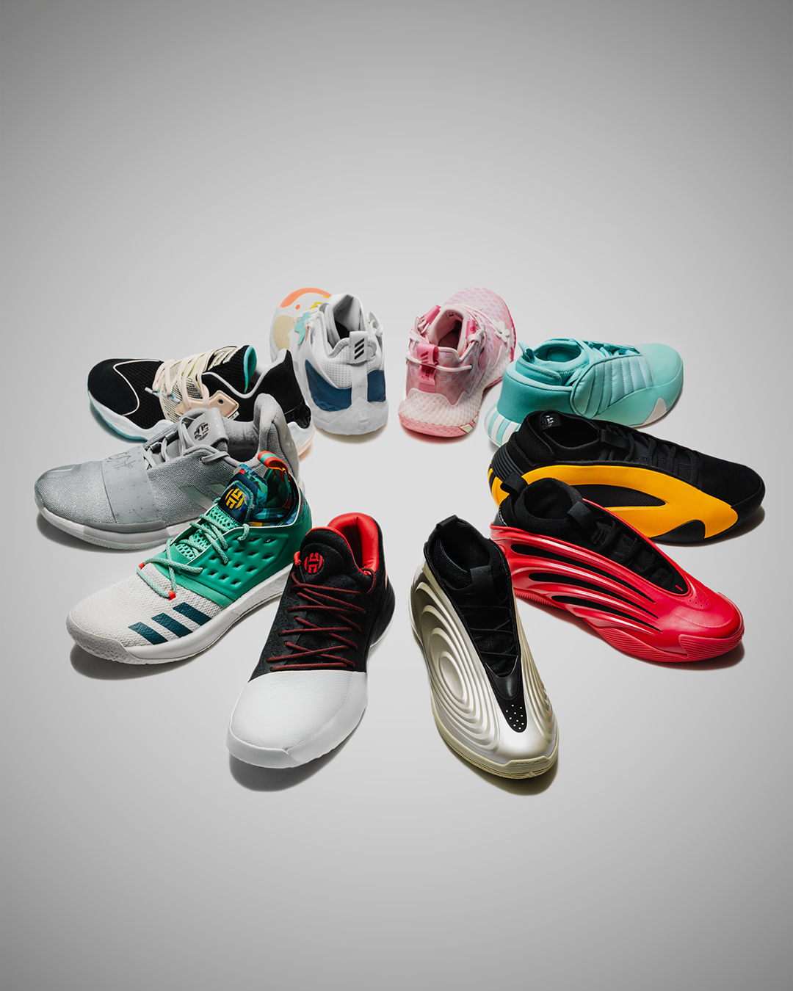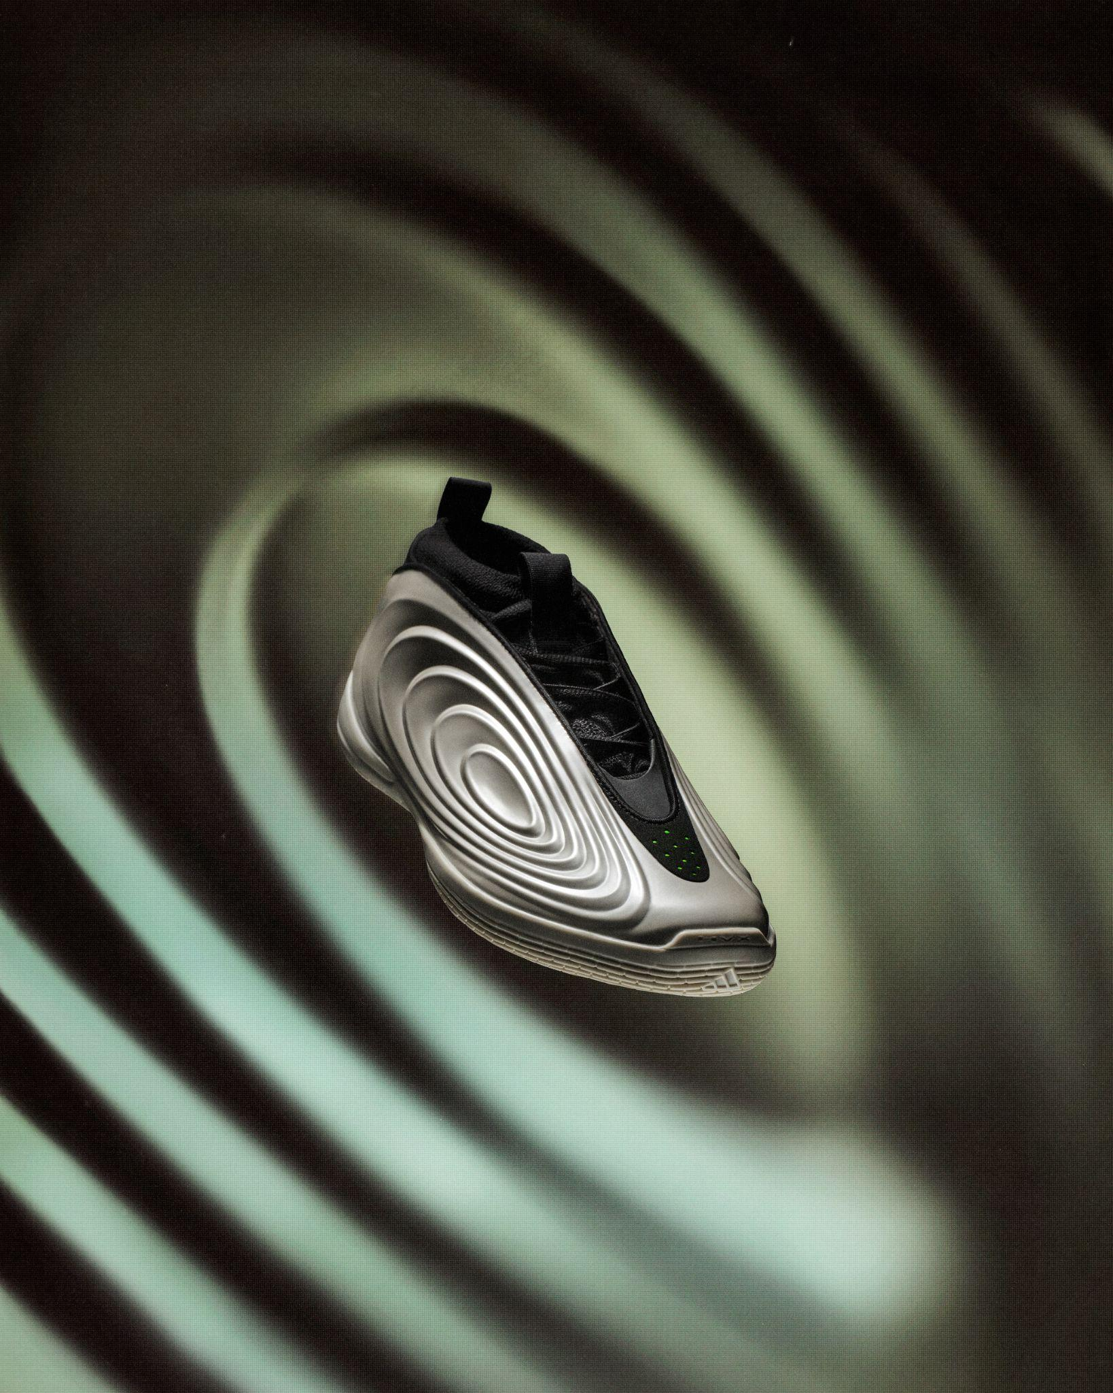

Download Assets Here

- adidas Basketball and James Harden unveil the Harden Vol 10, celebrating a decade-long partnership between the NBA superstar and adidas
- The latest signature shoe blends performance and lifestyle, featuring full-length LIGHTBOOST cushioning, radial traction, and a molded upper, personally refined by Harden
- Launching in the “Imma Be a Star” colorway, the Harden Vol. 10 pays tribute to Harden’s journey from young dreamer to global icon and will be available December 15 on adidas.com and at select retailers worldwide

Los Angeles, Calif. (December 10, 2025) – adidas Basketball and NBA superstar James Harden proudly unveil the Harden Vol 10, marking a major milestone in one of the most influential signature franchises in basketball.

Celebrating a decade of design evolution, the Harden Vol 10 represents the next chapter in Harden’s legacy blending his creativity, signature moves, and transcendent style for players who move through the world of UNO.

“From the very beginning of this process with adidas, I wanted to create a shoe that connects where I came from with where I’m going. The 10 is way more special as it’s a reflection on everything we’ve built and represents the legacy I want to leave behind. But I have so much more to give on the court and to my community - I feel in some ways that I’m just getting started.” – James Harden

Building on the foundation of the Harden Vol 9, the tenth iteration showcases Harden’s enduring influence on sport and culture. Harden personally reviewed each design detail, from material textures to colorways, ensuring every aspect reflects his identity and journey.

Engineered for effortless versatility, the Harden Vol 10 delivers a seamless blend of performance and lifestyle, featuring:

- LIGHTBOOST: Full-length LIGHTBOOST for lighter and greater energy return.
- Radial Multidirectional Traction: Retains the recognizable Harden design patterns. refined for optimized grip, improved traction and enhanced on-court control.
- Conforming Cuff: Provides a dynamic fit and freedom of movement.
- Molded Upper: Ensures secure lockdown and comfort through every play.

“For us at adidas Basketball it's all about being the next generation brand of basketball. James having not only shaped, but also defined basketball culture for the next generation continues to be a key part in our journey. His 10th edition captures that confidence and creativity through a polarizing design and unapologetic narrative that continues to inspire the next generation." – Max Staiger, Global General Manager, adidas Basketball

Harden Vol 10 will launch with the “Imma Be a Star” colorway, a tribute to James’ journey from ambitious young hooper to global icon. One insole features a handwritten note he penned to his mother as a child; the other, a message from his son, together symbolizing ambition, legacy and generational drive that defines Harden’s story. Other subtle “Easter eggs” reference James’ motto “Under No One”, as playful nods to his off-court personality and competitive spirit.

Harden Vol 10 “Imma Be a Star” retails for $160 USD and will be available starting December 15 on adidas.com and at select adidas retail locations worldwide.

###

About adidas:
adidas is a global leader in the sporting goods industry. Headquartered in Herzogenaurach/Germany, the company employs more than 62,000 people across the globe and generated sales of €23.7 billion in 2024. For more information, please visit www.adidas-Group.com.

For more information and to stay updated on the Harden Vol 10, please visit: https://www.adidas.com/us/james_harden

adidas Basketball
IG: @adidasbasketball / @adidas
X/Twitter: @adidashoops / @adidas

NAM | adidas.com/us | https://www.adidas.com/us/men-basketball-shoes
NAM | adidas.ca/fr | https://www.adidas.ca/fr/hommes-basketball-chaussures
NAM | adidas.ca/en | https://www.adidas.ca/en/men-basketball-shoes
LAM | adidas.com.ar | https://www.adidas.com.ar/zapatillas-basquet
LAM | adidas.co | https://www.adidas.co/zapatillas_y_tenis-basketball
LAM | adidas.cl | https://www.adidas.cl/zapatillas-basketball
LAM | adidas.mx | https://www.adidas.mx/zapatillas_y_tenis-basketball
LAM | adidas.pe | https://www.adidas.pe/zapatillas-basquet
LAM | adidas.com.br | https://www.adidas.com.br/tenis-basquete
EU Big 6 | adidas.co.uk | https://www.adidas.co.uk/basketball-shoes
EU Big 6 | adidas.de/en | https://www.adidas.de/en/basketball-shoes
EU Big 6 | adidas.de | https://www.adidas.de/basketball-schuhe
EU Big 6 | adidas.fr | https://www.adidas.fr/chaussures-basketball
EU Big 6 | adidas.it | https://www.adidas.it/scarpe-basket
EU Big 6 | adidas.es | https://www.adidas.es/calzado-baloncesto
EU Big 6 | adidas.nl | https://www.adidas.nl/basketbal-schoenen
EU | adidas.cz | https://www.adidas.cz/obuv-basketbal
EU | adidas.dk | https://www.adidas.dk/basketball-sko
EU | adidas.at | https://www.adidas.at/basketball-schuhe
EU | adidas.ch/de | https://www.adidas.ch/it/scarpe-basket
EU | adidas.ch/en | https://www.adidas.ch/fr/chaussures-basketball
EU | adidas.ch/fr | https://www.adidas.ch/en/basketball-shoes
EU | adidas.ch/it | https://www.adidas.ch/de/basketball-schuhe
EU | adidas.gr | https://www.adidas.gr/μπάσκετ-παπούτσια
EU | adidas.be/nl | https://www.adidas.be/nl/basketbal-schoenen
EU | adidas.be/fr | https://www.adidas.be/fr/chaussures-basketball
EU | adidas.be/en | https://www.adidas.be/en/basketball-shoes
EU | adidas.fi | https://www.adidas.fi/basketball-shoes
EU | adidas.ie | https://www.adidas.ie/basketball-shoes
EU | adidas.no | https://www.adidas.no/basketball-sko
EU | adidas.pt | https://www.adidas.pt/calcado-basquetebol
EU | adidas.pl | https://www.adidas.pl/buty-koszykowka
EU | adidas.sk | https://www.adidas.sk/obuv-basketbal
EU | adidas.se | https://www.adidas.se/basket-skor
EU | adidas.hr | https://www.adidas.hr/kosarka-obuca
APAC | adidas.jp | https://www.adidas.jp/シューズ・靴-バスケットボール
APAC | adidas.com.au | https://www.adidas.com.au/basketball-shoes
APAC | adidas.co.nz | https://www.adidas.co.nz/basketball-shoes
EM | adidas.ae | https://www.adidas.ae/basketball-shoes
EM | adidas.co.in | https://www.adidas.co.in/basketball-shoes
EM | adidas.com.tr/tr | https://www.adidas.com.tr/tr/ayakkabi-basketbol
EM | adidas.com.tr/en | https://www.adidas.com.tr/en/shoes-basketball
EM | adidas.co.za | https://www.adidas.co.za/basketball-shoes
EM | adidas.com.vn/vi | https://www.adidas.com.vn/vi/bong_ro-giay
EM | adidas.com.vn/en | https://www.adidas.com.vn/en/basketball-shoes
EM | adidas.com.sg | https://www.adidas.com.sg/basketball-shoes
EM | adidas.com.ph | https://www.adidas.com.ph/basketball-shoes
EM | adidas.com.my | https://www.adidas.com.my/en/basketball-shoes
EM | adidas.co.th/th | https://www.adidas.co.th/th/บาสเกตบอล-รองเท้า
EM | adidas.co.th/en | https://www.adidas.co.th/en/basketball-shoes

