**adidas Originals Celebrates Football as Fashion’s**

**Ultimate Muse at Paris Fashion Week SS26**

*A year defined by football.*

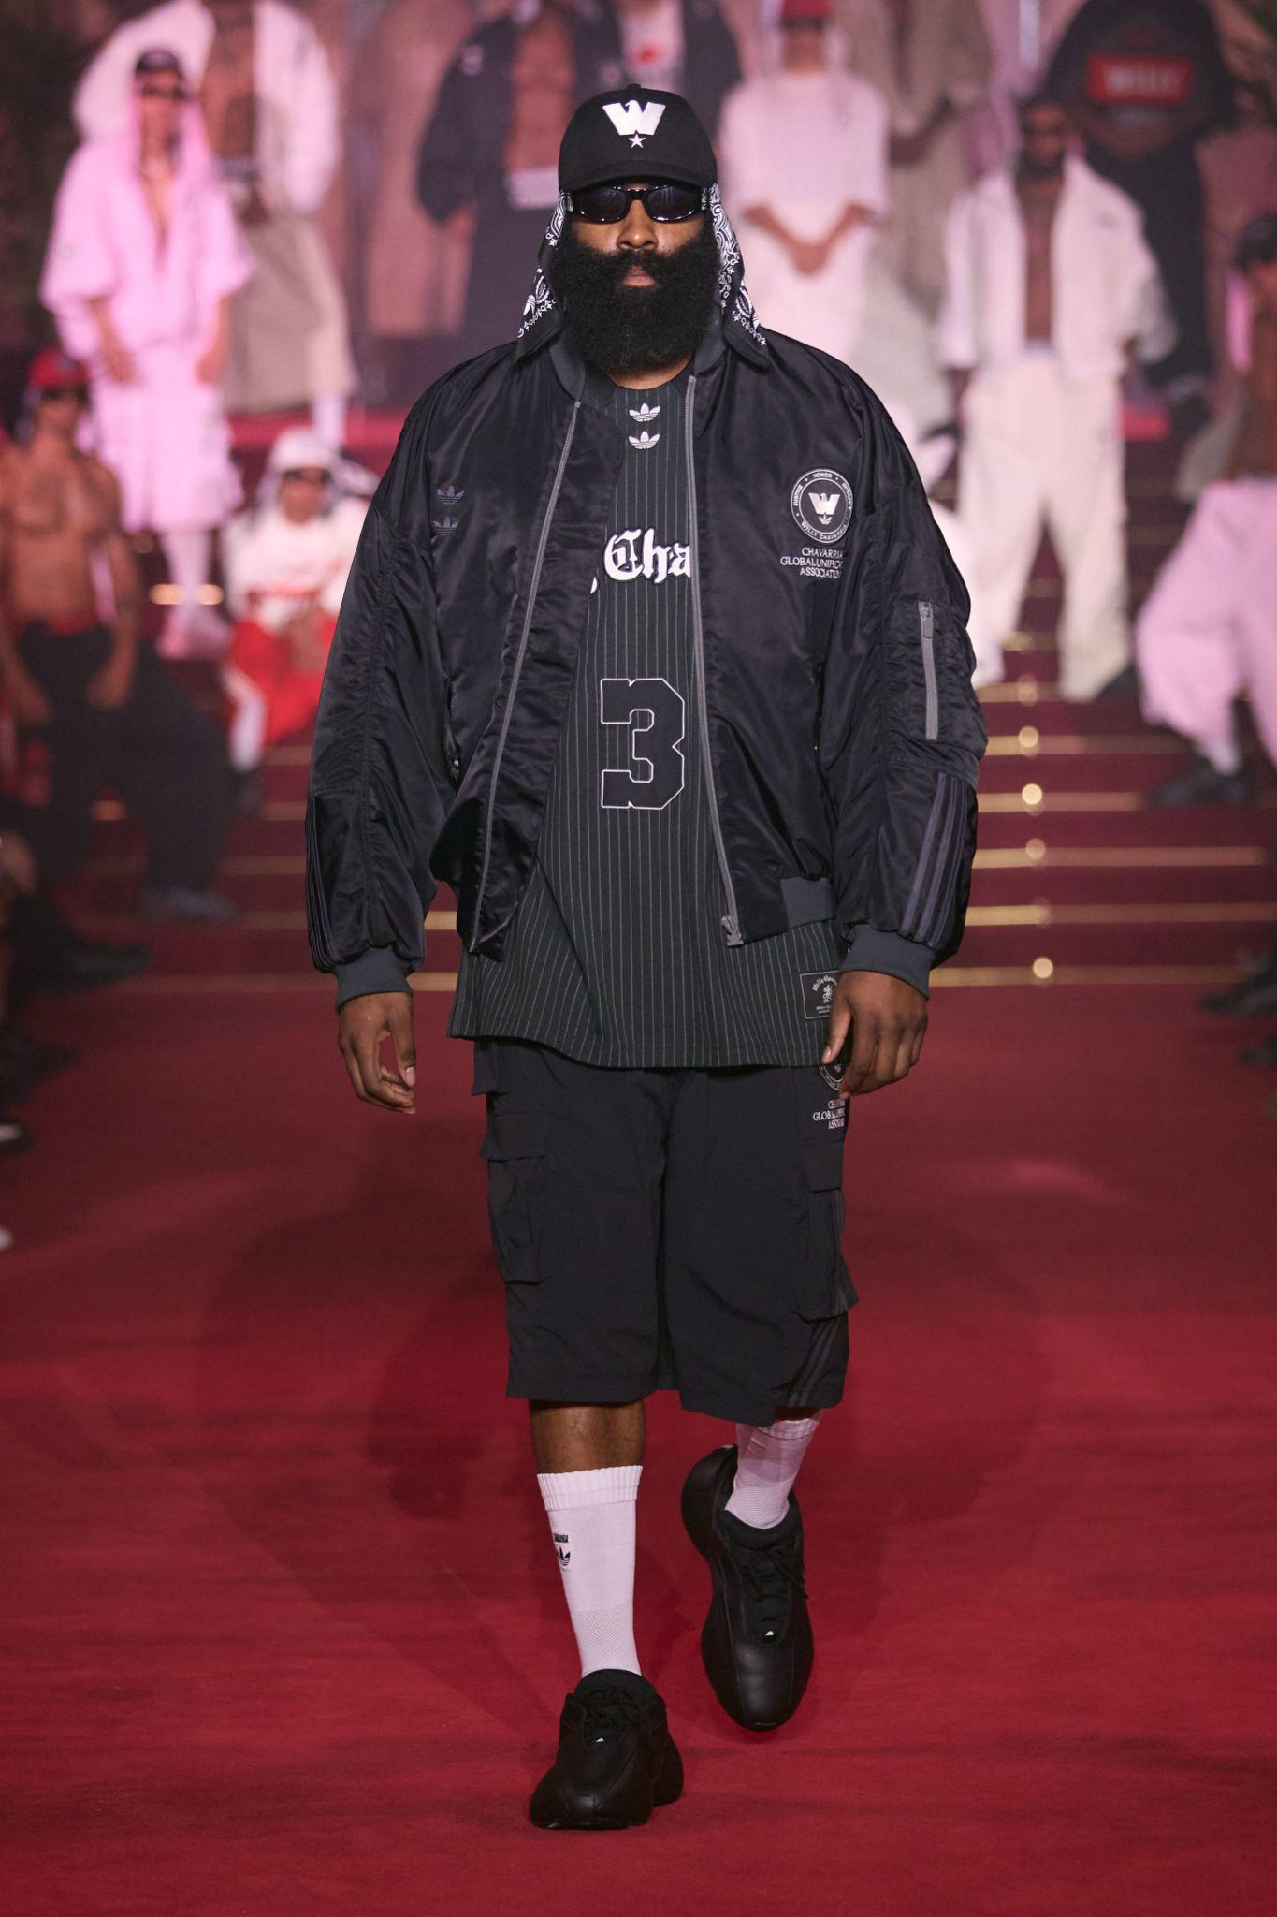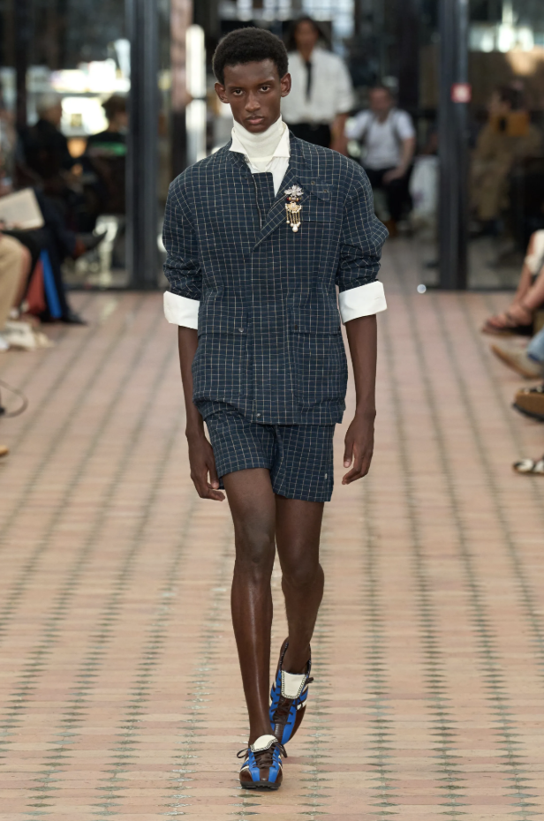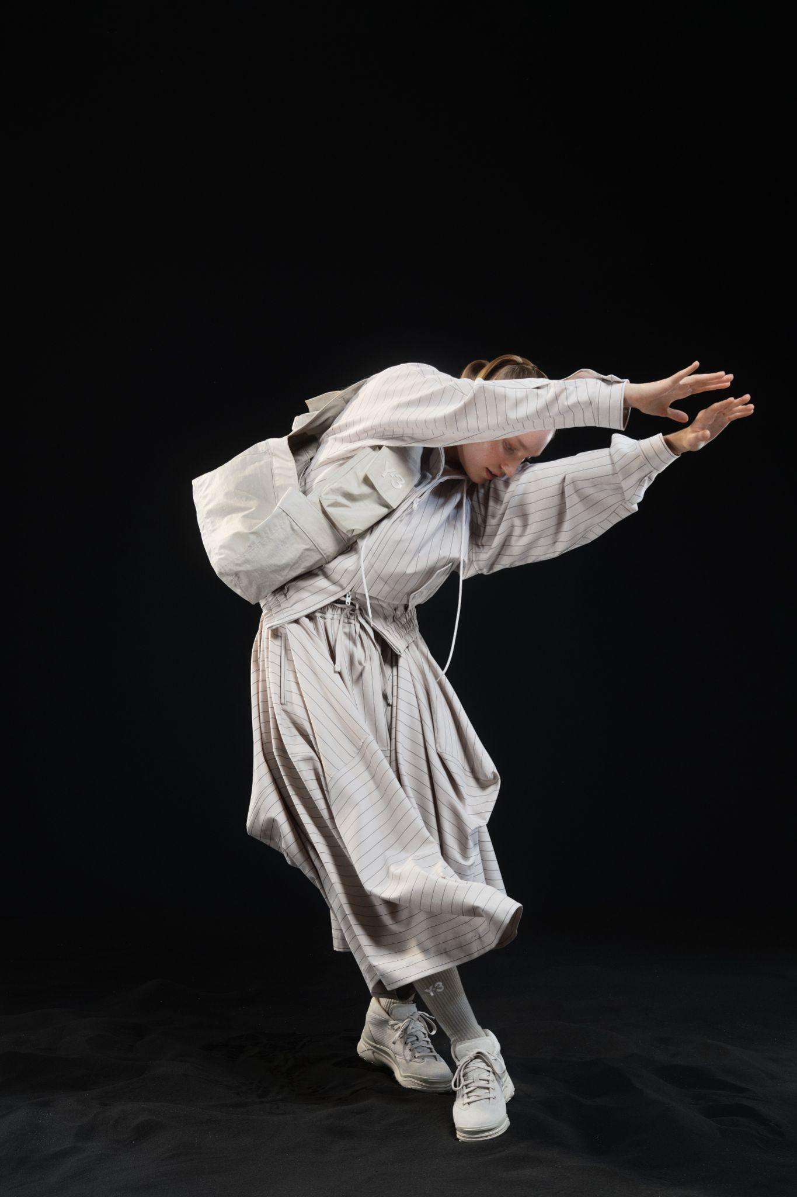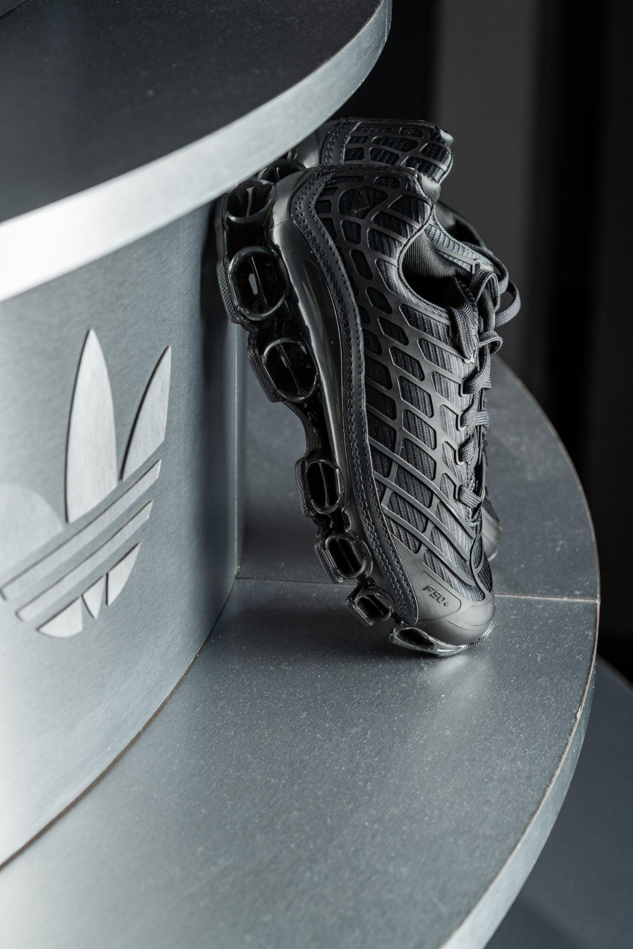

**Herzogenaurach, June 30, 2025** – Since adidas’ inception, football has been intertwined with the brand’s story, and for the past several decades, the sport’s influence has transcended the pitch – becoming a creative muse on the streets, on the runway, and deep in the archive. A global language of passion, movement, identity, and expression: as the brand continues to innovate for the world’s leading athletes in the realm of performance gear, **adidas Originals** celebrates football culture outside the stadium, in the streets, and at the after parties.

During Paris Fashion Week Men’s SS26, the brand showcased its storied past in the game with a display brought directly from the brand’s archive in Germany, alongside a first look at how the Three Stripes’ designers and collaborators (**Willy Chavarria, Wales Bonner, and Y-3**) are bringing football style codes to the streets for the coming season – including a reveal of the exclusive **F50 MEGARIDE** silhouette and upcoming collaborations continuing to advance football style.

**The Past:**

Helping to tell this story, adidas Originals’ hosted an exclusive **exhibition of the brand’s archival football products** in Paris. A rare experience outside of the brand’s HQ in Germany, adidas Historian Sandra Trapp hosted private explanatory tours through the archival exhibition, with guests invited to use the now-iconic white ‘adidas archive’ gloves to handle select pieces.

The exhibition itself is opened with two FIFA World CupTM balls, the Questra from 1994 and the Teamgeist from 2006. These two footballs symbolise two important eras for adidas. 1994 being the last time the tournament was hosted in the USA and also representative of the testing grounds for nascent streetwear brands, skate culture, and so many music genres. 2006, meanwhile, was the last time the World Cup was hosted in Germany, adidas’ home country. Equally, it represents the peak of Y2K style and culture, with key pieces from the era – from **F50 to MEGARIDE** – being the cornerstones of moodboards today.

Elsewhere, the exhibition consists of products that have gone onto inspire the upcoming offering from the Trefoil including: the Argentinian Boot (1954), the Predator Cup boot (1994), the Predator Accelerator Boot (1998), the Predator Precision Boot (2000), the a 3 Megaride sneaker (2004), the F50 TRX FG boot (2004), the F50+ XTRX FG boot (2005), the F50 YY Tunit Tiger boot (2006), the Predator Absolute boot in Gold (2006), and the F50 adiZero TRX SG Chameleon boot (2010).

**The Future:**

Unveiled as the focal point of the new football inspired offering is the **F50 MEGARIDE**. Bringing one of the brand’s most iconic football boot franchises – **the F50+ XTRX FG** – together with the legendary a**3 MEGARIDE** running tooling, the new silhouette is a bold projection of street style, inspired by yesterday, built for tomorrow.

adidas Originals also offered a look into the future of football style, as envisioned by an unparalleled roster of creative collaborators, with stories shaped by the likes of **Willy Chavarria, Grace Wales Bonner, Yohji Yamamoto (Y-3), Brain Dead, Avavav**, and more.

**The Present:**

Alongside the product showcase and archival exhibition, adidas Originals’ exploration of football’s enduring cross cultural influence continues with a sonic experience curated by **Jah Jah** and friends. Conceptualised as a monument to sound and sport, a sculpture – which takes inspiration from the iconic and ubiquitous steel bleachers found near football pitches worldwide – features 150 vinyl records and 34 speakers. As guests experienced adidas’ archive and received custom product seeding, a chorus of music envelops the space in sound, providing a rhythmic pulse of connection as if in a football stadium.

Throughout the weekend, adidas partners including model **Paloma Elsesser**, rapper **Lancey Foux**, footballer **Myles Lewis-Skelly**, and more stopped by the adidas Originals showroom. Positioned within the brand space was a **Chamberlain Coffee** booth serving signature cold brews and specialty drinks from adidas partner **Emma Chamberlain**, in addition to gifted **Wildflower phone cases** from partner **Devon Lee Carlson**. A lunch spread from **Jah Jah**, Paris’ beloved plant-based Caribbean canteen, rounded out the immersive experience with vibrant, flavorful dishes that celebrated creativity and community.

Outside of the showroom, adidas extended the brand narrative with additional touchpoints across the city — blending sport, style, soccer, and fashion in unexpected ways that invited the city to experience the energy of the brand beyond the official spaces.

On June 25th, British designer and adidas partner **Grace Wales Bonner** unveiled a new collaboration with adidas Y‑3, showcased during her SS26 runway show. The revived field shoe was showcased in a metallic copper and brown, featuring mismatched Three Stripes and retro-inspired detailing.

On June 27th, New York designer **Willy Chavarria** premiered “**HURON**,” in collaboration with adidas Originals, setting the tone for a powerful exploration of Mexican-American identity, belonging, and redefined masculinity. The show opened with NBA athlete and adidas partner **James Harden**, showcasing this season’s new collaborative pieces. The collection featured oversized sportswear and gravity-defying silhouettes, stealing hearts with Chavarria’s bold take on adidas’ Megaride: both **Megaride XL** and **Megaride AG** appeared in chunky, tech-forward forms.

To continue celebrations following the show, Willy Chavarria and adidas hosted an intimate cocktail hour, followed by an electric afterparty with music from **Honey Dijon**, and attendance from **James Harden, Becky G, Jerry Lorenzo, Gigi Goode, Sevdaliza, Maria Bottle**, and more. Downloadable assets [here](https://bfa.com/events/50384/share/ee053ba9df341e) and [here](https://bfa.com/events/50382/share/6d039897e6cf19).

Closing out the week for adidas was a distinct **Y‑3** presentation on June 28th, where adidas Originals unveiled its own version of the **Megaride** silhouette under the **Yohji Yamamoto** imprint. The collaboration gave the chunky, maximalist sole its high-fashion moment at PFW, blurring distinctions between runway concept and street-ready design. The presentation was staged as an experimental dance performance, with performers moving in fluid, sculptural formations to highlight the interplay of movement and style.

Through this dynamic, multifaceted presence in Paris, adidas Originals reaffirmed its position at the intersection of sport, style, and culture — showcasing the timeless influence of football beyond the pitch. By bridging archival heritage with contemporary collaborations and future-forward design, adidas continues to redefine what football means today: not just a game, but a global language of creativity and self-expression.

###

**Credits**

Design by PLAYLAB, INC.

Produced by Broadwick

Sound and Food by Jah Jah

Coffee by Chamberlain Coffee

Wildflower Cases by Devon Lee Carlson

**PR Contacts**

Belle Ross | [belle@pitchblend.com](mailto:belle@pitchblend.com)

Sarah Bronilla | [sarah@pitchblend.com](mailto:sarah@pitchblend.com)

**About adidas Originals**

Inspired by the rich sporting heritage of adidas - one of the world’s leading sports brands and a global designer and developer of athletic footwear and apparel - adidas Originals is a lifestyle brand founded in 2001. With the adidas archive at its foundation, adidas Originals continues to evolve the brand’s legacy through its commitment to product innovation and its ability to filter the creativity and courage found on the

courts and sporting arenas through the lens of contemporary youth culture. Marked by the iconic Trefoil logo that was first used in 1972 and championed by those that continue to shape and define creative culture, adidas Originals continues to lead the way as the pioneering sportswear brand for the street.