adidas and global superstars Lionel Messi and Patrick Mahomes push each other to new heights in brand’s latest You Got This campaign film
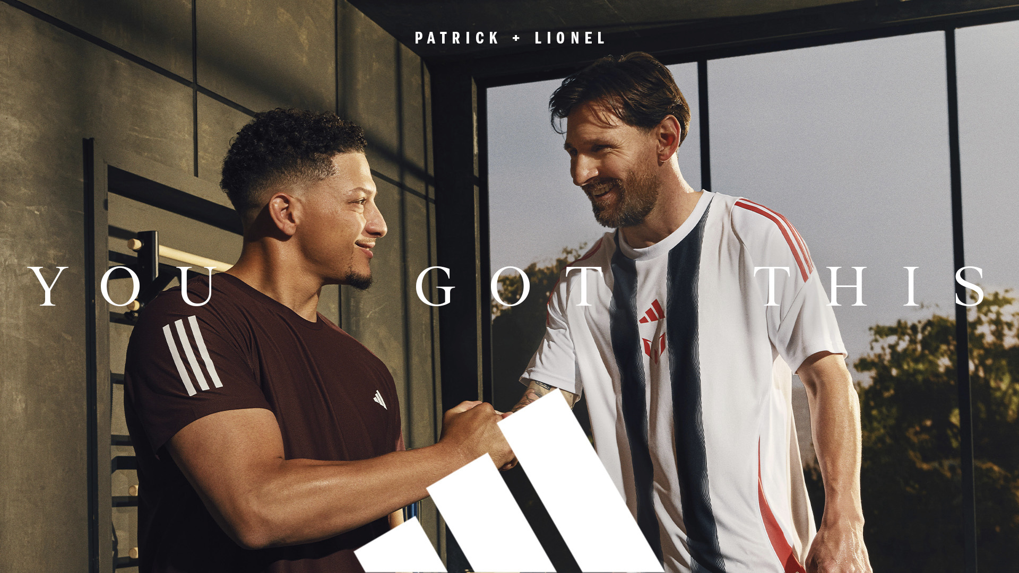
What happens when you pin two of the most competitive global superstars in sport — Lionel Messi and Patrick Mahomes — against each other in a head-to-head workout? They elevate each other’s performance to new heights.

Fans will see this iconic collaboration brought to life in the latest adidas film released today, which is part of the brand’s global campaign, You Got This. In the film, Messi and Mahomes, two adidas partners, raise the stakes in a battle of speed on the treadmill. Centered around the campaign’s belief that we all need someone to make us believe, the film shows that no matter how great you are, you can always raise your game further through the encouragement of your peers.

“Whenever I am on the pitch, whether for my club or my country, I feel a deep responsibility to give my best,” said Lionel Messi. “Patrick and I come from two different worlds of football, but the passion is the same. Knowing people everywhere are watching and believing in us drives everything we do. The support from fans around the world is más que palabras, more than words, and we hope it inspires everyone to lift each other up.”

As the campaign film opens, Antonela Roccuzzo and Brittany Mahomes are seen working out alongside a pair of treadmills occupied by Messi and Mahomes. Their steady pace is disrupted by Messi, who first pushes Mahomes’ speed up a few notches.
As the film continues, Messi and Mahomes keep challenging each other to go faster, to push harder — before the film concludes with the two playfully batting each other’s hands away from the speed controls as they bond over their competitive spirit.
“In sports, as in anything that you are passionate about, the work never stops,” said Mahomes. “But nobody succeeds alone. You need people who believe in you and who challenge you to be better. It was an honor to team up with Leo for this campaign. It’s a reminder that we achieve more together than we ever could alone.”
The film was directed by Ryan Booth, with Mark Fitzloff and Rob Palmer overseeing the creative direction. The film is available on adidas social channels today and will be aired across broadcast channels throughout the rest of 2025.
Find out more at adidas.com/yougotthis.
###
About adidas:
adidas is a global leader in the sporting goods industry. Headquartered in Herzogenaurach/Germany, the company employs more than 62,000 people across the globe and generated sales of €23.7 billion in 2024.

