ADIDAS LAUNCHES NEW ADIZERO BOSTON 13 – DESIGNED FOR FAST TRAINING RUNS

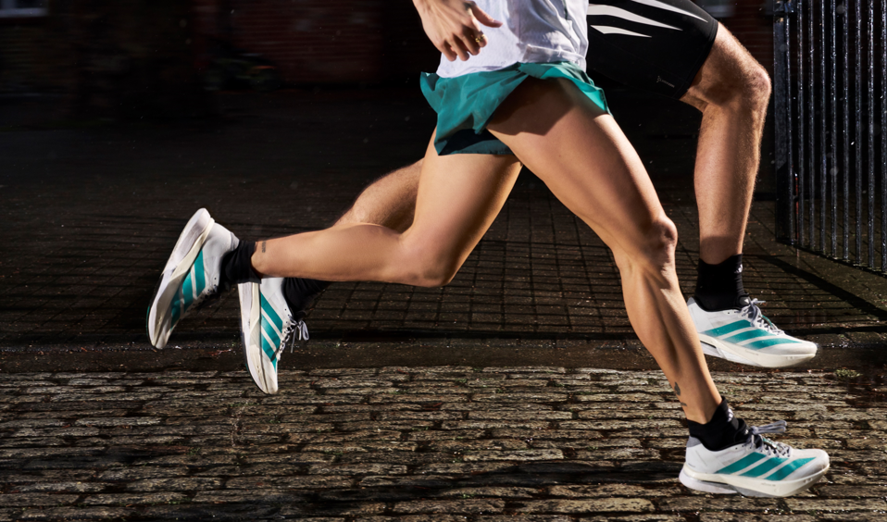

- The new Adizero Boston 13 – the pinnacle training shoe in the Adizero franchise – is updated with 13.8% more Lightstrike Pro midsole foam compared to its predecessor – resulting in a softer and more comfortable underfoot feeling
- Ahead of the Boston Marathon, a special edition of the Adizero Boston 13 launches in the EQT (Equipment) colorway, as part of a wider Boston Marathon pack consisting of apparel, accessories and footwear. The drop is inspired by vintage adidas equipment designs and colorways of Boston Marathon staff uniforms from 1991
- The Adizero Boston EQT footwear and apparel pack will be available from May 5, 2025 in-store, on adidas.com and via the adidas flagship app, with additional colorways of the Adizero Boston 13 available from June 4, 2025

Herzogenaurach, April 18, 2025 – Today, adidas introduces the Adizero Boston 13 – the latest addition to adidas’ speed-focused running family. Designed to provide consistent speed for fast workouts and tempo runs, the Adizero Boston 13 is the perfect training accompaniment to those who race in the Adizero Adios Pro 4.

First introduced in 1980, the Boston has become an iconic model with a rich history in performance running. Now on its 13th iteration, the Adizero Boston features adidas’ latest technologies, whilst staying true to its heritage – a symbol of adidas’ lasting commitment to help runners chase their fastest times in training.

The latest model in the Adizero Boston range is another example of adidas’ continued commitment to create the best products with and for athletes. Alongside its signature ENERGYRODS 2.0 and engineered mesh upper, key technology and design updates to the model include:

- INCREASED LIGHTSTRIKE PRO: 13.8% more Lightstrike Pro foam makes the midsole softer and more comfortable than its predecessor.
- ENHANCED COMFORT: Tuned with a padded tongue and collar, the shoe provides a more comfortable feeling for runners on top of the foot compared to the previous model.
- LIGHTTRAXION OUTSOLE: New for Adizero Boston models – and first seen in the marathon racer Adizero Adios Pro 4 – the LIGHTTRAXION patterned outsole construction is designed to reduce weight without sacrificing grip, by strategically placing it where it is needed the most.

Charlotte Heidmann, Global Category Director Running Footwear at adidas, says: “When creating the new Boston 13 model, we wanted to build the ultimate fast trainer. We gathered athlete and consumer feedback from the Boston 12, which revealed that they wanted more comfort from the shoe – taking it back to the USP of the original Boston. The design and development of the new model was informed by these insights, with improvements made to the cushioning in the midsole and upper to provide a softer feeling for runners moving at speed.”

Premiering ahead of the Boston Marathon weekend, the Adizero Boston 13 launches as an EQT edition as part of a wider head-to-toe collection of apparel and accessories. All pieces come in a set of retro teal, white and black colorways, inspired by the shades and designs of vintage adidas Equipment pieces from the brand’s archive, as seen on Boston Marathon staff uniforms from 1991. The Adizero Boston EQT pack includes the Adizero Archive Running Singlet for men and women, the Adizero Archive Running Gel Shorts for women and Adizero Archive Running Short Leggings for men, with the Adizero Archive Running Jacket completing the look.

The Adizero Boston 13 EQT – coming in a FTWR White and Pure Teal colorway – and Adizero Boston 13 – in a Semi Flash Aqua, Flash Aqua and Lucid Lemon colorway – will both cost €160 / $160, with the Boston EQT pack apparel ranging from €50 / $50 to €130 / $130. The Adizero Boston EQT footwear and apparel pack will be available from May 5, 2025 in-store, on adidas.com and via the adidas flagship app, with additional colorways of the Adizero Boston 13 available from June 4, 2025.

Follow the conversation on Instagram and X/Twitter using #Adizero Boston 13 and @adidasrunning.

