
ADIDAS TEAMS UP WITH MARVEL STUDIOS’ “DEADPOOL & WOLVERINE” TO REVEAL EXCLUSIVE COLLECTION IN CELEBRATION OF THE FILM’S RELEASE
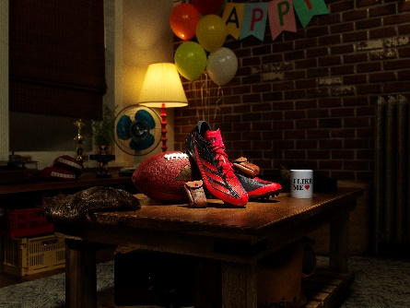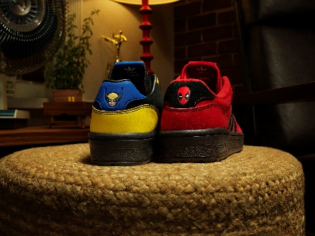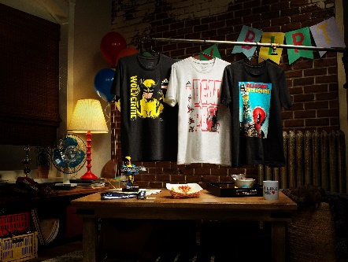
- This is the first Deadpool-inspired collection from adidas combining adidas Originals and performance product featured in and inspired by the franchise’s third film releasing July 26.
- The adidas | Marvel Studios’ Deadpool & Wolverine collection will be available to purchase in select markets from August 1.
PORTLAND, Ore. (July 18, 2024) – Today, adidas unveiled an exclusive collection to celebrate the theatrical release of Marvel Studios’ “Deadpool & Wolverine”, in U.S. theaters July 26. The collection features a combination of adidas Originals and performance footwear and apparel featured in and inspired by the third film in the iconic franchise, starring Ryan Reynolds and Hugh Jackman.
This is the first Deadpool-inspired adidas collection featuring a combination of adidas Originals and performance product which consists of two themed Rivalry Low shoes, an adizero Electric cleat, graphic tees and an adidas Originals silhouette worn in the film which will be unveiled July 26 once the film hits theaters.
The collection embodies unmistakable color blocking and distinct detailing of Deadpool and Wolverine’s iconic characters, including tongue-and-cheek jokes on sock liners, censored language characters, and storage pouches on the Deadpool-inspired Rivalry Low and adizero Electric cleat—nodding to the seemingly excessive amount of pouches the ‘Merc with a Mouth’ keeps on his costume. The Wolverine-inspired Rivalry Low includes color blocking as homage to the classic yellow Wolverine Super Hero suit, which will make its in-film debut.
Shane Jochum, senior director NAM strategic partnerships at adidas, said: “Bringing together these iconic franchises with Marvel Studios’ ‘Deadpool & Wolverine’ has been an exciting collaborative journey. Our relationship with Marvel and its fans continues to unlock opportunities for us as a brand to develop products to be used in films and worn by fans as they celebrate the launches of highly anticipated films. We’re excited for fans to get their hands on this collection and see it come to life in the film this summer.”
The collection builds upon adidas’ relationship with Marvel for several years, which has produced other collections and costuming such as "Black Panther: Wakanda Forever".
The adidas | Marvel Studios’ Deadpool & Wolverine collection will be available to purchase in select markets from August 1 via the adidas app, online, in stores and selected retailers.
For further information, please visit adidas.com/us/marvel or follow @adidas on TikTok and @adidasFBallUS on X and Instagram to join the conversation.
About adidas
adidas is a global leader in the sporting goods industry. Headquartered in Herzogenaurach/Germany, the company employs more than 59,000 people across the globe and generated sales of € 22.5 billion in 2022.
About Marvel Studios’ “Deadpool & Wolverine”
Marvel Studios’ “Deadpool & Wolverine” delivers the ultimate, team-up throwdown on July 26.

Shawn Levy directs “Deadpool & Wolverine,” which stars Ryan Reynolds, Hugh Jackman, Emma Corrin, Morena Baccarin, Rob Delaney, Leslie Uggams, Karan Soni, and Matthew Macfadyen.

Kevin Feige, Ryan Reynolds, Shawn Levy and Lauren Shuler Donner produce with Louis D’Esposito, Wendy Jacobson, George Dewey, Mary McLaglen, Josh McLaglen, Rhett Reese, Paul Wernick and Simon Kinberg serving as executive producers.

Marvel Studios’ “Deadpool & Wolverine” is written by Ryan Reynolds & Rhett Reese & Paul Wernick & Zeb Wells & Shawn Levy.

