ADIDAS UNVEILS NEW ULTRABOOST 5 – BUILT TO PROVIDE THE MOST ENERGY RETURN YET
- The revolutionised silhouette – created to energise the everyday run – marks the biggest redesign of the franchise since 2015 debut
- Built for a generation of runners looking to maximise energy, the shoe offers an all-new Boost midsole and revamped upper
- Ultraboost 5 is available in-store and online via [markets to insert local SEO link*], from July 18th, with Early Access for members of the adidas adiClub from July 11th

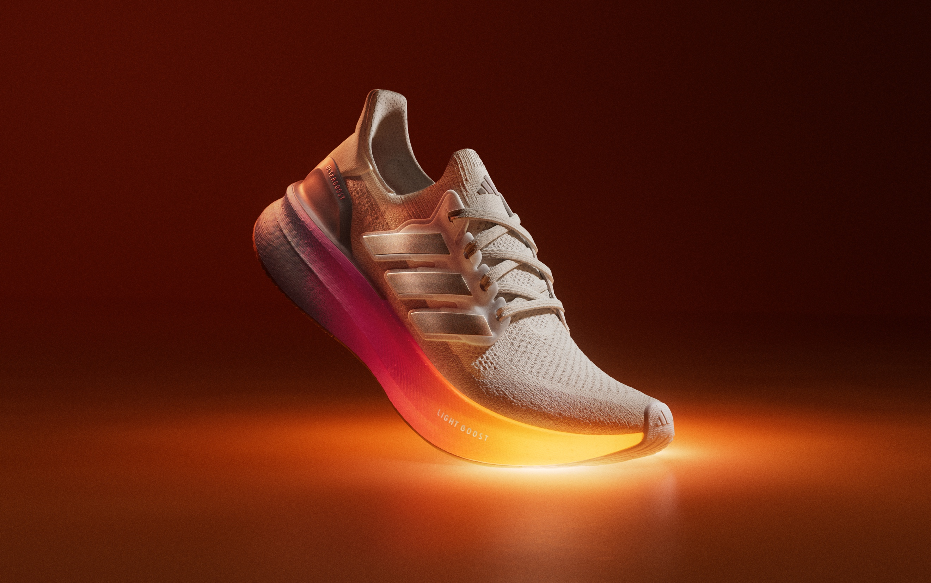

Herzogenaurach, 11th July, 2024 – Today, adidas unveils the Ultraboost 5. Redesigned from the ground up, it gives runners the highest energy return yet* thanks to a new midsole construction that offers 9mm more Boost.
The shoe is built for those looking to get more out of their run, and to understand runners’ relationship to energy adidas commissioned research which revealed that one in five 18–24-year-olds (21%) cite their energy levels as their biggest concern right now.
Dr Eliza Filby, Historian of Generational Evolution, who led the research, says: “The next generation is under a lot of pressure, burnt out, feels disorientated at the state of the world and there are so many demands on their energy and time. When it comes to making a choice about what they focus on, physical exercise like running can often be one of the first things to go. 60% of those who don’t dedicate as much time as they’d like to sport, mention a lack of energy as the main reason, despite the positive endorphins it releases.”
For those looking for more energy from their runs, adidas has designed the Ultraboost 5, which uses a re-engineered LIGHT BOOST™ midsole packed with 9mm more foam under the heel and forefoot which allows for reduced weight, higher cushioning and 2% more forefoot energy return than the Ultraboost Light 1. How? The Boost-packed midsole, which offers higher responsiveness and cushioning in the heel and in transition instantly bounces back to its original shape as a runner’s foot hits the ground, allowing them to go further while expending the same amount of energy.
And, thanks to a new adaptive Primeknit upper, it offers adaptability and enhanced fit in key zones, maximising breathability where possible to make sure the foot is cool each step of the way.
“The Ultraboost is a true running icon and this is our best yet” says Simon Lockett, Footwear Product Marketing Category Director, at adidas. “82% of people that have tested it say they prefer its energy return to their own shoes, and 70% say they had more fun while running wearing it. That’s always been the superpower of Ultraboost, especially now it’s back with more Boost, and a lighter weight than ever before.”
To keep the energy going, adidas has collaborated with nutritionist and adidas Runners Captain, Kiara Mayo, to create top energy-rich recipes, built to give runners that much-needed pre-run and post-run boost, as well as launching an exclusive content series where running leaders from around the world – including German fashion blogger and model Caro Daur, Mexican online personality Juan Bertheau and Brazilian social media personality, model, and influencer Jade Picon – share their mood-boosting essentials.
The Ultraboost 5 launches for both men and women in a white and grey base with expressive ‘Spark Orange’ and ‘Lucid Pink’ colour pops to represent the burst of energy the shoe unlocks. Available from €180, the Ultraboost 5 and the Ultraboost 5X are available in-store and online at adidas.com/running-shoes, with Early Access for members of the adidas adiClub from today.
To find out more, please visit: adidas.com/running-shoes. Follow the conversation on Instagram, TikTok and X using #ULTRABOOST @adidasrunning.

*The Ultraboost 5 gives the highest energy return of any previous silhouette in the Ultraboost family yet. Survey of 2,348 18-24-year-olds globally across 9 markets (UK, US, UAE, Mexico, France, Germany, China, Japan and South Korea) via Focaldata between 31st May to 4th June 2024.
adidas conducted a study in London of 307 runners from 35 countries*. This survey unveiled that when compared to their own running shoe, the majority (82%) preferred the energy return of the Ultraboost 5 whilst seven out of 10 said they had more fun running in the shoe.

