ADIDAS ANNOUNCES SECOND YEAR OF MOVE FOR THE PLANET - FUNDING PROJECTS IN AREAS IMPACTED BY EXTREME WEATHER CONDITIONS AROUND THE WORLD
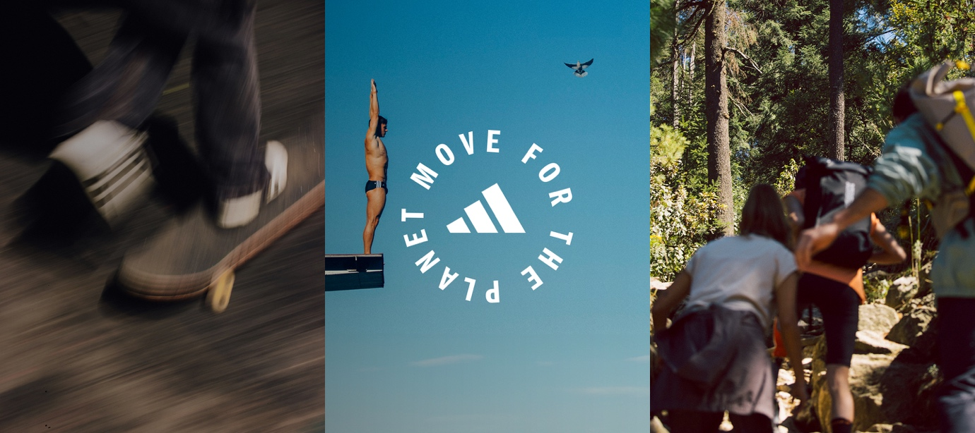
- For every ten minutes of movement logged by users on the adidas Running App, adidas is pledging to donate €1 – up to €1.5 million – between 10th and 22nd May.
- Users can log time against over 100 sports including the likes of Handball, Zumba Fitness, Padel and many more.
- Partnerships with Common Goal and the UN Climate Change Sports for Climate Action to support projects that offer sustainability education and help to make sports facilities more resilient against extreme weather
Herzogenaurach, May 2, 2024 – Today, adidas announces the return of Move For The Planet – its global initiative harnessing collective movement to create collective impact. adidas is calling on all athletes at every level across the world to track their physical activity across a variety of sports to raise money for projects in areas impacted by heat waves, flooding, and other extreme weather conditions.
Extreme weather conditions are having an increasing impact on the places people play and practice sport. From the neighbourhood pitches to global sports venues. Statistics reveal that by 2050, almost one-fourth of the English football league team's stadiums (23 out of 92) are projected to be partially or completely flooded every year. Further research by the UN states that approximately half of former Winter Olympic host cities will likely be unable to host future games in the same timeframe.
In 2023, over a million people took part in the first year of Move For The Planet, with the leading activities for minutes recorded including running (63.1%), walking (17.9%) and cycling (9.2%). This year adidas has expanded the initiative to include over 100 sports including Football, Kayaking, Jump Rope, Powerlifting and many more.
In 2024, for every ten minutes of movement logged on the adidas Running App between 10th – 22nd May, adidas will donate €1 – up to a total of €1.5 million. These funds will be used to help create real world change, through education on sustainability and the enhancement of facilities to make them more resilient against extreme weather conditions.
Ashley Czarnowski, Senior Director, Global Purpose Marketing at adidas said: “We’re excited to build on the success of the first year of Move for The Planet, which brought together a community of over one million people across the world.
This year people can record movement in over 100 sports and we are expanding the impact of the programme to include a new set of projects and initiatives. Whether it’s taking part at the grassroots or competing at the highest level, we all have a deep connection to the places we play. Together we can unite as a global sporting community to help some of those places, by making sports facilities more resilient to extreme weather conditions and providing education on sustainability.”
Common Goal is a global impact movement that aims to shift society towards a more sustainable and equitable future through sport - who unite Community organisations, athletes, clubs, brands and other stakeholders to collaborate towards the wellbeing of our people and planet.
Olivia Baston-Pitt, Senior Impact Sponsorship Manager at Common Goal said: "We’re thrilled that the Move For The Planet initiative is back for a second year. The success of last year meant we were able to increase the accessibility of sport for individuals who haven’t always had that privilege.
Take the Cancha Violeta sports space in San Pedro Xalostoc, Mexico, where we were able to support the installation of a brand-new multi-sport pitch and a drainage programme that collects water for the neighbouring grass pitch and garden.
Alongside Common Goal, adidas will also be supporting UN Climate Change – Sports for Climate Action to develop a series of training modules for sports and NGOs operating in the nexus of sport and development. The UN Climate Change is the United Nations entity tasked with supporting the global response to the threat of climate change. The partnership is centered on using sport to educate and engage communities on climate-related topics and sustainable practices.
The funds created by Move For The Planet will go towards creating publicly accessible training materials as well as the hosting of training sessions with networks of NGOs and other organisations to enable them to transform communities in the service of future for sport on a thriving planet.
For more information on how to join in or for more on the initiative itself, please visit adidas.com/movefortheplanet.

-ENDS-
ABOUT ADIDAS
adidas is a global leader in the sporting goods industry. Headquartered in Herzogenaurach/Germany, the company employs more than 59,000 people across the globe and generated sales of € 22.5 billion in 2022.

ABOUT COMMON GOAL
Common Goal is a global impact movement for the world of sport, rooted in the belief that the world’s most popular sport is one of the few cultural forces strong enough to help shift society towards a more sustainable and equitable future for all.
The movement unites organisations, athletes, clubs, brands and other stakeholders in football to radically collaborate towards the wellbeing of our people and planet. To do so, Common Goal develops impact solutions to tackle humanity’s biggest challenges and provides opportunities for everyone that is part of the football community to contribute.
Common Goal is a movement for those who love football and want the game to be the best version of itself, driving positive transformation within the game and inspiring everyone to work together towards a better future for all.

