FOURTH EDITION OF ADIDAS RACE EVENT: WORLD-CLASS ATHLETES GEAR UP FOR ADIZERO: ROAD TO RECORDS SHOWDOWN ON CAMPUS IN HERZOGENAURACH

Herzogenaurach, March 27th, 2024: Today, adidas Running announces an all-star line-up of athletes, new race distances and speed-focused course updates for the fourth edition of its annual Adizero: Road to Records event, held at the brand’s headquarters in Herzogenaurach, Germany on April 27, 2024.

Renowned for bringing top-tier athletes from across the globe, this year’s line-up brings 120 world class adidas athletes from 26 countries to compete in the newly-established 800m and 1 mile races, as well as the 5K and 10K. The races will take place on a specially designed course around the adidas World of Sports campus, with the aim of pushing the limits of speed. Among the confirmed participants is the current 10KM world record holder Agnes Ngetich of Kenya, former 5KM world record holder Senbere Teferi of Ethiopia, Yomif Kejelcha of Ethiopia, Jacob Krop of Kenya and 1-mile WR holder Hobbs Kessler of United States.

The elite race course has been updated to be entirely run on tarmac for the first time to make it even faster for the athletes. With each lap spanning just over 1.3km in distance around iconic adidas campus buildings, including Laces, Halftime and Arena for the finish line, the course is set to be a visual spectacle for both athletes and spectators alike. Viewers from around the world will be able to watch the action unfold via the live stream on the adidas Running YouTube channel.

Following the conclusion of the elite races, there will be an Adizero: Road to Records 5k Run available for public participation, welcoming adidas employees, partners, adidas Runners and members of the public.

"For athletes and running fans alike, the 4th iteration of the event is more than just a day of racing; it's a celebration of sports, athletes and the unyielding spirit of competition at the heart of our brand," said Alberto Uncini Manganelli, General Manager Running & Credibility Sports at adidas. "This event showcases the pinnacle of athleticism and our everyday commitment to creating the best products to support our athletes on their journeys, and I'm honored to be a part of it."

This year, for the first time, adidas has created a limited-edition Adizero: Road to Records race pack, which all athletes will be wearing on race day in honor of the late Agnes Tirop of Kenya. The race kit includes 8-pieces of Adizero apparel and footwear – special editions of the Adizero Takumi Sen 10 and Adizero Adios Pro 3, as well as crop-tops, shorts and singlets. The leopard print designs and bright colorways are inspired by the race kit Agnes wore at Adizero: Road to Records in 2021, where she broke the women-only 10K world record.

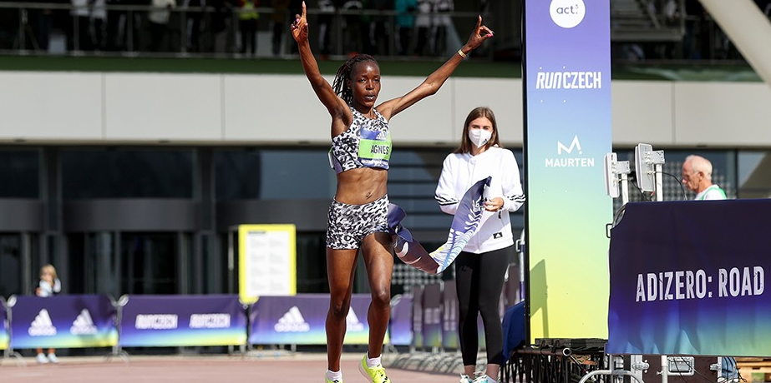
The late Agnes Tirop pictured winning the women’s 10K race and breaking the women-only world record at Adizero: Road to Records in 2021

The race pack was designed with the ambition to raise awareness for the issue of gender-based violence against women and to keep Agnes’ legacy alive, with a portion of the proceeds going to Tirop’s Angels – an organization set up by family members, fellow athletes and friends of Agnes following her tragic death in 2021.

Runners looking to get their hands on the Adizero: Road to Records race pack can buy select pieces via the app, online and in specialist stores from March 27, 2024. To find out more please visit: www.adidas.com/adizero. Follow the conversation on Instagram, Facebook and Twitter using #RoadToRecords and @adidasrunning.

