adidas Partners with Hailey Van Lith to Inspire Student-Athletes on Overcoming Pressure, Shares Update on Historic NIL Ambassador Network
- adidas unveils next chapter of its global brand campaign in partnership with college basketball phenom Hailey Van Lith.
- Brand shares update on historic NIL Ambassador Network, including news that over 12,000 student-athletes have participated.
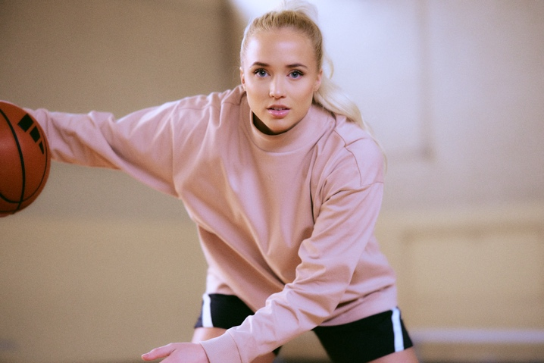
Ahead of one of the most exciting events in sport, adidas today released its newest commercial with partner Hailey Van Lith, amplifying the brand’s recent campaign around helping elite and grassroots athletes disarm pressure and return to the love and joy of sport.
“As athletes navigate high-stake sport moments throughout their careers, it can be difficult to cope with the weight of expectations. Our focus is helping these athletes re-capture the joy they have playing sports,” said adidas Senior Vice President of Brand Marketing Chris Murphy. “In partnership with Hailey Van Lith, we’re inspiring the next generation of athletes, and helping them get back to why they started playing sports in the first place – to have fun.”
adidas officially unveiled this ambition last month uniting a wide range of sporting icons including eight-time WNBA All-Star Nneka Ogwumike to demonstrate how the world’s best athletes manage pressure and inspire everyday athletes to do the same with the joyous rally cry - ‘You Got This’. As this year’s tournament, adidas is working with brand partner Hailey Van Lith to remind elite and everyday athletes to embrace the nature of sport as a game and play free. The commercial will air during both the Men’s and Women’s tournament across broadcast networks and social channels.
“Throughout my journey with the sport, I never shied away from a challenge and that’s made me the competitor I am today,” said star guard and adidas partner Hailey Van Lith. “Putting yourself in situations where you’re tested and proving that you can overcome internal or external pressure gives you confidence to play freely and lean into those competitive moments, like championship tournaments, with eagerness rather than fear. It's critical to remind yourself that you’ve navigated pressure before and just focus on being the player and teammate you know you can be.”
One of the keys to playing without pressure is empowering the athlete – on and off the court or field. This desire to empower athletes was at the core of adidas’ initial announcement of the NIL network in March 2022, which gives all student-athletes at adidas-partnered Division 1 schools the chance to benefit from their Name, Image and Likeness. Since its inception, over 12,000 student-athletes across a variety of sports have participated in the network, earning a percentage of the sales they drive for key products and campaigns. Notably, university programs across basketball, track & field, football, soccer, and baseball have the highest sport representation across the network. Throughout the upcoming tournament, the brand also will be engaging several NIL Network athletes across social channels to showcase their unique styles with adidas product and to share personal stories of how they overcame pressure.
The brand is seeing tangible results from the network, including millions of social media impressions driven by student-athletes and feedback from participants that the network is helpful in driving entrepreneurial growth. adidas will continue to invest and evolve the network based on insights gathered over the past two years. The brand also plans to visit university schools nationwide to educate student-athletes on growing NIL opportunities.
Building on recent signings, including University of Washington’s Rome Odunze and Michael Penix Jr. and four players from Overtime Elite, adidas recently welcomed Texas A&M Women's Basketball forward Janiah Barker to the three stripes family as the brand’s newest NIL athlete. Barker arrived at Texas A&M for the 2022-2023 season as a McDonald’s All-American Game Alumni and the No. 3 recruit in the country. Following a season that saw her named to the SEC All-Freshman team, Barker averages 12.2 points and 7.7 rebounds per game this season and played a key role in helping her team make it to the SEC Tournament quarterfinals.
In addition to the expansion of its NIL roster, adidas will continue to partner with its university partners and student-athletes to drive long-term equity in sport and create unique, innovative product.
Visit www.adidas.com/us/yougotthis to explore more about the campaign and stay tuned to instagram.com/adidas, instagram.com/adidasbasketball and tiktok.com/adidas for updates throughout the tournament.
--
Media Contact
Will Yeo
william.yeo@hillandknowlton.com

