ADIDAS UNVEILS FEDERATION KITS FOR AN UNFORGETTABLE SUMMER OF FOOTBALL IN AMERICA

- The Americas’ top teams get bold new kits that reimagine traditional elements with modern cultural identity for a new generation of fans and players
- Kit built to provide only the best for the athlete – featuring adidas technologies that keep players comfortable in moments of pressure
- The new collection is available from select retail stores and from 14th March at selected adidas retail stores

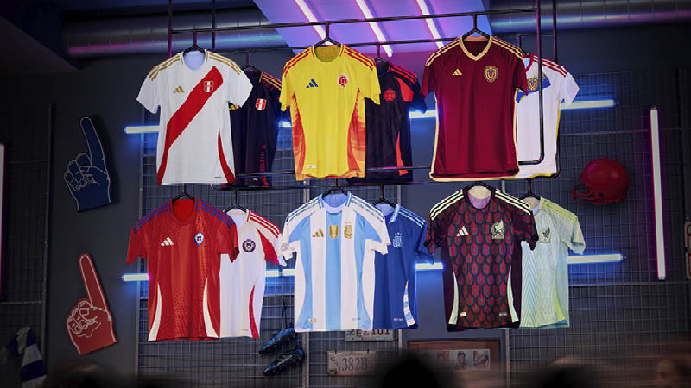
Herzogenaurach, March 14th, 2024 – Ahead of the largest international football tournament in the Americas, adidas unveils the latest series of technical performance kit for five of the most successful football teams in the world.
Today, fans and players of Argentina, Chile, Colombia, Mexico, and Peru, get their first view of the home and away jerseys to be worn this summer, whether on the pitch, in the stands or as part of a modern wardrobe. This latest launch adds to the already released Venezuela kits and will be complemented later in the year, with further releases to follow for the Jamaican and Costa Rican Federations.
Each of the home and away jerseys are built to inspire a sense of pride and belonging, blending traditional elements, with modern style to create something truly new for this next generation of players. Building on the canvas of the jersey - a symbol of hope and unity - the adidas design team focused on delivering something that gives an unexpected, and fresh perspective from what has come before, while remaining respectful and true to their football heritage.
These concepts are explored in different ways throughout the collection, including:
- Fresh application of national colours, and exploration into new bolder hues – as seen in the Chile away shirt which evokes tradition via a noble, white base colour – mirroring the snow found atop the Andres Mountains – which is ignited by a vibrant blue and red highlight to ignite La Roja’s passion ahead of the summer.
- Recoding traditional patterns and applying them in a fresh way, as with Mexico’s home and away kits, which are emblazoned with eye-catching folk-art patterns, representing the colourful and playful way those from Mexico see life.
- Introducing fresh symbols to traditional federation wear, as with the selection of a phoenix to proudly form part of Colombia’s home kit; a motif famously synonymous with fresh energy and transformation. The wings of the phoenix applied along the side panel of the jersey, hug the body to form a protective layer as players take on a fresh challenge at this summer’s tournament.
- Across the collection, a blend of dynamic shapes and colours express the jubilation and hope that fans and players share ahead of, and during, a major tournament.
Sam Handy, SVP of Product and Design at adidas said, “We are proud to present our new adidas federation jerseys - a fusion of artistry and innovation for a thrilling summer of football. Our goal was to create a collection that showcases the pinnacle of performance, while presenting designs that embrace the rich tapestry of each nation’s culture. We believe these kits will resonate with modern-day fans across the globe, encouraging a spirit of expressive freedom – both on the pitch and in the stands. It is a real honour for us to work with each of these federations, to create jerseys what we believe will unite everyone who wears them.”
Crafted for performance and to support world class players in high pressure moment, the lightweight jerseys have been created in close collaboration with each federation - featuring the latest in adidas performance benefits.
Each jersey includes either HEAT.RDY technology, optimized to keep players feeling comfortable, or AEROREADY technology, sweat-wicking or absorbent materials that keep players feeling dry. Lighter crests and additional mesh panels are also applied, helping improve airflow and comfort, to help players focus on the game at hand.
All adidas teams federation jersey will be available from March 14th via adidas.com and select retail stores.
- END -

NOTES TO EDITORS:
About adidas
adidas is a global leader in the sporting goods industry. Headquartered in Herzogenaurach/Germany, the company employs more than 59,000 people across the globe and generated sales of € 22.5 billion in 2022.

About adidas in Football
adidas is the global leader in football. It is the official supplier of the most important football tournaments in the world, such as the FIFA World Cup™, the FIFA Women’s World CupTM, the UEFA European Football ChampionshipTM, the UEFA Champions LeagueTM & the UEFA Women’s Champions LeagueTM. adidas also sponsors some of the world’s top clubs including Real Madrid, Manchester United, Arsenal, FC Bayern Munich & Juventus. Adidas is also partner to some of the best athletes in the game including Leo Messi, Jude Bellingham, Mohamed Salah, Pedri, Florian Wirtz, Alessia Russo, Paulo Dybala, Lena Oberdorf, Gabriel Jesus, Roberto Firmino, Joao Felix, Serge Gnabry, Manuel Neuer, Karim Benzema, Vivianne Miedema, Mary Fowler, and Wendie Renard.

Market SEO links:
NAM | adidas.com/us | https://www.adidas.com/us/soccer-jerseys
 | adidas.ca/en | https://www.adidas.ca/en/soccer-jerseys
 | adidas.ca/fr | https://www.adidas.ca/fr/soccer-maillots
LAM | adidas.com.ar | https://www.adidas.com.ar/argentina
 | adidas.cl | https://www.adidas.cl/chile
 | adidas.co | https://www.adidas.co/colombia
 | adidas.mx | https://www.adidas.mx/mexico
 | adidas.pe | https://www.adidas.pe/peru
 | adidas.com.br | https://www.adidas.com.br/camisas-homem-futebol
EU Big 6 | adidas.co.uk | https://www.adidas.co.uk/men-football-jerseys
 | adidas.de | https://www.adidas.de/manner-fussball-trikots
 | adidas.de/en | https://www.adidas.de/en/football-jerseys
 | adidas.fr | https://www.adidas.fr/maillots-football-hommes
 | adidas.it | https://www.adidas.it/maglie_da_divisa-calcio-uomo
 | adidas.es | https://www.adidas.es/camisetas_deportivas-futbol-hombre
 | adidas.nl | www.adidas.nl/heren-voetbal-sportshirts
EU | adidas.cz | https://www.adidas.cz/dresy-fotbal
 | adidas.dk | https://www.adidas.dk/fodbold-spillertrojer
 | adidas.at | https://www.adidas.at/fussball-trikots
 | adidas.ch/de | https://www.adidas.ch/de/fussball-trikots
 | adidas.ch/en | https://www.adidas.ch/en/jerseys-football
 | adidas.ch/fr | https://www.adidas.ch/fr/maillots-football
 | adidas.ch/it | https://www.adidas.ch/it/maglie_da_divisa-calcio
 | adidas.gr | https://www.adidas.gr/ποδόσφαιρο-φανέλες
 | adidas.be/en | https://www.adidas.be/en/football-jerseys
 | adidas.be/fr | https://www.adidas.be/fr/maillots-football
 | adidas.be/nl | https://www.adidas.be/nl/voetbal-sportshirts
 | adidas.fi | https://www.adidas.fi/football-jerseys
 | adidas.ie | https://www.adidas.ie/football-jerseys
 | adidas.no | https://www.adidas.no/fotball-troyer
 | adidas.pl | https://www.adidas.pl/koszulki_sportowe-pilka_nozna
 | adidas.pt | https://www.adidas.pt/camisolas_de_desporto-futebol
 | adidas.sk | https://www.adidas.sk/dresy-futbal
 | adidas.se | https://www.adidas.se/fotboll-traningstoppar
APAC | adidas.jp | https://shop.adidas.jp/item/?sport=football&category=wear
 | adidas.com.au | https://www.adidas.com.au/football-jerseys
 | adidas.co.nz | https://www.adidas.co.nz/football-jerseys
EM | adidas.ae | https://www.adidas.ae/en/football-jerseys
 | adidas.co.in | https://www.adidas.co.in/football-jerseys
 | adidas.com.tr/tr | https://www.adidas.com.tr/tr/forma-futbol
 | adidas.com.tr/en | https://www.adidas.com.tr/en/men-jerseys-football
 | adidas.co.za | https://www.adidas.co.za/soccer-jerseys

