OVERTIME ELITE ATHLETES JOIN ADIDAS BASKETBALL FAMILY AS NIL AMBASSADORS

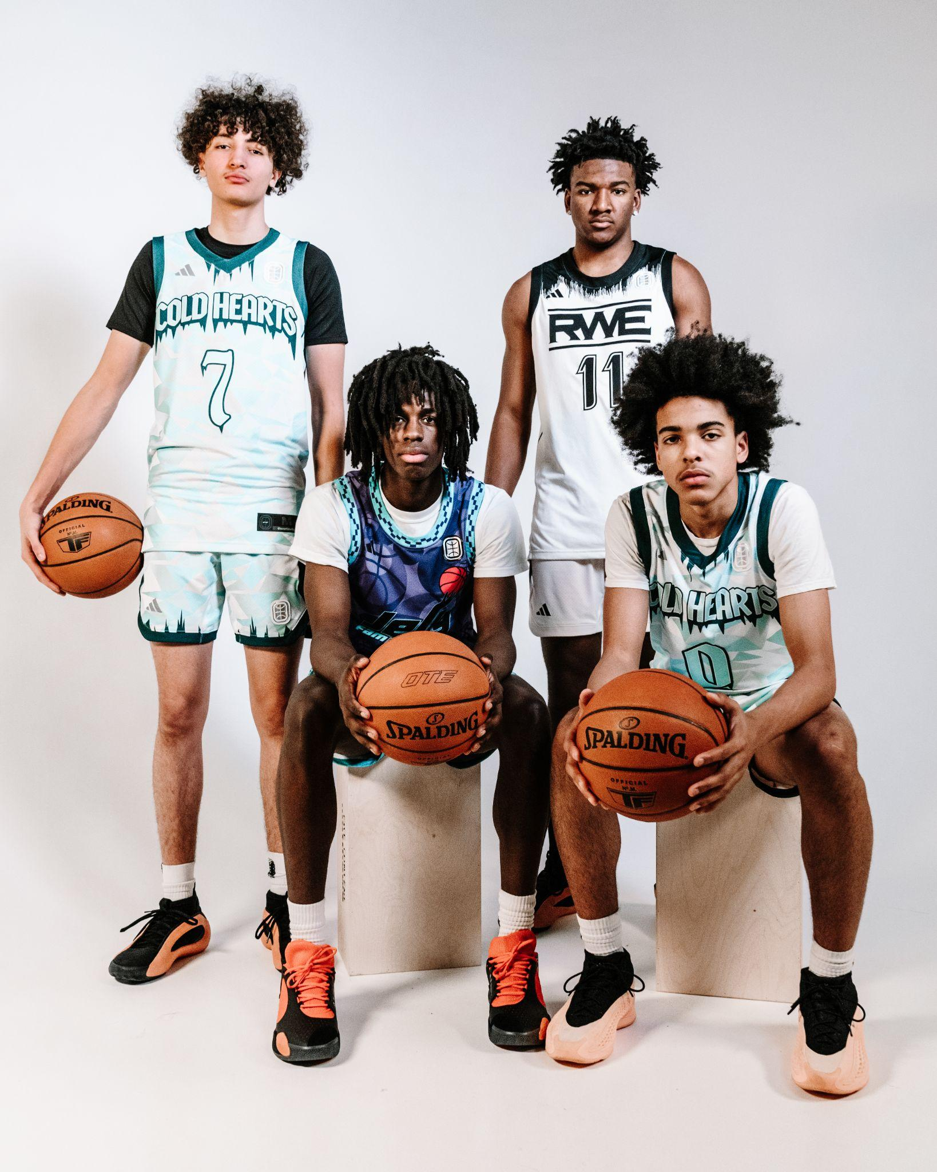

PORTLAND, OR - adidas Basketball is thrilled to announce the signing of four remarkable Overtime Elite (OTE) athletes as NIL brand ambassadors: Ian Jackson, Karter Knox, Mikel Brown Jr., and Adam Oumiddoch. This quartet of signings marks a significant step in adidas' ongoing dedication to the sport's evolution and investment in the future of basketball.

This collaboration is a strategic extension of the multi-year partnership established in October 2023, where adidas was named the exclusive apparel and footwear sponsor of OTE. Both organizations share a unified vision centered around an athlete-first approach, ensuring the well-being and development of OTE players remain pivotal to their collaborative efforts.

“The partnership with Overtime Elite and the integration of these talented young hoopers into the adidas family empowers us to champion the future leaders of basketball and reaffirms our pledge to the sport's advancement," said Eric Wise, adidas General Manager of Global Basketball. "We are immensely proud to foster a collaborative environment that not only equips athletes with performance-driven adidas products but propels them to success beyond the court.”

This alliance offers OTE athletes an unprecedented platform to build relationships within adidas, and the brand in turn secures early exposure to next-generation stars. The newly minted NIL ambassadors will not only embody the spirit of adidas Basketball but will also have access to educational opportunities ranging from product testing to visiting adidas headquarters to mentorship opportunities and NIL preparedness.

Highlighting the ambassadors:

- Ian Jackson (Class of 2024) - A 2024 McDonald’s All-American and two-time gold medalist with USA Basketball, now committed to the University of North Carolina.
- Karter Knox (Class of 2024) - Also a 2024 McDonald’s All-American, celebrated as Florida's top player and the 3A Florida Player of the Year in his junior year, with a gold medal from the 2022 USA Basketball U17 National Team.
- Mikel Brown Jr. (Class of 2025) - A promising floor general who’s currently shooting 39% from three and exploring dozens of scholarship offers from high major Division 1 colleges.
- Adam Oumiddoch (Class of 2026) - One of the Top 20 players in his class, a sophomore who is the only underclassmen at OTE averaging double figures in scoring.

“adidas is focused on the next generation athlete, and their commitment to providing OTE players with opportunities to expand their own brands aligns perfectly with how we look to empower our players,” said Jack Jenkins, VP, Brand Partnerships at Overtime.

The two brands have kicked off their partnership in a big way, amassing millions of views, with shared content creation across league games and visits from current adidas athletes including Donovan Mitchell and Trae Young.

As an exciting extension to the partnership, OTE and adidas will spotlight top high school talents, including three NIL ambassadors, in four league games across two days in Indianapolis, coinciding with NBA All Star Weekend festivities. These games promise to be a showcase of elite young talent and will be broadcast live on Amazon Prime Video, YouTube, and all league social channels.

February 15th, 2024
7 PM ET -City Reapers vs YNG Dreamerz
9 PM ET - Cold Hearts vs RWE

February 16th, 2024
2 PM ET - City Reapers vs Cold Hearts
4 PM ET - RWE vs YNG Dreamerz

For more on adidas Basketball

adidas Basketball:
IG: @adidasbasketball / @adidas
Twitter: @adidashoops / @adidas

FOR MORE INFO:
adidas.com/basketball

###

About OTE:

Overtime Elite (OTE) is a basketball league featuring top 16-20-year-old domestic and international players. There are eight teams in the league, and games are played primarily at OTE Arena in Atlanta. OTE, owned and operated by Overtime, brings fans as close as possible to the action through broad digital distribution on accounts that have millions of followers.

While playing in the league, players receive innovative, cutting-edge education and training to prepare them for college and professional basketball.

About adidas:

adidas is a global leader in the sporting goods industry. Headquartered in Herzogenaurach/Germany, the company employs more than 59,000 people across the globe and generated sales of € 22.5 billion in 2022.

For general inquiries, please contact:

JR Heffner
Jr.Heffner@adidas.com

Whitney Bell
whitney@itsovertime.com

Claire Skelley
claire@pitchblend.com

