adidas, Patrick Mahomes Unveil Mahomes 2
LAS VEGAS, NV (Feb. 9, 2024)—adidas and Patrick Mahomes today unveil Mahomes 2, the next iteration of the football icon’s signature footwear and apparel collection with the brand.
Mahomes launched his first signature training shoe—Mahomes 1 Impact FLX—and the Future Icons apparel collection in August 2021. The new Mahomes 2 collection was designed in close collaboration with Mahomes, bringing together adidas’ top footwear and apparel designers to create a unique collection that emulates the iconic athlete and his passions.
The first drop of the Mahomes 2 Impact FLX is interwoven with matte gold and bronze accents, inspired by his obsession with time and vast collection of luxury watches. The shoe’s design was enhanced through Mahomes 1 Impact FLX data and features a generative traction outsole, enhanced mesh upper, and repetitor foam midsole.
The full collection includes:
- The Mahomes 2 Impact FLX Grey and Metallic Silver colorway
- Two Mahomes ZNE Full-Zips (bronze strata and white)
- Two Mahomes ZNE Pants (bronze strata and white)
- Three Mahomes Graphic Tees (bronze strata and white)
- Three Mahomes ZNE Shorts (bronze strata and white)
“Myself, my team and adidas spent over a year perfecting every detail in Mahomes 2, down to the timepiece symbols featured on the first shoe and the zippers on the hoodies,” said Patrick Mahomes. “Our hard work and passion comes to life today, and I can’t wait to see fans rocking the collection.”
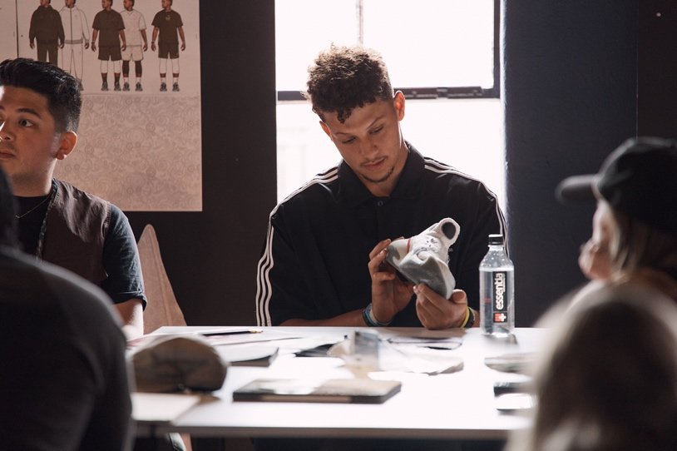
“Patrick’s a generational force in sports—not just football—shaping the next generation of athletes and serving as an inspiration to all by overcoming pressure in the biggest moments and finding joy in the game,” said Chris Murphy, Senior Vice President of Brand Marketing at adidas. “Mahomes 2 has been years in the making and is the result of unparalleled collaboration between Mahomes and our industry-leading designers to create a premium, unique collection.”
Mahomes 2 will be available for purchase starting February 2024 through limited releases on adidas.com/us/patrick_mahomes and through the adidas app.

Join the conversation with @adidasFballUS and @PatrickMahomes on X and Instagram.

About adidas
adidas is a global leader in the sporting goods industry. Headquartered in Herzogenaurach/Germany, the company employs more than 59,000 people across the globe and generated sales of € 22.5 billion in 2022.

Media Contact
Will Yeo
william.yeo@hillandknowlton.com

