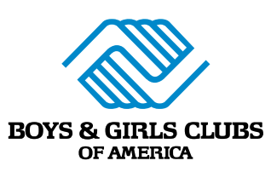
adidas Helping to Level the Playing Field for Next Generation of Athletes Through Partnership with Boys & Girls Clubs of America
adidas providing local grant funding to Boys & Girls Clubs that will promote equal opportunity in sport for young people
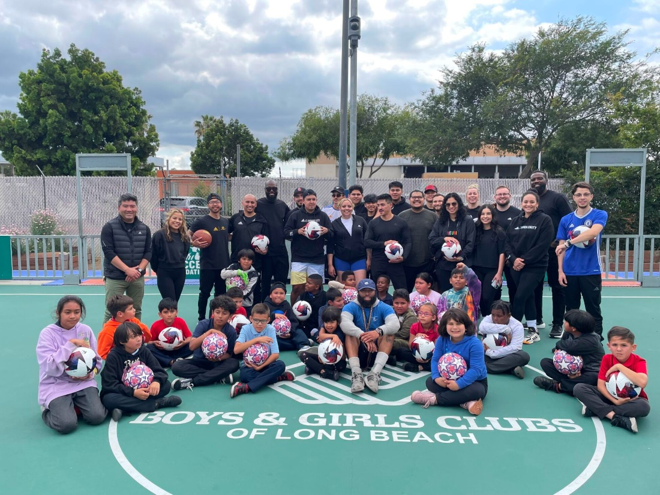
LAS VEGAS, Feb. 9, 2024 — Building upon an existing three-year relationship with Boys & Girls Clubs of America, adidas announced today a formal two-year agreement with the nation's largest youth development organization as part of both parties’ efforts to spread the joy of sport to kids and teens in all communities across the nation. By coming together to help drive substantive, long-lasting impact, the partnership will serve as a reminder that through sport, we have the power to change lives.
Over the course of the two-year partnership, adidas will grant $1 million to Boys & Girls Clubs of America to allocate across Clubs representing majority under-resourced Black and Latinx communities in more than a dozen U.S. cities, including New York, Los Angeles and Atlanta. Participating Clubs will receive funding to provide kids and teens with sport, wellness, education and e-sports programming.
adidas will also contribute additional funds to Boys & Girls Clubs of America through optional round-up donations from consumers at adidas locations throughout the U.S. Through these round-up efforts over the course of the last three years, adidas has generated nearly $2 million in funding for Boys & Girls Clubs of America and expects this route to unlock additional possibilities for young people across the country.
“We are honored to team up with adidas to spread equality, wellness and education of sports to Boys & Girls Clubs during this Super Bowl and throughout our upcoming partnership,” said Chad Hartman, National Vice President of Corporate Partnerships & Engagement, Boys & Girls Clubs of America. “This two-year partnership will not only increase youth access to sports programming but will expand kids and teens’ knowledge of the powerful role sport can play in a young person’s life.”
adidas’ support for Boys & Girls Clubs of America is part of the brand’s historic promise to invest $120 million to empower Black and Latinx communities in the U.S. through 2025. Other investments under the Creating Lasting Change Now effort include Cultivate & B.L.O.O.M., now titled, adidas Community LAB, an accelerator program for social entrepreneurs of color, and sustained funding for S.E.E.D. (School for Experiential Education in Design), a strategic pipeline to welcome diverse talent into the brand and the design industry.
“Seeing our communities thrive through access to safe, inclusive, spaces to play - is one of the greatest outcomes of the work our Purpose team leads. Through allyship with dedicated partners like Boys & Girls Clubs of America we further realize the mission to create safe spaces and programming to support the highest needs of those we serve,” said Ayesha Martin, Senior Director of Purpose, Communities & Social Impact at adidas. “While we won’t get there overnight, through the power of collaboration and a commitment to help remove barriers, we can create new possibilities in sport and culture that enable our communities for generations to come.”
"We're thrilled to partner with Adidas and Resorts World for an unforgettable experience. The Adidas Field Day isn't just about sports; it's a holistic event combining art, sports, and e-sports, offering our youth unique opportunities to discover new passions and skills,” said Andy Bischel, President & CEO of Boys & Girls Clubs of Southern Nevada. “This collaboration represents our commitment to providing diverse and enriching experiences for our members.”
To celebrate the launch of the partnership, adidas and Boys & Girls Clubs of America hosted a Field Day event with a local Club in Las Vegas in the lead-up to the Super Bowl. Boys & Girls Clubs of Southern Nevada, adidas athletes including Minnesota Vikings quarterback Kirk Cousins, New York Jets wide receiver Garrett Wilson, Las Vegas Aces forward Chelsea Gray and Detroit Lions wide receiver Amon-Ra St.Brown, and leadership from adidas and Boys & Girls Clubs of America came together at the event to celebrate play and promote equality in sport. After receiving adidas gear, Club Kids competed in various drills and skill challenges on the field alongside adidas athletes, helped design footwear with adidas program Wood U, and got to check out the soon-to-be-released Mahomes 2.
The agreement with Boys & Girls Clubs of America reflects adidas’ ongoing commitment to help make sport equal, because when it comes to sport, fair play doesn’t yet exist for all. Using the power of sport to create a better future for the planet and people, the brand is focused on creating possibilities through products, programs and partnerships. From an understanding that this can’t be done alone, adidas works collaboratively with – and supports – fellow changemakers such as Boys & Girls Clubs of America on the journey to enabling access, equity and safety for our communities.

####
About adidas
adidas is a global leader in the sporting goods industry. Headquartered in Herzogenaurach/Germany, the company employs more than 59,000 people across the globe and generated sales of € 22.5 billion in 2022.
About Boys & Girls Clubs of America
For more than 160 years, Boys & Girls Clubs of America (BGCA.org) has provided a safe place for kids and teens to learn and grow. Clubs offer caring adult mentors, fun and friendship, and high-impact youth development programs on a daily basis during critical non-school hours. Boys & Girls Clubs programming promotes academic success, good character and leadership, and healthy lifestyles. Over 5,200 Clubs serve 3.3 million young people through Club membership and community outreach. Clubs are located in cities, towns, public housing and on Native lands throughout the country, and serve military families in BGCA-affiliated Youth Centers on U.S. military installations worldwide. The national headquarters is located in Atlanta. Learn more about Boys & Girls Clubs of America on Facebook and X (formerly Twitter).
About Boys & Girls Clubs of Southern Nevada
Boys & Girls Clubs of Southern Nevada is a non-profit organization with 13 Clubhouses throughout Southern Nevada. Our mission is to enable young people, especially those who need us most, to reach their full potential as productive, caring, responsible citizens. Focused on three main impact areas – Academic Success, Healthy Lifestyles, and Good Character & Leadership – Clubhouses provide a safe, supportive place to go (both physically and mentally), life-changing opportunities, and the chance for youth to learn, grow, and become who they want to be. Serving over 7,000 youth annually between the ages of 6-18, Clubs operate Monday through Friday before and after school, with extended hours over school breaks such as spring break, winter break, and summer break. For more information: www.bgcsnv.org | Facebook @BGCSNV | Instagram @BGCSNV | Twitter @BGCSNV | 702-367-2582

