ADIDAS UNVEILS SS24 MELBOURNE COLLECTION – HELPING PLAYERS FEEL COOL WITH AIRCHILL TECHNOLOGY

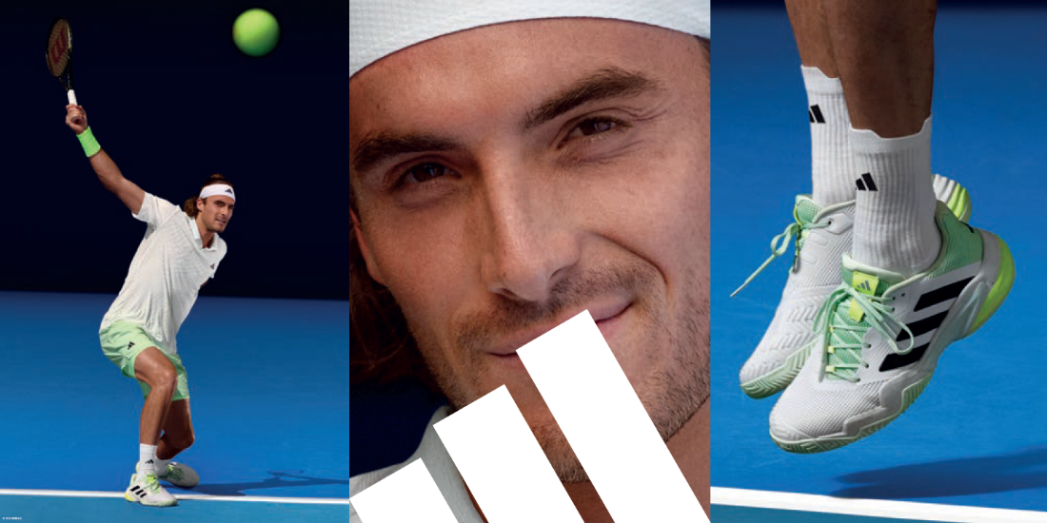

- adidas’ AIRCHILL material technology – used for the first ever time in a tennis range – involves loose-knit fabrics which optimize airflow during high-intensity games and workouts
- Each piece in the collection adorns nature-inspired colors and graphic patterns
- The SS24 Melbourne collection is available to buy on adidas.com/tennis-clothing and via the adidas app from December 1, 2023
Herzogenaurach, January 8, 2024 – Today, adidas unveils its SS24 Melbourne collection to mark the start of the 2024 Grand Slam season. AIRCHILL technology – a first for adidas in tennis – works in tandem with HEAT.RDY material technology to support players performing in the heat of the moment.
AIRCHILL material technology supports cooling through thermally zoned, raised pattern motifs and mesh layers. The lightness of AIRCHILL helps skin breathe – deliberately placed in high sweat and evaporation zones – under the armpits, chest and back. The raised patterns and open mesh fabrics are designed to optimize airflow during high-intensity workouts and matches.
The 26-piece range for men and women also boasts a tranquil color palette and pattern scheme, specially crafted to help evoke a sense of calm. The spectrum of greens – including the key colorway ‘Green Spark’, inspired by the natural phenomena of bioluminescence – were carefully chosen for their soft, glowing shades, meanwhile prints adorning the fabric emulate recurring fractal shapes in nature.

Stefanos Tsitsipas, elite tennis player, commented: “One of the biggest factors in being a successful tennis player is staying composed and enjoying yourself. This is especially important at the first major tournament of the season – which sets the scene for the rest of the year. It’s crucial to remember the love of the game, that drew me to the sport in the first place. For me, staying calm and collected in the heat of the moment allows me to play the best I can.”
Hero pieces for women include the AIRCHILL Dress Pro, the AIRCHILL Match Tank Pro and the AERO.RDY Skirt Pro. For men, hero pieces include the AIRCHILL FreeLift T-Shirt Pro, the Mesh Layering T-Shirt Pro and the Printed HEAT.RDY Ergo Short Pro 7 Inch.
The apparel collection is made from 100% recycled materials and comes in sizes XS-2XL for men and 2XS-2XL for women.
The collection premiers at one of the most prominent hard-court tournaments and will be worn by athletes including Caroline Wozniacki, Elina Svitolina, Xinyu Wang, Dana Mathewson, Jessica Pegula, Karolína Muchová, Maria Sakkari, Stefanos Tsitsipas, Felix Auger Aliassime, Jason Wu and Martin de la Puente.
All pieces will be available to buy at adidas.com and via the adidas app from December 1, 2023.
For further information please visit adidas.com/tennis-clothing or follow @adidasTennis on Instagram to join the conversation, using #MelbourneCollection, #adidasTennis and #adidas.

