ADIDAS INTRODUCES NEW SUPER-FOAM FOR EVERYDAY RUNNERS WITH THE REVAMPED SUPERNOVA FRANCHISE
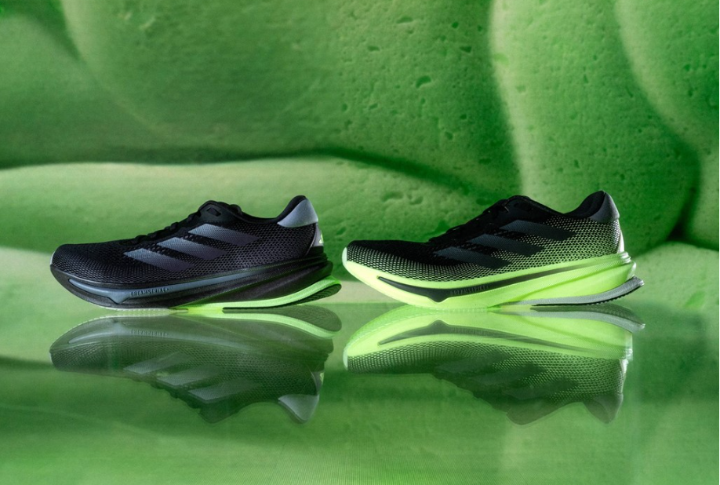
- Designed to re-define the standards of comfort, new features include a fully redesigned upper, a super-foam Dreamstrike+ midsole and Support Rod System to deliver maximum comfort and cushioning
- adidas study looking into the needs and demands of the everyday runner highlights comfort as one of the top priorities when selecting a running shoe
- SUPERNOVA RISE is available globally to purchase from December 1, 2023, exclusively via selected retail partners, with the introduction of SUPERNOVA SOLUTION and SUPERNOVA STRIDE – and wider distribution – starting from February 22, 2024

Herzogenaurach, December 1, 2023 – Today, adidas reveals the reimagined SUPERNOVA franchise with the first of three new silhouettes – SUPERNOVA RISE. Launching in a women’s and men’s specific last, the new running shoe is designed to deliver maximum comfort and help everyday runners be distraction-free.

Throughout the development process, the Product and Design teams tapped into research conducted by adidas with 1,300 female runners, which revealed comfort as one of the most important criteria for everyday runners when selecting a running shoe.

Built from these insights and years of experience garnered through delivering performance running shoes for athletes of all levels, the adidas Product team assessed cutting-edge technology within other adidas Running franchises – and how those can be transferred to the new SUPERNOVA silhouettes. The result sees the introduction of Dreamstrike+, a new midsole foam which takes inspiration from LIGHTSTRIKE PRO – the midsole material utilized across the record-breaking ADIZERO franchise – but with an updated formula to offer unparalleled comfort and cushioning. To provide runners with a tailored comfort offering suited to their own needs, the material forms the entirety of the midsole on SUPERNOVA RISE and SUPERNOVA SOLUTION, whilst on the SUPERNOVA STRIDE model, it is positioned in the forefoot region alongside an EVA compound midsole.

JT Newcomb, Category Director, adidas Running Footwear, said: “We are very excited to introduce a totally new chapter of the Supernova franchise – our everyday running shoes. The driving motivation behind revamping the Supernova was to enable more people to run, more of the time. When we listened to what was important to the everyday running community it was comfort that stood out and we’ve focused our efforts on creating a range of shoes that deliver that benefit in a way we are sure all runners will love.”

In the SUPERNOVA RISE and SUPERNOVA SOLUTION models, the Dreamstrike+ midsole is complemented by a Support Rod System. Inspired by the physiology of the foot in motion, this new technology is embedded in the outsole to grant harmonized support and transition, as well as stability where it is needed. The Support Rod System in SUPERNOVA SOLUTION slightly differs from that featured in the SUPERNOVA RISE, with the two middle rods splinted together to offer additional support for runners who seek it. With both technologies working in tandem, Dreamstrike+ and the Support Rod System provide runners with a comfortable, yet well-supported running experience.

Other key product features include a Comfort Heel Fit, which uses a combination of cushioning foam and soft textile designed for maximum comfort and support. While the engineered sandwich mesh and expertly crafted details ensure that all runners’ needs are accommodated.

For the colorway of the SUPERNOVA RISE, the adidas Design team - inspired by nature and the energy of bioluminescence - selected a dark base of Black and Aurora with Semi-Green Spark detailing. The Supernova Rise is priced at €150 / $140, and will be available for purchase from December 1, 2023. The SUPERNOVA SOLUTION and SUPERNOVA STRIDE will be introduced starting from February 22, 2024.

For further information, please visit adidas.com/running-shoes or follow the conversation on Instagram and Twitter using #adidassupernova and @adidasrunning.

– ENDS –

adidas Consumer Study, Winning With Female Runners, March 2022.

