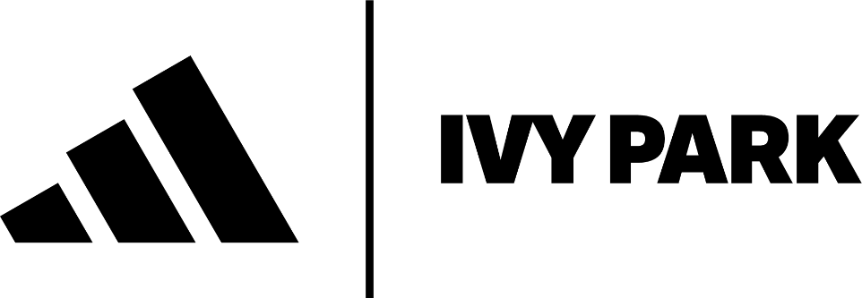

Elevated monochrome form meets innovative material function in IVY PARK NOIR – a capsule wardrobe from adidas x IVY PARK

Los Angeles, CA – October 6, 2023 – adidas and IVY PARK unveil the final installment of their collaboration together, titled IVY PARK NOIR. A celebration of movement and materiality, the all-black capsule champions the human form, through silhouettes that epitomize power, freedom and individuality.

The new range represents a culmination of the two brands’ work together, combining adidas’ athletic and functional excellence, with IVY PARK’s signature emphasis on shape, and trend-defying creative vision. Using a singular, black color palette, IVY PARK NOIR intentionally draws focus to fabric, fit and texture, cultivating enduring elegance through sensual, material play.

Considering all chapters of an active way of life- from warm up, to cool down- the collection elevates one’s everyday pursuits through a mix of tight and loose fitting styles. Fabrications include luxurious embossed leather, exposed mesh and lacquered latex that combine to create a complex yet sophisticated capsule. Standout pieces include body-con cropped top and pant, relaxed 3-D molded knit sweatsuits, multifunctional jackets, and the IVY PARK signature jersey.

IVY PARK NOIR’s head to toe offering includes bold and innovative footwear that re-imagines a new era of style and function. Sleek molded and debossed elements add an architectural foundation to the collection’s sneakers, while a chunky, over the knee boot offers utilitarian fantasy.

Designed with the inclusivity endemic to the IVY PARK brand, the range offers sizing from XXS- 3XL and price points from $35 - $350 USD. IVY PARK NOIR will be available in select adidas stores, online at adidas.com/ivypark and in select partner stores globally beginning October 12, 2023.

The Campaign
Drawing inspiration from the Film Noir genre, and strength and dynamism of the photographers the likes of Helmut Newton and Richard Avedon, the campaign lauds the essentialism of the all-black line. Elevated black and white portraits, taken against a soft white grey background, are offset by a playful spotlight that imbues the images with intrigue, and freedom. The campaign, like IVY PARK, upholds fearless confidence, celebrating those that move through the world, unapologetic in their self-expression.

Notes to Editors
The adidas x IVY PARK NOIR collection consists of:

- Fabrics and trims:
  - Jersey
  - Leather
  - Mesh
  - 3-D Molded Knit
  - Spandex
  - Twill
  - Velvet

- Colorways:
  - Noir
  - Vantablack

About Parkwood Entertainment
Parkwood Entertainment is a film and production company, record label, and management firm founded in 2010 by entertainer and entrepreneur Beyoncé. With offices in Los Angeles and New York City, the company houses departments in music, film, video, live performances and concert production, management, business development, marketing, digital, creative, philanthropy, and publicity. Under its original name, Parkwood Pictures, the company released the film Cadillac Records (2008), in which Beyoncé starred and co-produced. The company has also released the films Obsessed (2009), with Beyoncé as star and executive producer, the winner of the Peabody Award for Entertainment, Lemonade (2017), the Emmy®-nominated Homecoming: A Film By Beyoncé (2019), which documents Beyoncé’s history-making performance at the Coachella Valley Music & Arts Festival in 2018, and the Emmy®-winning Black Is King (2020). Parkwood Entertainment produced The Mrs. Carter Show World Tour (2013-2014), The Formation World Tour (2016), and the aforementioned “Homecoming” performances at Coachella (2018) and co-produced the ON THE RUN Tour (2014) and ON THE RUN II (2018).

About adidas Originals
Inspired by the rich sporting heritage of adidas – one of the world’s leading sports brands and a global designer and developer of athletic footwear and apparel – adidas Originals is a lifestyle brand founded in 2001. With the adidas archive at its foundation, adidas Originals continues to evolve the brand’s legacy through its commitment to product innovation and its ability to filter the creativity and courage found on courts and sporting arenas through the lens of contemporary youth culture. Marked by the iconic Trefoil logo that was first used in 1972 and championed by those that continue to shape and define creative culture, adidas Originals continues to lead the way as the pioneering sportswear brand for the street.

For press inquiries please contact:

IVY PARK and Parkwood Entertainment
Yvette Noel-Schure, yns@parkwood-ent.com

adidas
Andrew Wirch, andrew.wirch@adidas.com
Hanna Domingo, hanna.domingo@adidas.com

PR Consulting
adidasteam@prconsulting.net

