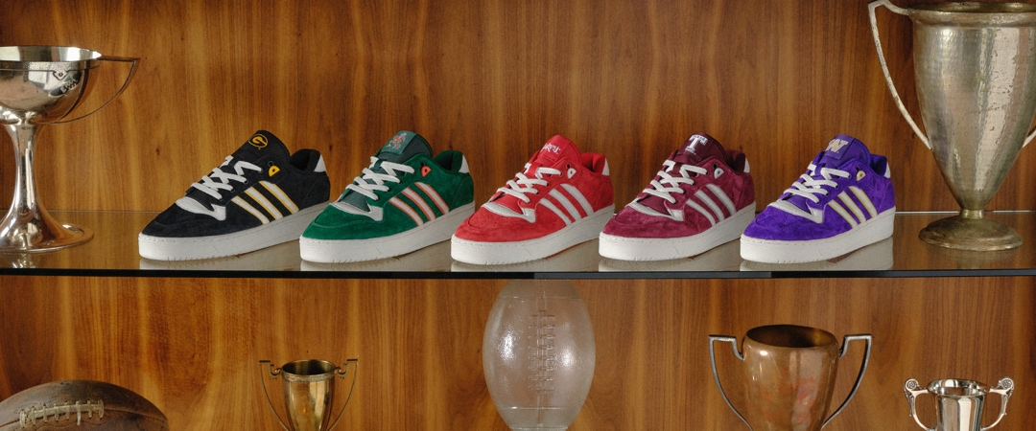
ADIDAS ORIGINALS UNVEILS FIRST-EVER FOOTWEAR COLLECTION CUSTOMIZED FOR UNIVERSITY STUDENTS AND FANS
- For the first time, adidas Originals tailors its lifestyle footwear specifically for adidas NCAA partner programs
- New Rivalry Collection meets students at the cross section of style and sport as the college football season kicks off
- Officially licensed colorways for Grambling State, Miami, Nebraska, Texas A&M and Washington will be available for purchase starting this Friday, September 1, 2023
Portland, Oregon (Aug. 28, 2023)— With the kickoff of the college football season and students returning to campuses across the country, adidas today unveiled a Rivalry Collection for five partner NCAA programs, marking the first time the adidas Originals brand has entered the collegiate space.
“adidas is at the forefront of this growing crossover between the worlds of style and sports, and this collection marks our style culture being tailored and amplified across universities,” said Peter Gellert, Director of adidas Originals Basketball Footwear. “It's an exciting moment for fans, and there’s no better time or place to bring it to life than the start of the college sports season.”
Originally rooted in basketball, the Rivalry shoe features a retro ‘80s look with a sleek silhouette that works for everything from the classroom to kickoff. Now, fans and students from Grambling State University, University of Miami, University of Nebraska, Texas A&M and the University of Washington can represent their college colors with their own Rivalry looks. Additional adidas Originals’ collections are slated to drop later this season to give more colleges and universities the chance to rock their school colors.
“College football is back and what better way to celebrate than by giving students and fans the chance to sport their school colors through an iconic shoe like the Rivalry,” said Jeanne Schneider, director of NCAA marketing and licensing at adidas. “We’re proud to be working with our NCAA partner programs to grow and promote their brands.”
Students and fans can purchase the newest Rivalry colorways starting Friday, Sept. 1 for $110 at adidas.com/us/college and the adidas app.
Join the conversation and share your OOTDs with @adidasOriginals on TikTok and Instagram.
About adidas
adidas is a global leader in the sporting goods industry. Headquartered in Herzogenaurach/Germany, the company employs more than 59,000 people across the globe and generated sales of € 22.5 billion in 2022.
Media Contact
adidas
adidaspress@hkstrategies.com

