ADIDAS INTRODUCES SWITCH FWD – FUELLED BY FORWARD MOTION TECHNOLOGY, DESIGNED FOR A SMOOTH RUNNING EXPERIENCE

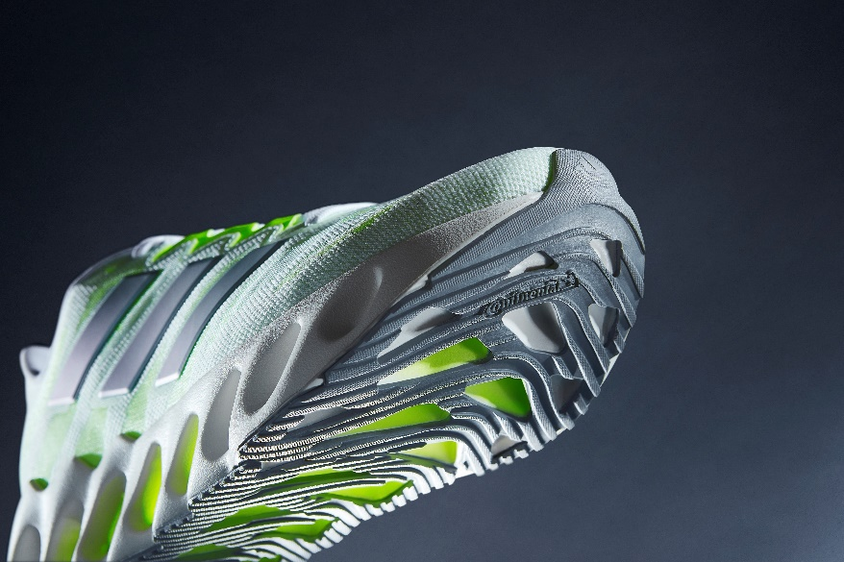

- SWITCH FWD uses voids in its EVA midsole to transfer weight into forward motion for a fresh running experience for athletes of all levels
- Intentionally positioned windows feature throughout the engineered mesh upper to provide enhanced breathability
- From 27th July, SWITCH FWD will be available to buy globally via the adidas app, online, in stores and select retailers
Herzogenaurach, July 27th, 2023: adidas today reveals SWITCH FWD, as it continues its commitment to unwavering innovation in the pursuit of only the best for all runners.

Constructed using cutting-edge design processes, the shoe’s engine – the EVA compound midsole – features intricately designed voids that collapse and spring forward, converting weight into forward motion; unlocking the potential of athletes of all levels by moving them forward with every stride. The result is a smooth-running experience that’s unique to forward technology-fueled running shoes.

The soft EVA compound midsole, working in unison with the TPU plate, ensures a stable and cushioned transition through the forefoot and midfoot during the forward motion process.

Mili Seiffert, Global Product Manager at adidas Running said: “We’re always looking at innovative ways to redefine our design processes to bring real benefits to our community – whether they are at the top of the sport, or an everyday runner. While it sounds simple, the ambition to convert weight into forward motion is easier said than done. It’s taken years of testing with athletes of every level to get where we have today. It’s a triumph to innovation, and a testament to our ambition and drive to deliver new running shoe technology.”

Additional features of the new SWITCH FWD include a lightweight Continental™ outsole, which gives runners extra grip in all weather conditions. This is complemented by a lightweight engineered mesh upper, which features strategically placed windows on the forefoot and midfoot, for enhanced breathability.

The shoe launches in a primary white and silver violet colorway with lucid lemon detailing for women, and a primary white and wonder blue colorway for men with lucid lemon accents.

SWITCH FWD is priced at €140, and will be available to buy globally via the adidas app, online http://www.adidas.com/running and in stores from July 27th.

Follow the conversation on Instagram, TikTok and Twitter using #SWITCHFWD @adidasrunning.

- ENDS –

About adidas
adidas is a global leader in the sporting goods industry. Headquartered in Herzogenaurach/Germany, the company employs more than 59,000 people across the globe and generated sales of €22.5 billion in 2022.

*Market SEO links:
NAM | adidas.com/us | https://www.adidas.com/us/women-running-shoes
 | adidas.ca/en | https://www.adidas.ca/en/men-running-shoes
 | adidas.ca/fr | https://www.adidas.ca/fr/course-chaussures
LAM | adidas.com.ar | https://www.adidas.com.ar/zapatillas-running
 | adidas.cl | https://www.adidas.cl/zapatillas-running
 | adidas.co | https://www.adidas.co/zapatillas_y_tenis-running
 | adidas.mx | https://www.adidas.mx/zapatillas_y_tenis-running
 | adidas.pe | https://www.adidas.pe/zapatillas-running
 | adidas.com.br | https://www.adidas.com.br/tenis-running
EU Big 6 | adidas.co.uk | https://www.adidas.co.uk/men-running-shoes
 | adidas.de | https://www.adidas.de/frauen-running-schuhe
 | adidas.de/en | https://www.adidas.de/en/running-shoes
 | adidas.fr | https://www.adidas.fr/chaussures-running
 | adidas.it | https://www.adidas.it/scarpe-running-uomo
 | adidas.es | https://www.adidas.es/calzado-running
 | adidas.nl | https://www.adidas.nl/hardlopen-schoenen
EU | adidas.cz | https://www.adidas.cz/obuv-beh
 | adidas.dk | https://www.adidas.dk/lob-sko
 | adidas.at | https://www.adidas.at/running-schuhe
 | adidas.ch/de | https://www.adidas.ch/de/running-schuhe
 | adidas.ch/en | https://www.adidas.ch/en/running-shoes
 | adidas.ch/fr | https://www.adidas.ch/fr/chaussures-running
 | adidas.ch/it | https://www.adidas.ch/it/scarpe-running
 | adidas.gr | https://www.adidas.gr/τρέξιμο-παπούτσια
 | adidas.be/en | https://www.adidas.be/en/running-shoes
 | adidas.be/fr | https://www.adidas.be/fr/chaussures-running
 | adidas.be/nl | https://www.adidas.be/nl/hardlopen-schoenen
 | adidas.fi | https://www.adidas.fi/running-shoes
 | adidas.ie | https://www.adidas.ie/running-shoes
 | adidas.no | https://www.adidas.no/loping-sko
 | adidas.pl | https://www.adidas.pl/buty-bieganie
 | adidas.pt | https://www.adidas.pt/calcado-running
 | adidas.sk | https://www.adidas.sk/obuv-beh
 | adidas.se | https://www.adidas.se/lopning-skor
APAC | adidas.jp | https://shop.adidas.jp/item/?sport=running&category=footwear
 | adidas.com.au | https://www.adidas.com.au/running-shoes
 | adidas.co.nz | https://www.adidas.co.nz/running-shoes
EM | adidas.ae | https://www.adidas.ae/en/running-shoes
 | adidas.co.in | https://www.adidas.co.in/men-running-shoes
 | adidas.com.tr/tr | https://www.adidas.com.tr/tr/erkek-ayakkabi-kosu
 | adidas.com.tr/en | https://www.adidas.com.tr/en/shoes-running

