CELEBRATING 50 YEARS SINCE THE MOMENT THAT CHANGED WOMEN’S TENNIS WITH THE ADIDAS FW23 NEW YORK COLLECTION
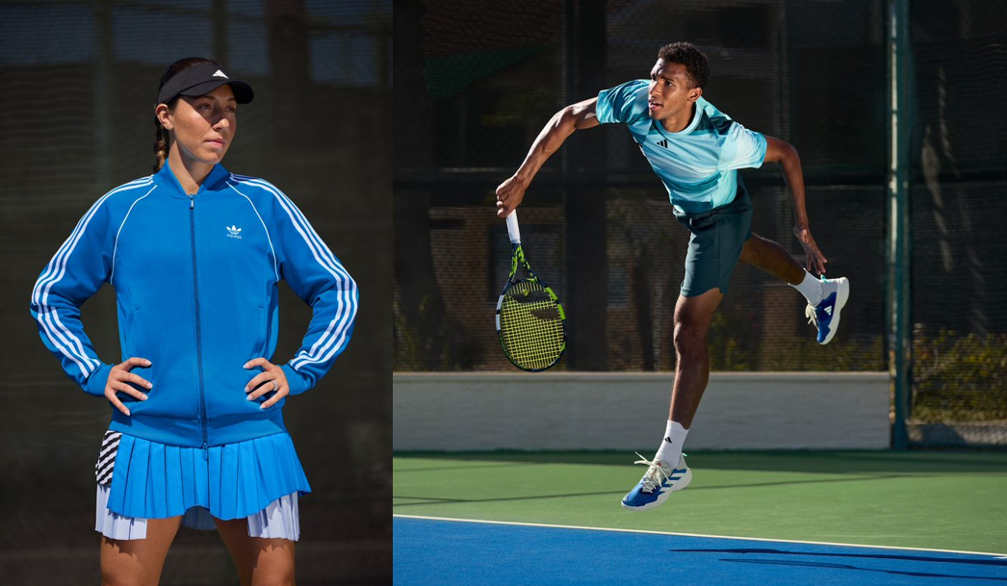
- adidas launches its FW23 New York collection, which celebrates 50 years since Billie Jean King won the Battle of the Sexes and broke new ground for women in sport
- Hero of the 12-piece collection is the iconic blue SST Jacket, as well as an updated Avacourt shoe retold in the season’s colorway and updated materials
- The FW23 New York collection will be available to buy on adidas.com/tennis-clothing and via the adidas app from August 14, 2023
Herzogenaurach, August 14, 2023 – adidas today launches its new FW23 New York collection – designed as an homage to the player who paved the way for future generations of athletes.
As part of the 12-piece collection, adidas introduces the SST Jacket – for men and women – as well as the Avacourt in a refreshed look. Both pieces share a bold blue hue – synonymous with the outfit that Billie Jean King wore in the Battle of the Sexes match – which is applied throughout the collection as a consistent design story.
The SST Jacket is inspired by the classic adidas tennis tracksuits from the era when Billie Jean King was at the height of her career, changing tennis on and off the court for years to come.
The Avacourt, having originally launched in 2022, is created and engineered to best support women when playing tennis – featuring a women’s specific last, increased torsion, softer materials and a midfoot support saddle. Updates for the 2023 season bridge today’s silhouette with the one worn by Billie Jean King 50 years ago – which was adidas’ first ever signature tennis shoe for women – via its color story, as well as key material updates. The suede leather tongue has a retro feel and soft premium touch, with the toe guard made from a synthetic suede finishing. Adding to the comfort, the heel collar is lined with terry cloth – a fabric synonymous with the era.
Other key pieces in the collection include the Tennis Modular Leotard AEROREADY Pro with detachable skirt, the Tennis Transformative AEROREADY Dress Pro that evolves into two different styles, and the Tennis Reversible AEROREADY Match Skirt Pro with Tennis HEAT.RDY Short Tight Pro layered underneath. For men, key pieces include the Tennis HEAT.RDY Freelift Polo Shirt Pro, the Tennis Reversible AEROREADY Freelift T-Shirt Pro and the Tennis AEROREADY 2 IN 1 Short Pro.
The collection premiers at the world’s most foremost hard-court tournament and will be worn by athletes including Xinyu Wang, Dana Mathewson, Jessica Pegula, Maria Sakkari, Elina Svitolina, Karolína Muchová, Stefanos Tsitsipas, Felix Auger Aliassime and Martin de la Puente.
Jessica Pegula, elite tennis player, commented: “Tennis history shows that greatness is never defined by gender. It hasn’t always been easy to choose this path – players like Billie Jean King had to fight for the right to be on the same court as men and gain respect from fellow players. I’m proud to be an advocate for gender equality in sport – both on and off the court.”
The SST Jacket – €75 / $80 – comes in a Team Royal Blue colorway and a size range of 2XS to 2XL. The blue Avacourt shoe – €150 / $150 – comes in a Team Royal Blue colorway and a size range of UK 3.5-10. Both pieces will be available to buy at adidas.com and via the adidas app from August 14.
For further information please visit adidas.com/tennis-clothing or follow @adidasTennis on Instagram to join the conversation, using #NewYorkCollection, #adidasTennis and #adidas.

