ADIDAS EXPANDS ITS FASTEST FRANCHISE WITH THE LAUNCH OF THE ALL-NEW ADIZERO BOSTON 12 AND ADIOS 8

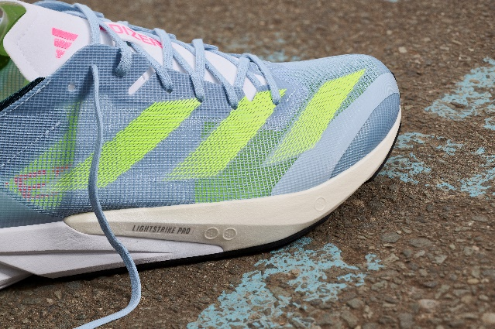
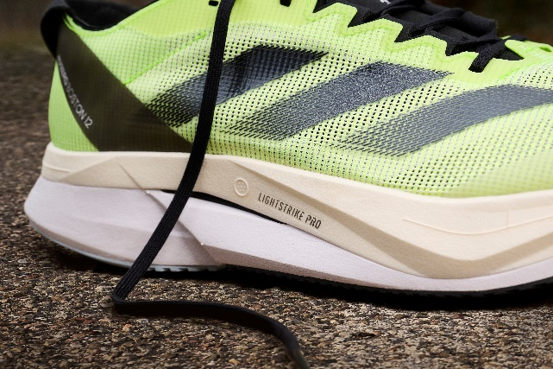

- Featuring the latest adidas technology and innovation, the ADIZERO BOSTON 12 provides that race day feeling in training runs, whilst the ADIZERO ADIOS 8 is built for speed on race day
- Developed with and for elite runners, the ADIZERO BOSTON 12 was tested across 19 sessions with adidas’ professional athletes in Kenya
- The ADIZERO BOSTON 12 and ADIZERO ADIOS 8 will be available to buy globally from June 15, 2023 via the adidas app, online and in stores
Herzogenaurach, June 1, 2023 – Today, adidas introduces the ADIZERO BOSTON 12 and ADIZERO ADIOS 8 – the latest additions to its award winning ADIZERO franchise. Both shoes have a long history of serving the different needs of adidas’ fast running community, having originally launched in 1982 and 2008 respectively. Haile Gebrselassie broke his own Marathon World Record wearing the ADIOS 1 in 2008, while the BOSTON is now on its 12th iteration.
A testament to adidas’ continued determination to push the boundaries of innovation forward, the BOSTON 12 was tested across 19 sessions with its pro athletes in Kenya, including Peres Jepchirchir, Abel Kipchumba and Angela Tanui. The unique insights obtained during those sessions were leveraged throughout the development process to ensure this shoe would best serve the needs of adidas’ ambitious running community.
The result is the ADIZERO BOSTON 12, which is designed to give runners the race feeling on fast training runs, with high-performance technology inside a training shoe. Also joining the ADIZERO franchise is the ADIZERO ADIOS 8 – a racing allrounder that, thanks to its lightweight design in combination with a low profile and responsive midsole, offers runners a direct and snappy feeling in races and speed workouts.
Charlotte Heidmann, Senior Global Product Manager, Running Footwear at adidas commented: “At adidas, we work with some of the most successful elite athletes on the planet. So listening closely to them and implementing their invaluable feedback is a crucial part of the development process of new products. Our latest round of athlete testing led to the ADIZERO BOSTON 12 becoming an even more powerful partner for speedwork and tempo runs. Meanwhile, we’ve also created the ADIZERO ADIOS 8 which is softer and lighter than previous iterations.”
TRAIN TO RACE WITH THE ADIZERO BOSTON 12
Taking runners from training to race day, the ADIZERO BOSTON 12 is a lightweight, fast and cushioned training shoe, featuring a range of technological updates including:
- ENGINEERED MESH – Helping runners take on their tempo training runs with a breathable fit. Experience the targeted support of engineered key zones that provide both midfoot lockdown and forefoot flexibility.
- ENERGY RODS 2.0 – Feel high-performance midsole stiffness with the glass-fiber infused ENERGY RODS 2.0. A holistic system designed for a seamless transition from heel to toe, bringing race-day performance to high-speed training runs.
- LIGHTSTRIKE PRO + LIGHTSTRIKE 2.0 – A layered midsole construction consisting of adidas’ high-performance foam, LIGHTSTRIKE PRO, and the all-new LIGHTSTRIKE 2.0 is engineered to deliver a cushioned and dynamic ride. The Continental™ outsole provides superior grip in the most demanding conditions.
- MADE IN PART WITH RECYCLED MATERIALS – Made with at least 50% recycled materials in the upper, this product represents just one of adidas’ solutions to help End Plastic Waste.
RACE TO WIN WITH THE ADIZERO ADIOS 8
When it comes to race day, the new ADIZERO ADIOS 8 is a purpose-built racing shoe designed to help runners achieve their best times. New tech features of the model include:
- LIGHTWEIGHT MESH UPPER - The all-new upper construction of the Adios 8 is stripped back, making it the lightest Adios ever. With the new micro-fit pattern, the shoe still locks runners in during high-speed races.
- ENERGYTORSION ROD 2.0 – The updated ENERGYTORSION ROD 2.0 is embedded in the midsole and features a new third rod that runs from the midfoot to the forefoot for a snappy toe-off.
- LIGHTSTRIKE PRO + LIGHTSTRIKE 2.0 – Experience an enhanced low-stack midsole construction. Featuring adidas’ LIGHTSTRIKE PRO foam in the forefoot and the all-new LIGHTSTRIKE 2.0 in the heel and midfoot area. This combination gives runners a cushioned landing and a dynamic spring feeling. Continental™ rubber on the outsole provides superior grip in all road racing conditions.
- MADE IN PART WITH RECYCLED MATERIALS – Made with at least 50% recycled materials in the upper, this product represents just one of adidas’ solutions to help End Plastic Waste.
Reigning Olympic Champion and two-time world major marathon winner Peres Jepchirchir, said: “Working collaboratively with adidas throughout the development of a new training or racing shoe is a very important experience for me as an athlete. It gives me a unique opportunity to share my experience and feedback and seeing how that shapes the designs makes me feel like I have footwear personalized for me and tailored for my needs. Testing the new ADIZERO BOSTON 12 was a great experience – they were really put through their paces!”
The new ADIZERO BOSTON 12 – launching in a Lucid Lemon colorway with Core Black accents for men, and a Wonder Blue colorway with Lucid Lemon accents for women – will cost €160 / $160. The new ADIZERO ADIOS 8 – launching in a Wonder Blue colorway with Lucid Lemon and Lucid Pink accents – will cost €130 / $130.
The ADIZERO BOSTON 12 and ADIZERO ADIOS 8 will be available to buy globally from June 15, 2023 via the adidas app, online and in stores.
To find out more, please visit: https://www.adidas.com/us/women-running-shoes. Follow the conversation on Instagram, Facebook and Twitter using #ADIZEROBOSTON12, #ADIZEROADIOS8 and @adidasrunning.

