May 9, 2023

SEC DEFENSIVE PLAYER OF THE YEAR AND NO. 1 OVERALL DRAFT PICK ALIYAH BOSTON JOINS ADIDAS FAMILY

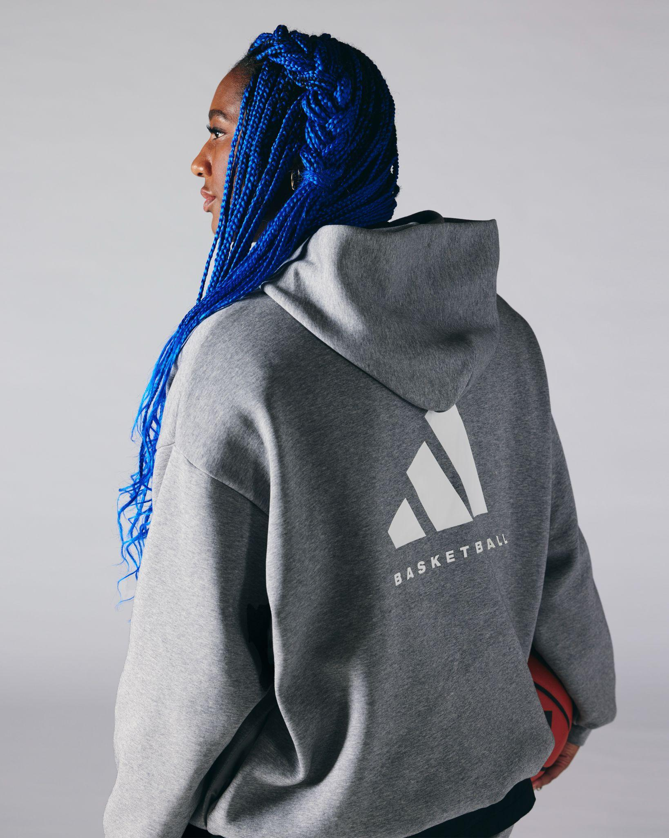

PORTLAND, Ore. - adidas Basketball is thrilled to announce the 2023 WNBA Draft first overall pick, Aliyah Boston, as the newest addition to the brand's esteemed women’s basketball roster.

"We are beyond excited to welcome Aliyah to our adidas Basketball family. She exudes strength, resilience, versatility and natural skill that is unmatched. I know she’ll leave a lasting impact on the future of the game and we are proud to be a part of this moment and support her on her journey to greatness," said Eric Wise, Global General Manager, Basketball at adidas.

The accomplished athlete and latest member of the Indiana Fever marks yet another addition to the brand's no. 1 draft pick signees including long-time partner and powerhouse Candace Parker. Boston could not have predicted that her iconic shout-out to Parker while accepting the NCAA Most Outstanding Player award in 2022 would presage her future, as she now joins Parker as a fellow adidas Basketball athlete partner.

"adidas is a brand that continues to grow the game and empowers their athletes on and off the court,” said Aliyah Boston. “I’m super excited to continue to evolve into the best woman and athlete I can be while dominating on the court and being a role model alongside an incredible roster of hoopers. It’s truly a blessing.”

Boston joins the brand's impressive women's professional basketball roster including Layshia Clarendon, Kahleah Copper, Sophie Cunningham, Chelsea Gray, Betnijah Laney, Angel McCoughtry, Nneka Ogwumike, Chiney Ogwumike, and Erica Wheeler, among others. The collective of basketball royalty includes National Collegiate and World Champions, Players of the Year, and Finals MVPs that are genuinely committed to advancing the women's game for themselves and the next generation of athletes. This is a sisterhood – a team built through one collective love for the sport and a genuine love for each other.

Boston will make her highly anticipated WNBA debut on May 19 as the Indiana Fever face off against the Connecticut Sun.

For more on adidas Basketball

adidas Basketball:
IG: @adidasbasketball / @adidas
Twitter: @adidashoops / @adidas

FOR MORE INFO:
adidas.com/basketball

###

About Aliyah Boston:
Aliyah Boston is an American professional basketball player for the Indiana Fever of the Women’s National Basketball Association (WNBA).

Born in Saint Thomas, United States Virgin Islands, Boston attended Worcester Academy in Worcester, Massachusetts, where she was a McDonald's All-American and a three-time Massachusetts Gatorade Player of the Year.

Boston attended the University of South Carolina from 2019 - 2022 and led the team to their second national championship in school history in 2022 and was named the NCAA Tournament Most Outstanding Player. She ended her four year collegiate career with a record of 129 wins and 9 losses.

Resume:
Gatorade Massachusetts Player of the Year (2017, 2018, 2019) McDonald's All -American (2019) (2020, 2021, 2022, 2023) Lisa Leslie Award (2020, 2021, 2022) USBWA National Freshman of the Year (2020) WBCA Freshman of the Year (2020) Academic All -American of the Year (2021, 2022) Unanimous First -Team All -American (2021, 2022, 2023) FIBA Americup Gold Medalist (2021) SEC Player of the Year (2022, 2023) Naismith Defensive Player of the Year (2022, 2023) SEC Tournament MVP (2022, 2023) USBWA Women's National Player of the Year (2022) Naismith College Player of the Year (2022) John R. Wooden Award (2022) Wade Trophy (2022) Honda -Broderick Cup (2022) NCAA Tournament Most Outstanding Player (2022) NCAA Champion (2022) WNBA #1 Draft Pick (2023)

About adidas
adidas is a global leader in the sporting goods industry. Headquartered in Herzogenaurach/Germany, the company employs more than 59,000 people across the globe and generated sales of € 22.5 billion in 2022.

For general inquiries, please contact:

Annastasia Rosip
annastasia@pitchblend.com

Alyssa Ahern
alyssa.ahern@adidas.com

