BUILT FOR DISGUISE: ADIDAS INTRODUCES ITS SS23 PARIS COLLECTION – DESIGNED TO HELP PLAYERS MAKE THEIR POINTS
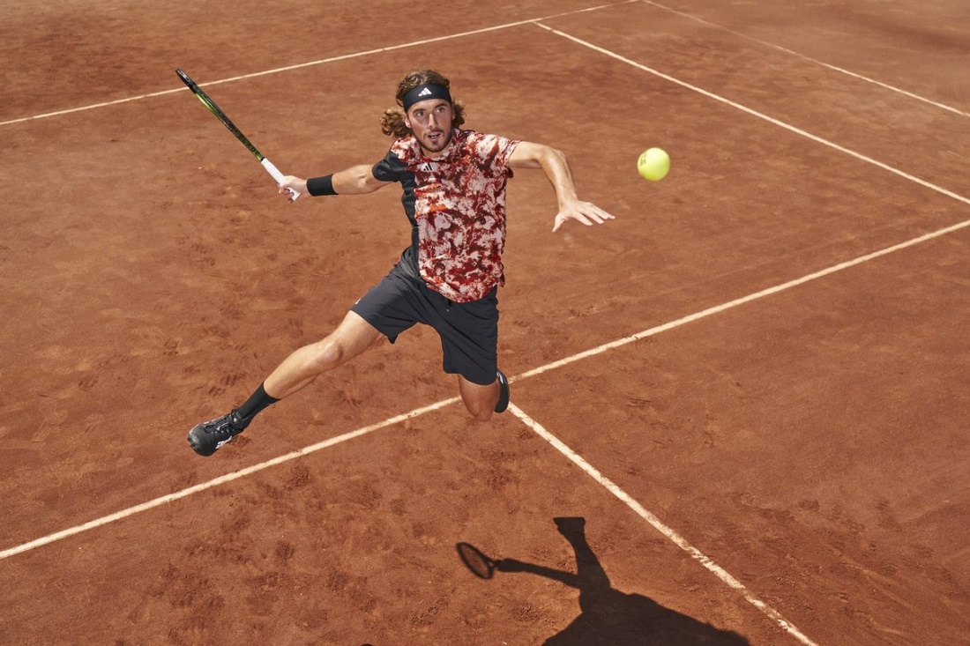
- adidas unveils its SS23 Paris Collection, inspired by the crushed stone, brick and shale of clay tennis courts
- Each piece features camo-style earthy prints, designed to help hide stroke preparation and player movements on challenging clay surfaces
- The collection will be available to buy on adidas.com/tennis-clothing and via the adidas app from April 14 2023
Herzogenaurach, April 14 2023 – Today, adidas introduces its SS23 Paris Collection – a high-performance tennis apparel range inspired by the clay courts upon which it will be worn. The 14-piece collection – which features designs for men and women – leverages both smart design and apparel technologies to help player performance, and will be worn by some of the best in the world in upcoming tournaments.
Launching ahead of clay season, the collection is adorned with camouflage-style prints in a palette of earthy tones, representing the colors and textures of the surface it was inspired by and designed for. The camo-style designs are set to disguise players’ stroke preparation and movement on what is often considered the toughest surface in a highly technical game.
Annette Steingass, Senior Director of Tennis & Court Sports Apparel, commented: “The clay of Paris is iconic, and so for this season, our aim was to take a fresh approach and use the terrain as inspiration for our apparel design. Playing tennis on clay is unique – the balls bounce differently in hotter temperatures, the pace can be less ferocious yet the techniques more technical. The players slide on the surface to make ordinarily improbable shots. With its technical design features, this new collection reflects those nuances of the game to serve our athletes and audiences in the best way.”
The collection includes multi-layered garments, including the men’s 2-in-1 shorts and women’s Match Tight and Skirt, which keep players warm in cooler temperatures. The men’s Techfit Tights provide a compressive feel for distraction-free comfort and optimal support. The long-sleeved tee offers zoned compression sleeves, woven to enable faster removal of lactic acid from the arm muscles.
Meanwhile, the men’s FRL Polo and Tee contain a FreeLift construction, which is a design feature in the arms that allows for free movement without the hem riding up during play – key for maintaining focus in those big match moments.
The whole collection also utilizes HEAT.RDY and AEROREADY technologies, so the garments help players to feel cool and comfortable on court. Select pieces in the collection, including the women’s MTBR Dress and men’s MTBR Tee. Made To Be Remade products, are the very first products for which adidas has developed an end-of-life solution. Once returned, every product is wear assessed to aid the development of future generations of products.
The SS23 Paris Collection will be premiered on-court during the clay season’s most prestigious tournament by Stefanos Tsitsipas, Garbiñe Muguruza, Felix Auger Aliassime, Dana Mathewson, Maria Sakkari and Sascha Zverev.
Stefanos Tsitsipas, elite tennis player, commented: “Clay can be an unpredictable and sometimes unforgiving surface – in 2021 I reached the final of the clay season’s most prominent tournament, but it’s also where I’ve been tested most heavily. My goal is to cement my position at the top of the game, so any wins on this surface can make a huge difference.”
The collection – adorned with colors such as burnt orange, black and white – will be available in an inclusive size range of 2XS-2XL and will be available to buy at adidas.com and via the adidas app from April 14.
For further information please visit adidas.com/tennis-clothing or follow @adidasTennis on Instagram to join the conversation, using #ParisCollection, #adidasTennis and #adidas.

