Introducing the adidas TERREX x National Geographic hiking collection,
built for exploration of the natural world

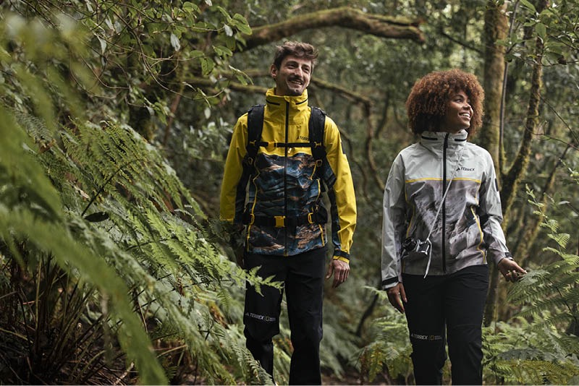

- The 51-piece collection fuses stunning nature photography with high-performance outdoor wear
- This is the first drop from a multi-season collaboration between adidas TERREX, the leading global outdoor brand and National Geographic - known globally for its legacy of exploration and storytelling
- Available from 27th April, on adidas.com, on the adidas app and in selected retail - exclusively for adiClub members

Herzogenaurach, 20th April 2023: Today, adidas TERREX announces a multi-season collaboration with National Geographic, in which these two leaders in outdoor adventure will release high-performance outdoor wear. The partnership is formed upon a shared appreciation of nature, and the foundational need for humans to connect to the world around them.

The inaugural collection is built to celebrate the role of photography in the culture of outdoor sport - as well-equipped hikers turn their ability to explore more places, and spirit of adventure, into stunning content.

To celebrate this relationship, designers at adidas TERREX combed the National Geographic photography archives for stunning stills of some of the most remote yet moving locations on earth, integrated in unique all over prints in a bold new hiking collection. All pieces are unified by National Geographic’s iconic yellow icon.

Nadia Svensson, Senior Product Director BU Outdoor said, “Nature is special beyond words. It allows us to become more inspired, more present, more conscious, more human. When in these places we are compelled to capture it through photography, to try and evoke the emotions of a place when we can’t physically be there. This collaboration celebrates nature through beautiful photographs — abstract colourful ecosystems told from above — revealing incredible stories about the Earth. It is born from, and built for, exploration of the natural world around us.”

Places celebrated in the collection include a snow-covered sandstone monocline in Comb Ridge, Utah, a 120-mile-long, north to south stretch that defines the State’s red rock landscape, as well as textured portraits of shale, - captured on the coast of Norway’s northernmost county - highlighting the sedimentary rock’s distinctive formations.

The 51-piece collection includes women’s, men’s, and gender-neutral offerings – all built to equip the wearer in multi-terrain environments.

- A hero part of the collection is the RAIN.RDY Jacket; a 2.5L waterproof and seam-sealed outer garment built to facilitate epic adventures. The men’s jacket features a bold print of the shell formations in the Porsanger Peninsula, Norway, while the women’s is inspired by stills of White Sands National Park in New Mexico. It also comes with smart design features including easily accessible pockets, pre-shaped sleeves for added protection, harness-compatible pockets, and a stowaway hood with a wire brim for improved coverage from the rain - that can also be easily stashed when the temperature changes. Additionally, it features a bold new logo design that alternates between TERREX and National Geographic from different perspectives, has a reflective tape on the back and is made in part with recycled materials. This is just one of the ways adidas is rethinking its materials, as it works towards replacing virgin polyester with recycled polyester wherever possible from 2024.
- A bold long sleeve shirt combines a stylish drop hem and lightweight fit for easy movement on the go. It is finished with the bold National Geographic yellow icon and reflective details.
- The TERREX Swift R3 GORE-TEX Hiking shoes offer the peak combination of a lightweight construction and cushioning as seen in trail running shoes with the stability of a hiking boot. Finished in a print inspired by a stunning aerial shot of Earth, the hiking shoes come with a GORE-TEX lining and membrane seal so water is kept out, and a Continental™ Rubber outsole for optimal grip in wet or dry conditions.
- The WIND.RDY: GET SHELTERED Jacket, with wind-resistant technology and a water repellent ripstop fabric, allows explorers to feel protected and confident in many weather conditions. The men’s and women’s versions come with bold prints inspired by photography including that of sandstone and snow at Comb Ridge, Utah. Smart design features including a bungee-cord enabled adjustable hem, a lightweight fabric and reflective details. Additionally, it features a bold new lenticular logo design that alternates between Terrex and National Geographic from different perspectives – and is made in part with recycled materials.

Yulia Boyle, VP of International Media and Licensing for National Geographic said, “Our storytellers and photographers spend so much time in the field, often braving the elements, to bring to life the beauty of our world and share its wonder with audiences around the globe. We hope that people will feel inspired by these beautiful and practical collections and be encouraged to get outside in similar ways.”

The product will be available exclusively to adiClub members as part of Member’s Week on adidas.com from 27th April.

-Ends-

Notes to editors

About adidas
adidas is a global leader in the sporting goods industry. Headquartered in Herzogenaurach/Germany, the company employs more than 61,000 people across the globe and generated sales of €21.2 billion in 2021.

