ADIDAS CELEBRATES MIKAELA SHIFFRIN BECOMING THE MOST SUCCESSFUL ALPINE SKIER OF ALL TIME

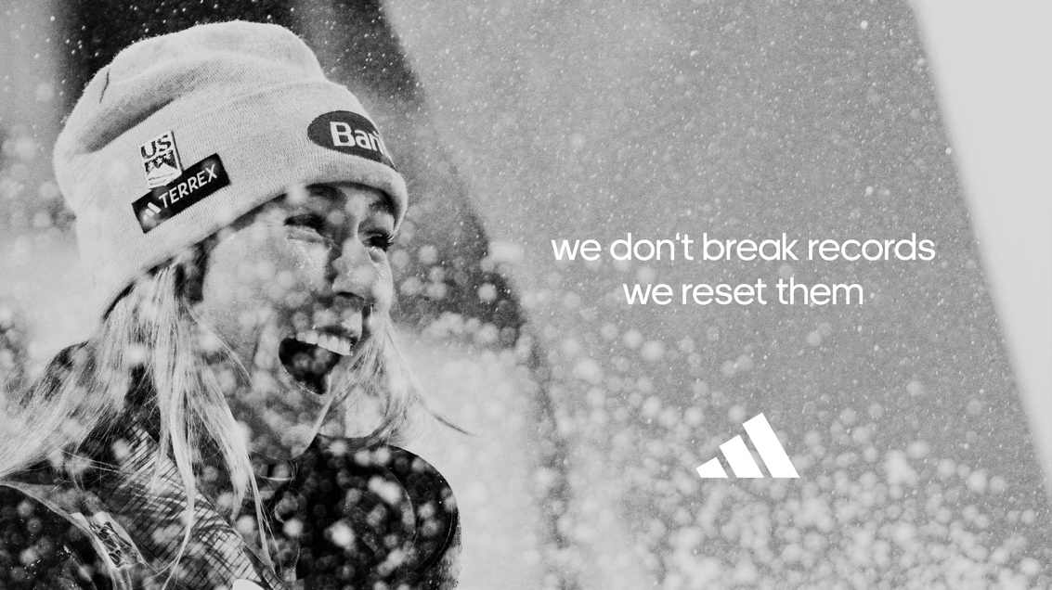

Herzogenaurach, March 11, 2023 – Following her 87th World Cup victory today in Are, Sweden, Mikaela Shiffrin has cemented her place in history by becoming the most successful alpine skier of all time. Overcoming many hurdles throughout her career, the trailblazing adidas TERREX athlete is committed to being an inspiration off the slopes, by using her platform to shine a light on issues close to her heart.
Speaking after her victory, Mikaela Shiffrin says: “It will take me a while to wrap my head around today’s win and what it means for the sport of alpine ski racing, and sport in general. Getting here has been far from easy; so much has gone in behind the scenes from so many people to make this possible. I owe my family, and my team, more than I can put into words. As much as I value this moment - it has never been my mission to break records, win titles or achieve ‘GOAT’ status. I am driven by enjoying the process of improving in this sport that I love so much, and sharing my perspective with the world, hoping to inspire people along the way. That’s what gets me out of bed and onto the slopes every morning.”
“At adidas, we believe that through sport we have the power to change lives and Shiffrin Mikaela is the personification of that.” says Carla Murphy, Global General Manager, adidas TERREX. “From raising awareness of the climate crisis and mental health issues, to addressing being on her period whilst competing - all while winning more World Cup races than anyone before her – Mikaela is more than a sporting inspiration for athletes and fans around the world, she is an inspiration for so many more, every day challenging the norms and expectations of what's possible. We are honoured to support and partner with Mikaela on this journey.”
Find more about the adidas TERREX skiing offering here: www.adidas.com/skiing-winter_sports

ENDS

About adidas
adidas is a global leader in the sporting goods industry. Headquartered in Herzogenaurach/Germany, the company employs more than 61,000 people across the globe and generated sales of €21.2 billion in 2021.

