THE LIGHTEST EVER ULTRABOOST – EXPERIENCE EPIC ENERGY AND LIGHTNESS IN EVERY STRIDE WITH THE NEW ADIDAS ULTRABOOST LIGHT

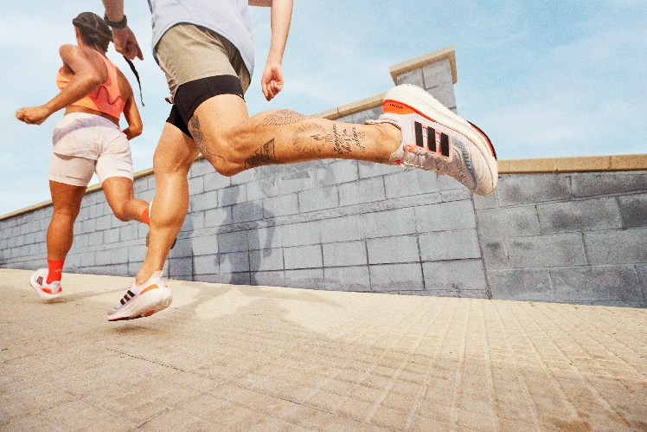
- adidas premiers a ground-breaking material innovation: Light BOOST, resulting in a 30% lighter BOOST material when compared to previous Ultraboost iterations
- Designed to provide ultimate cushioning, comfort, and responsiveness, hundreds of BOOST capsules burst with epic energy every time a runner’s foot hits the tarmac
- Ultraboost Light is priced at €190 and available in-store and online at adidas.com/running-shoes, with Early Access for members of the adidas Adi Club from today
Herzogenaurach, 23rd February 2023 – Today marks a historic moment as adidas unveils the latest member of its most iconic running shoe franchise - the Ultraboost Light. A testament to adidas’ constant strive to take its innovation to the next level to design the perfect shoe for the different type of runners and in response to consumer feedback, the new Ultraboost Light has a ground-breaking new material at its core – the Light BOOST.
Marking a decade since the introduction of BOOST technology, the new and improved Ultraboost Light benefits from 30% lighter BOOST material, resulting in a performance running shoe designed to offer epic energy, ultimate cushioning, unrivalled comfort, and responsiveness.
Simon Lockett, Footwear Product Marketing Category Director, at adidas said: “At adidas, we know that running is personal. Everyone has a different goal and therefore, different requirements for their shoes. That is why we’re continuously looking at ways to improve our products for the adidas running community. Now, thanks to our ground-breaking material innovation – Light BOOST – runners retain the existing benefits of running in an Ultraboost, but with the bonus of a lighter silhouette.”
Dr. Matthew Klein, Chief Editor and Founder, Doctors of Running: "Running with tired or heavy legs can be uncomfortable, and heavy shoes may play a role in this sensation for some people. Lighter shoes however tend to make running more efficient, meaning they can potentially improve performance for both elite runners, but also entry and everyday runners."
Taking runners’ experiences to the next level, the all-new Ultraboost Light also boasts:
- A redesigned LEP: the Linear Energy Point found on the sole of the shoe has been reworked to optimize responsiveness and work in harmony with the new Light BOOST material.
- PRIMEKNIT+ upper: Built for ultimate breathability and comfort, the shoe features a lightweight upper, providing an adapted fit.
- Continental™ natural performance rubber: Provides optimum traction for a confident run in any weather condition.
- A 10% lower carbon footprint*: The new Ultraboost Light benefits from a lower carbon footprint compared to previous versions.
The new Ultraboost Light will launch in a white colorway, featuring solar red and core black detailing, priced at €190 – and is available to purchase from in-store and online at adidas.com/running-shoes, with Early Access for members of the adidas Adi Club from today.
To find out more, please visit: adidas.com/running-shoes.
Coinciding with the launch of the new Ultraboost Light, adidas will be encouraging everyone – whether an experienced runner or newbie - to enjoy their personal experience of running, wherever they are in the world, in the Just You And Your Run challenge. With the ambition of covering a total of 3,000,000 kilometres, the challenge runs from March 3rd – 12th and upon completion will see each runner who contributed to the challenge unlock an Ultraboost Light badge within the adidas Running app. Members of the adiClub also have the chance to win a pair of personalized pairs of Ultraboost Light shoes. Join the challenge via the adidas Running app here.
To celebrate the 10th anniversary of BOOST technology, adidas is also revealing a special edition version of the adidas Ultraboost Light with a dedicated colorway. The 10th-anniversary edition comes in a primarily black colorway, with black and yellow detailing – the same design found on Energy Boost, the first-ever adidas silhouette with BOOST technology.
Follow the conversation on Instagram, TikTok and Twitter using #ULTRABOOST @adidasrunning
*The new Ultraboost Light has a 10% lower carbon footprint than previous Ultraboost. From raw material extraction, processing, and packaging, all the way to the end of the product’s lift, we calculate and communicate its carbon footprint, conforming to an internationally recognized standard: ISO 14067. To reduce out footprint, we need to measure it. The concise footprint results made available cover the complete lifecycle of the product. This is just one of our initiatives to help reduce our footprint.

