ADIDAS INTRODUCES THE NEW SS23 MELBOURNE TENNIS COLLECTION – MADE TO RETHINK MATERIALS AND DESIGNED TO HELP PERFORMANCE
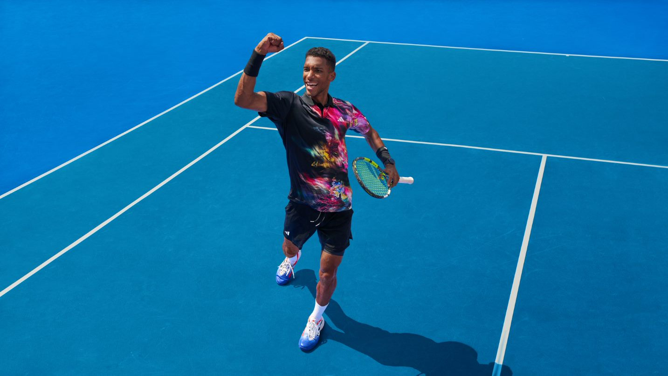
- adidas unveils its SS23 Melbourne Tennis Collection – an apparel range fit for performance
- Inspired by plants and florals, the collection features bold prints, vibrant colorways and a moiré effect textile
- The adidas SS23 Melbourne Tennis Collection will be available to buy on adidas.com/tennis-clothing and via the adidas app from Jan 13 2023
Herzogenaurach, Jan 13 2023 – Today, adidas launches its new SS23 Melbourne Tennis Collection, a range of performance apparel featuring striking colorful prints, inspired by plant life and nature. Select pieces feature a contrast-color mesh layering that when in motion creates a moiré effect and helps to mask the player’s movements and positioning on court.
Annette Steingass, Senior Director of Tennis & Court Sports Apparel, commented: “We've taken nature as inspiration for the design and construction of this collection – while harnessing adidas technologies designed for high performance. We're thrilled that players will have the opportunity to express themselves on and off the court with this vibrant collection.”
MADE TO RETHINK MATERIALS AND DESIGNED TO HELP PERFORMANCE
With the help of innovation, adidas is seeing possibilities in turning towards new resources. For these products adidas turned to a greenhouse gas technology. It uses captured industrial emissions as a new material feedstock. CO2 is fermented into ethanol which constitutes 30% by weight of a polyester yarn. adidas knitted this yarn into various products and now this carbon-based ethanol makes up a minimum of 15% by weight of these garments.
In addition, the collection also utilizes HEAT.RDY and Aeroready technologies. HEAT.RDY technology is designed to maximize airflow and optimize sweat distribution, while AEROREADY is powered by moisture-wicking fabric that absorbs sweat quickly for a dry feeling, helping players to move freely and comfortably on court.
Launching ahead of one of the most prominent hardcourt tournaments, the SS23 Melbourne Tennis Collection will be premiered on court by adidas athletes, including Stefanos Tsitsipas, Felix Auger Aliassime, Garbiñe Muguruza, Qiang Wang and Maria Sakkari, who all share a passion for working together to help make the world a better place.
Garbiñe Muguruza, elite tennis player, commented: "Being a professional tennis player is tough sometimes, especially with the constant pressure to win. Making my point on the tennis court is just as important as making a positive impact in the world, leaving a legacy that will last far beyond my sporting career. I’m excited to continue my tennis journey with adidas, a brand that is aligned with my purpose and values, embracing all the highs and the lows along the way.”
Stefanos Tsitsipas, elite tennis player, commented: “Using my voice to stand up for what I believe in is what’s most important to me. When my purpose matches my courage, there’s nothing that can stop me – on and off the court.”
THE COLLECTION
The collection features a range of styles for men and women, from a dress, crop-tops and skirts, to sleeveless tanks, 2-in-1 shorts and a long-sleeve tee.
As a set of mix and match pieces in a range of styles, this collection is designed to cater for the needs of athletes on and off the court, covering both performance and leisure. The casual woven jackets and pants are perfect garments for down-time and chilling between games.
The striking collection features a signature print throughout – a multi-colored photo pattern inspired by earth and plant life. The prominent colors of the collection are clear pink, black and white, for both men’s and women’s, with the pieces available in an inclusive size range of XS-2XL.
The SS23 Melbourne Tennis Collection will be available at adidas.com and via the adidas app from Jan 13.
For further information please visit adidas.com/tennis-clothing or follow @adidasTennis on Instagram to join the conversation, using #MelbourneCollection, #adidasTennis and #adidas.
- ENDS -
Notes to editors:
About adidas
adidas is a global leader in the sporting goods industry. Headquartered in Herzogenaurach/Germany, the company employs more than 61,000 people across the globe and generated sales of €21.2 billion in 2021.
About adidas Tennis
adidas Tennis is represented by top players such as Garbiñe Muguruza, Dana Mathewson, Maria Sakkari, Karolína Muchová, Dominic Thiem, Stefanos Tsitsipas and Félix Auger-Aliassime. For more information on adidas Tennis, please visit adidas.com/tennis-clothing. For additional images please visit our media Newsrooms on news.adidas.com and follow us on Twitter or on Instagram under @adidasTennis.

